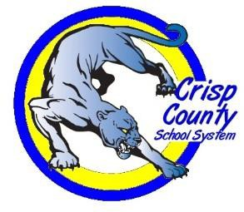
Title X, Part C – McKinney-Vento Education for Homeless Children and Youth
CRISP COUNTY SCHOOL SYSTEM

If your family lives in any of the following situations:
- In a shelter
- In a motel or campground due to the lack of an alternative adequate accommodation
- In a car, park or abandoned building
- Doubled up with other people due to loss of housing or economic hardship
Your school-age children may qualify for certain rights and protections under the federal McKinney-Vento Act.

The Crisp County School System assigns a Homeless Liaison/School Social Worker to oversee the Homeless Education Program. The Homeless Liaison assists the local schools to assure identified homeless children and youth receive the following services:
- Timely Enrollment
- Transportation
- Community Resource Information

The primary goal of the Homeless Liaison is to eliminate barriers to school enrollment and promote academic success for all students. In addition to providing support to local schools, the Homeless Liaison serves as the link between families and community resources.

If you are struggling with a housing crisis (i.e., you live in a motel, are living in someone else’s home, on the street, etc.), please contact our homeless liaison/school social worker Lisa Simpson for assistance.

Please click on the links below to learn more: Homeless Education Poster – English Click Here Homeless Education Poster –Spanish Click Here
What You Need to Know to Help Your Child in School- A Guide for Parents, Guardians and Caregivers Booklet- English Click Here
What You Need to Know to Help Your Child in School- A Guide for Parents, Guardians and Caregivers Booklet-Spanish Click Here

Lisa Simpson
Crisp County School Social Worker & Homeless Liaison 201 S. 7th Street
lsimpson@crispschools.org 229-276-3400 Ext. 1112

Department of Federal Programs Revised August 2015 1

