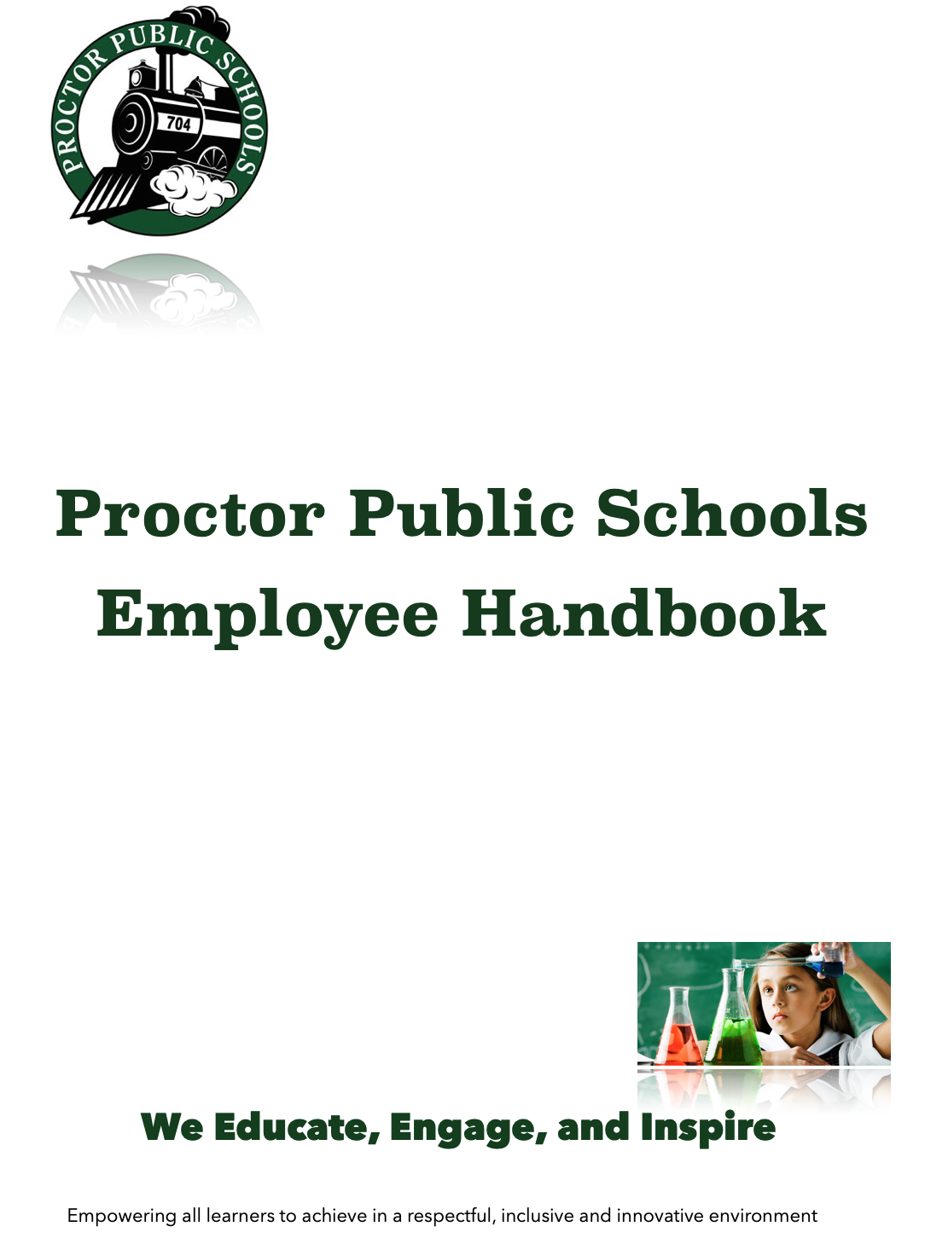

Proctor Public Schools
Employee Handbook

Superintendent Welcome
First of all, thank you for choosing to partner with Proctor Public Schools. Our faculty and staff are at the forefront of what makes our District a fantastic place to learn, work, and grow. I take great pride in the joint efforts of our team and the success of our District. I look forward to your contributions to help us achieve our school mission of “empowering all learners to achieve in a respectful, innovative, inclusive environment.”

As an organization, we are committed to advancing and promoting an environment that embraces equity, inclusivity, and diversity at all District levels. The Proctor District advances these principles with the assistance of the Duluth Family Freedom Center in an ongoing partnership to promote Engagement, Empowerment, and Education along the lines of race, poverty, and equity.

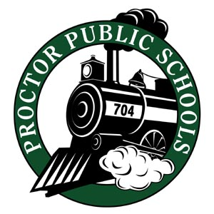
Together we can advance our school vision: "We Educate, Engage, and Inspire.” I am always willing to meet with you on any of your ideas about our schools. Together we will continue to accomplish great things.

I am excited to continue providing excellent education throughout our District, and I look forward to meeting you as the year progresses. I especially welcome you to stop at school to visit with me or to share your thoughts about our schools. Feel free to contact me via email or phone.

Partnering with you,
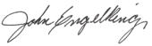
John Engelking, Superintendent of Schools
Proctor Public Schools
131 9th Avenue
Proctor, MN 55810
Office Direct Number: 218-520-3217
Cell Number: 218-390-9860

About this Handbook
The Proctor Public Schools Employee Handbook is an overview of organizational vision, priorities, and the most commonly referenced policies and procedures. Much more detail is available at www.proctor.k12.mn.us. Employees are encouraged to review and become familiar with the detailed online information.

Table of Contents | Page #
District Vision & Mission | 5
Beliefs & Values | 5-6
Strategic Plan | 7-9
District Overview | 10
District Calendar | 11
School Board | 11
Faculty & Staff | 12-13
TalentEd - Onboarding | 13
Human Resources | 14
Health Insurance of Benefit Plans | 14
Curriculum & Learning | 14-15
Professional Development | 16
Technology | 16
Activities & Athletics | 17
Community Education | 17
Transportation | 17
Nutrition Services | 18
Special Education | 18
Facilities | 19
Emergency/Safety Policies & Procedures | 19
Substitute & Student Teachers | 20
Commonly Used Abbreviations | 21

District Vision & Mission

Vision:
We Educate, Engage, and Inspire
Mission:
Empowering all learners to achieve in a respectful, innovative and inclusive environment.

Beliefs and Values

Proctor Public Schools prides itself on adhering to values and principles which help define what we require in our faculty and staff. These values and beliefs help to quantify the essence of trust as developed by David Horsager and the Trust Edge Institute.

It is because of our relationship and partnership with the Trust Edge that we have adopted the eight pillars of trust as guiding principles for the Proctor School District. All employees of Proctor Public schools should aspire to embrace these principles.

(David Horsager, The Trust Edge)
8 Pillars of Trust | Definition | What This Looks Like
Clarity | Students and adults benefit from clear and concise decisions and directions. | Give directions that are clear from the start so you aren’t clarifying things later.
Compassion | Individuals trust those who care for others. | This is simple: Be kind.
Character | Do the right thing, even when no one is watching. | Make decisions and take actions that you can be proud of.
Competency | Confidence builds within our schools when actions are made from informed decision making. | Stay relevant on trends and stay well-read in areas in which you are involved.
Commitment | Remain steadfast through difficult times and adversity. | When the going gets tough, stand up for your convictions.
Connection | Develop friendships and relationships. People tend to follow and believe in friends and acquaintances. | Make efforts to build relationships with students and our colleagues.
Contribution | Results build trust and buy-in. | Make efforts to generate results that can be recognized and appreciated.
Consistency | People love to see things done consistently. | Follow through with little things on a regular and consistent basis.

Equity - Inclusivity - Diversity
It is further understood that as an organization, we are committed to advancing and promoting an environment that embraces equity, inclusivity, and diversity at all levels of the District. The Proctor District advances these principles with the assistance of the Duluth Family Freedom Center in an ongoing partnership to promote Engagement, Empowerment, and Education along the lines of race, poverty, inclusion, and equity. It is also understood that these core values and beliefs constitute the ideals of Proctor Public Schools through ongoing input of the Community Strategic Planning Committee, the School Board, the administration, faculty, staff, students, and our greater community. Input is received through surveys and in-person committee meetings.

Defining Equity - Inclusion - Diversity
As employees of the Proctor School District, it is important to develop a shared understanding and awareness of what the terms equity, diversity and inclusion mean.
- Equity may be defined simply as, "Making sure students have what they need to be successful."
- Diversity may be easily defined as, "Differences among people - age, gender, race, religion, ability, etc..."
- Inclusion may be explained as, "Making sure everyone feels a sense of belonging and is respected for who they are.”

Strategic Plan
Proctor Public Schools partnered with our school communities, school board, faculty, and staff in developing our Strategic Plan. The Minnesota School Board Association led our Strategic Planning. We look forward to partnering in additional opportunities and continue to plan for future work on our Strategic Plan. Strategic Planning Committee

The Strategic Planning Process:
- On August 16, 2019, the School Board and Proctor Administration met with Gail Gilman and Terry Quist from the MSBA Strategic Planning Team to discuss the process that the District would follow during the planning.
- Surveys were launched, asking external and internal candidates to share both strengths and opportunities throughout the District on September 3rd with a completion deadline of September 20th.
  - 337 External Stakeholders participated
  - 108 Internal Stakeholders participated
- Listening Sessions were scheduled on September 17th and September 18th to allow diverse groups the opportunity to share their vision for the future of the Proctor School District.
- Listening Sessions Groups were:
  - Students
  - Transportation
  - Faculty and Staff
  - School Board Members
  - Administration
  - Community
- Each listening session lasted approximately 1 1/2 hours

Strategic Planning Committee Work:
- The next step involved creating a Strategic Planning Committee consisting of 35-40 members with the intended makeup of 60% external stakeholders and 40% internal stakeholders. The Strategic Planning Committee will meet three times to develop the focus for the District over the next three to five years.
- We believe this plan will help guide our District while allowing us to review prioritized dates and make adjustments along the way.

Strategic Planning Committee
Abby Knight  Amy Pocrnich  Brian Billman  Carlie Anderson  Chris Johnson  Christy Strohm  Corey Kemp  Desirae Marchand  Dewey Johnson  Diane Morin  Gina Cole  Jeff Gookins | Jennifer McDonald  Jess Manninen  Joe Ward  John Awsumb  John Engelking  Kara Graves  Karen Swanson  Kim Parmeter  Kim Sequin  Kris Bryant  Kristal Berg  Larry Shelton | Lori Johnson  Lynn Peterson  Mark Hughes  Micaela Johnson  Nancy Litman  Shelly McAllister  Sherie Lillie  Steve Anderson  Steve Isakson  Ted Peterson  Jennifer Lundberg

2019-2024 Proctor Public Schools Strategic Plan​​​​​​​
We believe in:
Equity:
Students will have equitable access to a safe, all-encompassing and engaging learning environment.
Safety:
Creating safe environments where all students feel valued is the core of our mission.

Community:
Collaboration, communication, and support among the home, the school, and the community have a positive impact on our students.
Inclusion:
All students will receive an education developed to meet their individual needs.
Excellence:
Delivering academic standards through the art of teaching is the foundation of educational excellence.

Investment:
Investing in our students, staff, and community will pay dividends in our future.

Focus Area #1: Student Achievement
We will achieve the goals of the World’s Best Workforce (WBWF) for all students in the school district.
We will annually evaluate the success of meeting the five goals of the World’s Best Workforce:
- All students are kindergarten ready;
- All students reading at grade level by third grade;
- Closing the achievement gap for identified student groups;
- All students graduating career and college ready; and
- All students graduating on time.
We will increase academic achievement by providing quality tier one instruction for all students.
- Continue to develop our PreK-12 MTSS process.
- Continue to implement RAILtime as an opportunity to provide intentional instruction to reach all individual learner needs.
- Establish data-informed protocol within the Professional Learning teams to guide instruction and assessment as a core practice across the district.
- Ensure all students should have a positive connection with an adult within the school setting.
- Ensure all students in Proctor Public Schools will show growth on state accountability and college ready assessments.
- Ensure all students understand the value of their education and interests

Focus Area #2: Student Support
We will meet the needs of all students.
- Have mainstream teachers collaborate with case managers to learn how to meet the needs of individual learners.
- Support the physical, social and emotional health of all learners.
- Implement a system designed to identify the individual needs of students and match identified students with appropriate evidence-based interventions at the secondary level and maintain the system at the elementary level.
- Provide high quality professional development around inclusion to increase teacher and staff capacity to meet the needs of all exceptional learners.
Create procedures and practices that support the district’s Equal Education Opportunities policy
- Annually review procedures and practices for implementing the district’s EEO policy
- Communicate the purpose of the policy to all internal and external stakeholders.
- Provide training on EEO policy for staff, students, and parents.

Focus Area #3: Workforce
We will recruit, hire and retain the highest quality professionals for every position in the school district.
- Identify and implement a system to annually assess how the district is sustaining a supportive, positive and trusting environment.
- Develop clear and viable job descriptions, expectations, and team responsibilities through district collaboration.
Every learner is prepared for post high school education and training.
- Create a plan for exposing learners to multiple career paths.
- Develop a career and college readiness plan for pre-K through 12th grade.

Focus Area #4: Facilities
Ensure facilities will meet the needs of early learners and early childhood education equitably throughout the district.
- Evaluate projected ECFE enrollment, program offerings, and physical space needs.
- Develop draft design plans to meet the needs of projected early learning enrollments.
- Create a plan to fund necessary facility improvements and/or additions.
Modernize classrooms to create learning environments which are safe, all encompassing, and engaging.
- Create modernized, safe and engaging classrooms to meet the needs of instructional programming
- Create student centered, welcoming, and safe learning environments.
- Evaluate and analyze media centers to better serve the needs of our students and faculty.

Focus Area #5: Communication
Create a coordinated and effective communication process throughout the school district and the community
- Audit current communication practices with all stakeholders and identify options for improving effective communication strategies.
- Develop and implement a plan to use multiple communication formats to reach all internal and external audiences within the school district.
- Provide effective and consistent communications within the transportation department, while providing excellent customer service.

District Overview
Proctor’s 150 square mile district serves the City of Proctor and the neighboring communities from Spirit Mountain to Fish Lake and the residents of: Bay View Heights, Twig, Midway, Solway, Grand Lake and Canosia Townships. Proctor Public Schools serves an average total enrollment of 1890 students.
Early Childhood
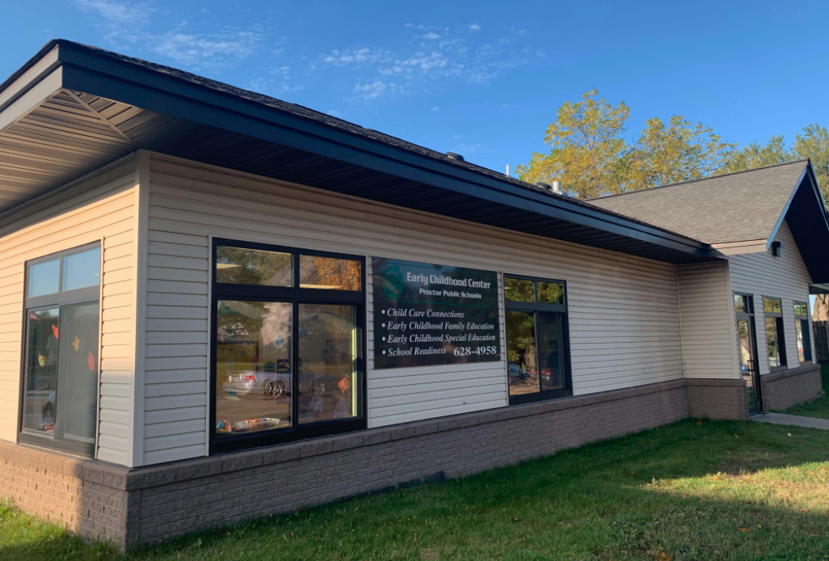 | Proctor Early Childhood Center  202 5th Street  Proctor, MN 55810  (218)729-9563  Faculty/Staff Directory - Handbook
Elementary Schools
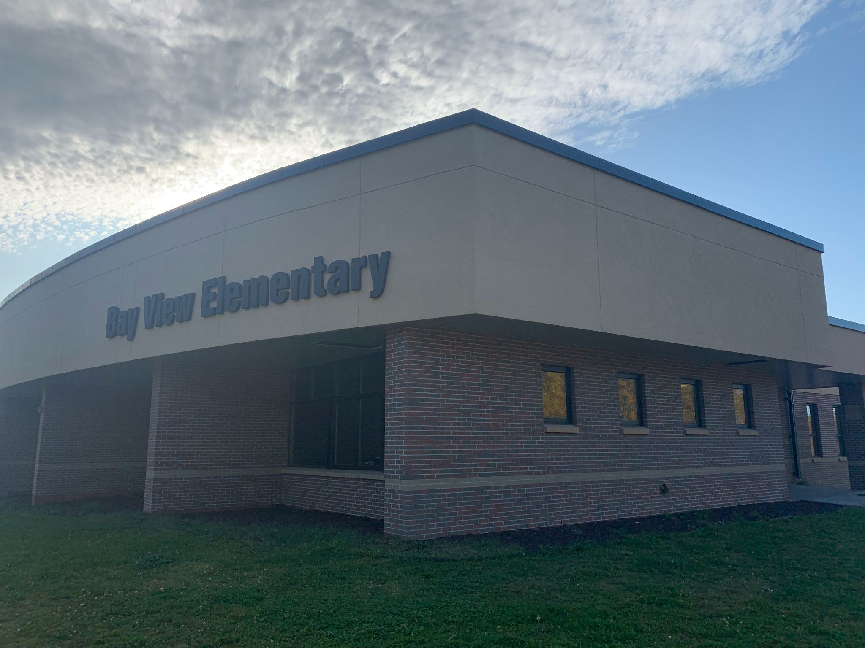  Bay View Elementary  8708 Vinland Street  Duluth, MN 55810  (218) 628-4949  PreK- Grade 5  Faculty/Staff Directory - Handbook | 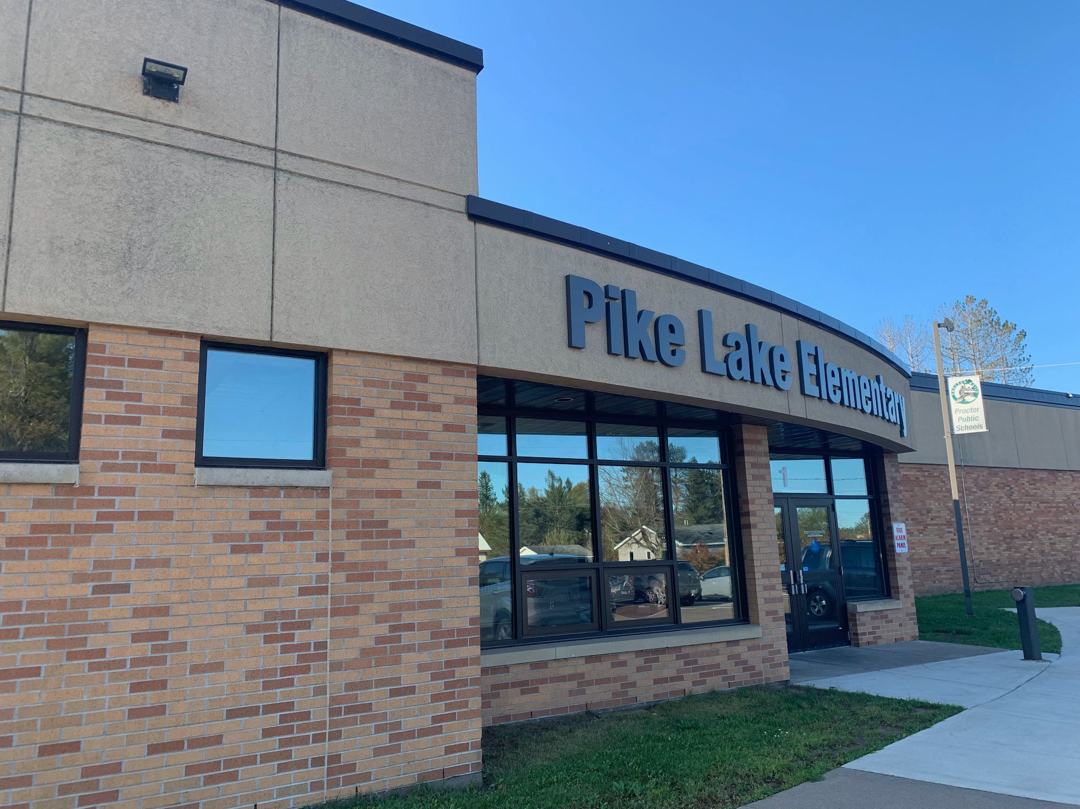  PikeLake Elementary  5682 Martin Road  Duluth, MN 55811  (218) 729-8214  PreK-Grade 5  Faculty/Staff Directory - Handbook
Secondary Schools
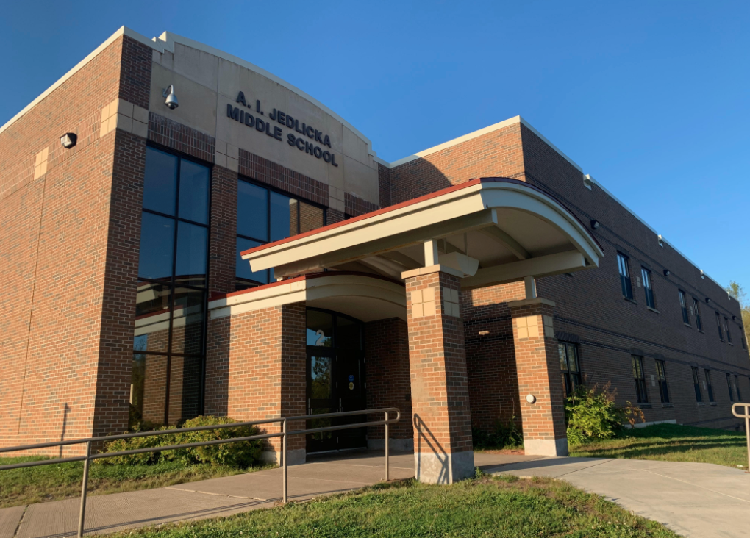 | 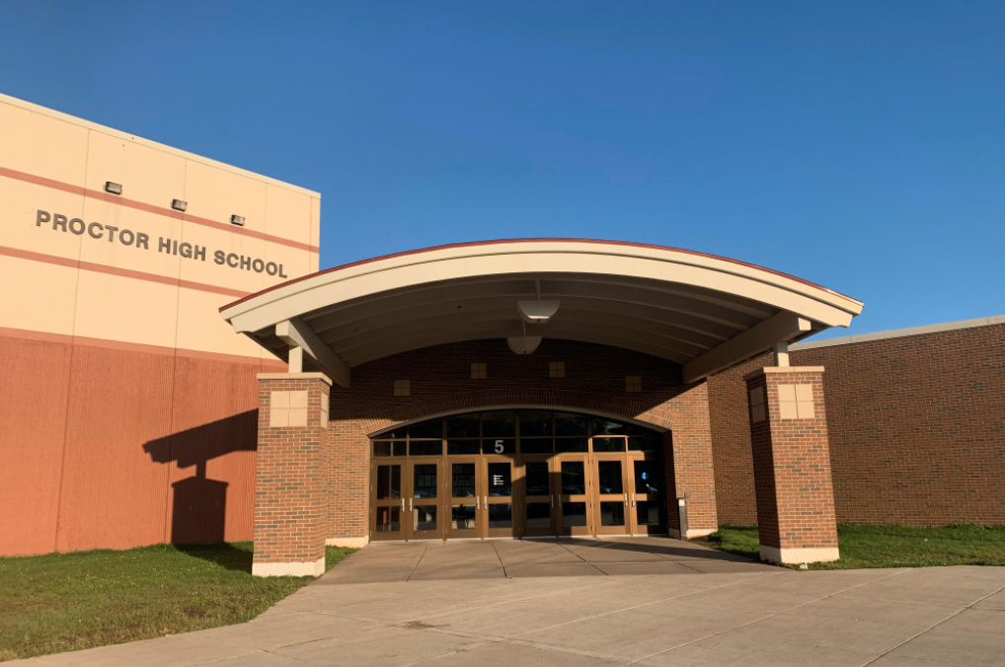
Jedlicka Middle School  131 Ninth Avenue  Proctor, MN 55810  (218) 628-4926  Grade 6-Grade 8  Faculty/Staff Directory - Handbook | Proctor High School  131 Ninth Avenue  Proctor, MN 55810  (218) 628-4926  Grade 9-Grade 12  Faculty/Staff Directory - Handbook

District Calendar
The Proctor District Calendar is established each year in early March. Access to our calendar is available through our website and is available in a printed format by contacting Lori Johnson in the District Office.

School Board
The Proctor School Board is made up of 7 elected community members. The board meets at 7:00 pm on the second and fourth Monday of each month at the St. Luke’s Event Center. Each year, the school board develops District School Board Goals ​​​​​​​​​​​​​ to guide their work. Each meeting will be televised on Rails TV for public viewing. Meeting agendas come out the Thursday prior to the meeting. Faculty and staff requesting to speak during a school board meeting must contact Lori Johnson prior to the meeting. Meeting minutes and school board contact information can be found on the School Board website.

School Board members:
Larry Shelton  Term: 01/2019-12/2022 | (218) 391-5779 | lshel81513@aol.com
Jennifer McDonald  Term: 01/2021-12/2024 | (218) 340-3295 | jennmcd777@gmail.com
Lynn Peterson  Term: 01/2019-12/2022 | (218) 391-3825 | lpeters2@proctor.k12.mn.us
Joe Ward  Term: 01/2019-12/2022 | (218) 624-4132 | racjoe13@msn.com
Kimberly Parmeter  Term: 01/2021-12/2024 | (218) 391-6808 | kparmeter@proctor.k12.mn.us
Jim Podgornik  Term: 01/2021-12/2024 | (218) 260-9592 | jpodgornik@proctor.k12.mn.us
Amy Pocrnich  Term: 01/2019-12/2022 | (218) 940-7884 | apocrnich@proctor.k12.mn.us

School board members are required to be an active member of various committees within the school district and Proctor community. All information about the current school board and to view the committees and participating members can be found on the school board website.

Faculty & Staff

Proctor’s District Faculty and Staff:
The continued success and growth of our District are directly related to our dedicated and talented faculty and staff. The Proctor District employs over 500 total employees which include 140 teachers and 115 union staff employees and bus drivers. Various committees are provided for members of the faculty, staff, and community to participate in to guide each site towards the district’s vision and mission. Faculty and staff are encouraged to participate in the district teams to ensure their voices are heard.
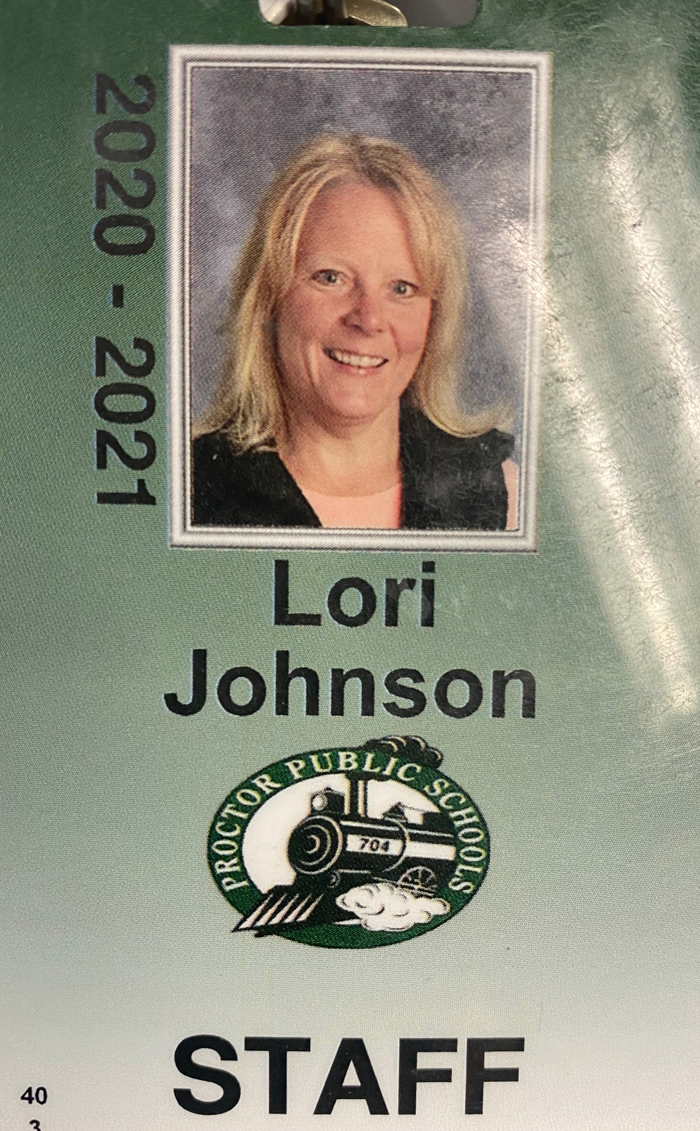
Identification and Faculty & Staff Pictures:
All faculty and staff are required to wear a staff ID (identification badge) while on campus and during the working day. This includes riding busses as well as attending class and events at any school facility, Faculty and staff pictures are taken at the beginning of each year at each of our campuses. Picture and photography schedules will be announced before the start of the school year during fall in-services.

Staff & Faculty Evaluation Procedures:
Evaluations are completed and reviewed by the staff and faculty immediate supervisor.

Mentorship:
Teaching staff will have the opportunity to participate in the mentorship program the first three years of employment in the Proctor School District. Details of the mentorship program are available on our website.

Parking:
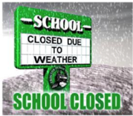
Staff parking is reserved at Proctor High School and Jedlicka Middle School and staff are required to display a parking permit. To obtain parking permits contact the High School Office. Your free parking permit is a window cling decal. Parking at our elementary schools and all other school facilities do not require parking permits. Principals and Directors will designate portions of our lots to faculty and staff parking at the beginning and end of the school year.

School Weather Related Closures:

Communication System and the Proctor School App:

Parent Link App - The Most Important App for School Information
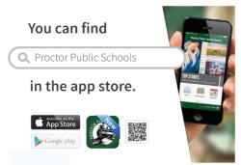
Proctor Public Schools has its very own App! The App developed by Blackboard Mass Communication (Bb Comms), allows the Proctor Public School District to have its own branded App which also provides a robust communication tool which sends:
- Notifications to anybody with our Proctor School App
- Phone call to current parents and staff
- Text messages to current parents and staff
- Emails to current parents and staff
To download the Proctor School App, please visit:
- Apple App Store​​​​​​​​​​​​​​
- Google Play for Android

Reimbursements:
Employees can submit forms to the District office for qualified reimbursements by accessing forms Employee forms - vouchers, mileage reimbursement

How to report suspected abuse - procedure
School employees are mandatory reporters and are required to report maltreatment of children and suspected abuse. If you have questions about how to report, contact your immediate supervisor. Access our policy related to reporting suspected abuse of minors.

Phones numbers and email accounts:
All faculty members have telephones in their classroom. There are also telephones assigned and installed in all of our offices. Complete list of phone numbers and extensions is available from the District office. Contact Lori Johnson if you have questions or if you need a phone directory.

Each faculty staff member will be assigned an email address. The email convention is the first letter of your first name, followed by your last name @proctor.k12.mn.us. Contact Phil Paulson if you have questions.

Keys:
All employees are assigned a card-key pass to enter their assigned building. Card-key passes are distributed by the building principal. Each employee is assigned a room key associated with their assignment. Keys are distributed by the building principal.

Local Union Presidents:
Education MN Proctor (Teachers’ Union) - Liz Proepper
Local 66 (Paraprofessionals, Custodians, Cooks) - Rachel Ward
Bus Drivers - Wally Mattson

Contract Information:
For a copy of your union contract contact Lori Johnson at ljohnson@proctor.k12.mn.us in the District Office or contact your local union president

Teachers must follow the MN Code of Ethics.

TalentEd - Onboarding
At Proctor Public Schools, we are committed to providing consistent and up to date information for staff. All staff will be provided an opportunity for onboarding through TalentEd. Current and new employees will be expected to complete the onboarding process. This process will occur at the beginning of each school year and/or prior to the start date of employment. The following are some of the required onboarding items.

Policies to review annually  - 413 - Harassment and Violence Report Form  - 416 - Drug and Alcohol Testing  - 418 - Drug-free Workplace/School  - 524 - Internet Acceptable Use and Safety | Technology  - Email set up  - Tech usage agreement  Instructional (handbook)  - Curriculum login info  - Dyslexia overview  - MTSS process  District wide  - Bloodborne pathogen  - Data privacy

Human Resources

The Human Resources department can be accessed through the Proctor Public Schools website. Links to access your payroll, benefits, and employment information are all available online. Proctor uses the SmartER system for employees to access the following information through the Employee Self Service link.
- Print and view ACA Form 1095
- View leave information
- View current and previous check information
- View and sign wage statements
- Change direct deposit information
- Change tax withholdings

Health Insurance and Other Benefits
Proctor Public Schools offers our employees the opportunity to enroll in health insurance and dental insurance. Each bargaining unit within the Proctor School District (Education Minnesota Proctor, AFSCME Local 66, and AFSCME Proctor Bus Drivers) have negotiated separate benefit limits and contributions to family health benefits and our 403b employee plans At the start of each school year the, the District will provide an inservice to explain health insurance as well as contributions to an employee’s 403b.

Proctor Public Schools also provides our employees with an opportunity to enroll in AFLAC supplemental insurance plans. At the beginning of each school year, an AFLAC representative will explain benefits and costs.

If you have questions about employee benefits, pay dates, bank time/hourly vouchers, insurance, or direct deposit, contact Robin Hanson at 218-520-3214.

Teachers and Paraprofessional Requesting Sick Leave and Personal Leave
If you are ill and need to request a day of leave, you need to request that leave using our absent management system. Employees will receive information explaining the procedures via email directly from “Absent Management.” For more information, contact Lori Johnson or your building principal.

Bus Drivers and Custodians Requesting Sick Leave and Personal Leave:
If you are ill and need to request a day of leave, you need to contact your immediate supervisor.

Curriculum & Learning

The department of Curriculum and Learning supports teachers, students, families, and staff within the Proctor Public Schools and community. Our goal is to empower all learners to achieve in a respectful, innovative, and creative environment by providing a guaranteed and viable curriculum. Keeping our focus on the Learning that Matters.

Proctor’s Curriculum Advisory Board works to ensure that the focus of the district curriculum follows our mission to educate, engage, and inspire the students and staff while following state requirements. The CAB meets monthly and is composed of ⅔ community members and ⅓ staff and faculty members.

Proctor follows the state timeline for curriculum review. The Curriculum Review Cycle reflects changes at the state level and may change based on Minnesota Department of Education Rulemaking modifications. Curriculum teams meet monthly to review the implementation of the MN State standards in all content areas.

Curriculum/Department Teams:
Curriculum & Department Teams meet regularly to assure the curriculum review cycle is implemented and follows district/state guidelines around curriculum and instruction in specific areas of instruction. The following tasks are completed by the teams.
- Create a timeline of the exploration process and communicate with stakeholders.
- Identify curriculum resources to explore, pilot, evaluate for purchase, and implement.
- Develop an implementation plan including a timeline of curriculum.
- Meets to assure instruction, resources and assessments fulfill district and state expectations.
- Create fidelity checks to review the implementation of academic standards.
- Review the current implementation and identify areas for improvement.
The process of reviewing curriculum resources is ongoing and always being updated based on current needs.

Grants & Partnerships that Support Learning:
Alternative Delivery of Specialized Instructional Services is an application process for districts and charter schools to apply for state special education aid. The purpose of ADSIS is to provide instruction to assist students who need additional academic support to succeed in the general education environment. The goal is to reduce the number of inappropriate referrals to special education by providing support early to struggling students. Districts are expected to align the ADSIS program within their existing continuum of supports, collect data as specified in the application, and submit evaluation information to the Minnesota Department of Education (MDE) each year to determine program impact. Proctor Public Schools ADSIS funds support Tier 2 instruction for all students without an IEP in grades Kindergarten through Grade 10. Reading and Math interventionists meet with students to establish goals and strategies to guide their academic achievement.

Title One is a school-wide program which serves approximately 60 students. The Bay View Title I Program is staffed with two teachers that support students in grades K-5 in both reading and math. Title I programming supports tiered intervention focused on differentiation. Interventions are conducted in daily, small group activities throughout the school week.

Native American Grant is provided through the Minnesota Department of Education. The goal of the funds is to support districts and schools to ensure that every Native American student in the state has equitable access to programs that are specifically designed to meet their unique educational and cultural academic needs. Proctor Public Schools utilizes the funds to implement appropriate and culturally responsive programs to support Native American students along with sharing the culture with all.

World’s Best Workforce:
Under Minnesota Statutes, school boards are to adopt a long-term, comprehensive strategic plan to support and improve teaching and learning. This plan addresses the following five goals:
- All children are ready for school.
- All third-graders can read at grade level.
- All racial and economic achievement gaps between students are closed.
- All students are ready for career and college.
- All students graduate from high school
Proctor Public Schools World’s Best Workforce Plan shares a reflection of the previous school year along with provides goals for the current school year.

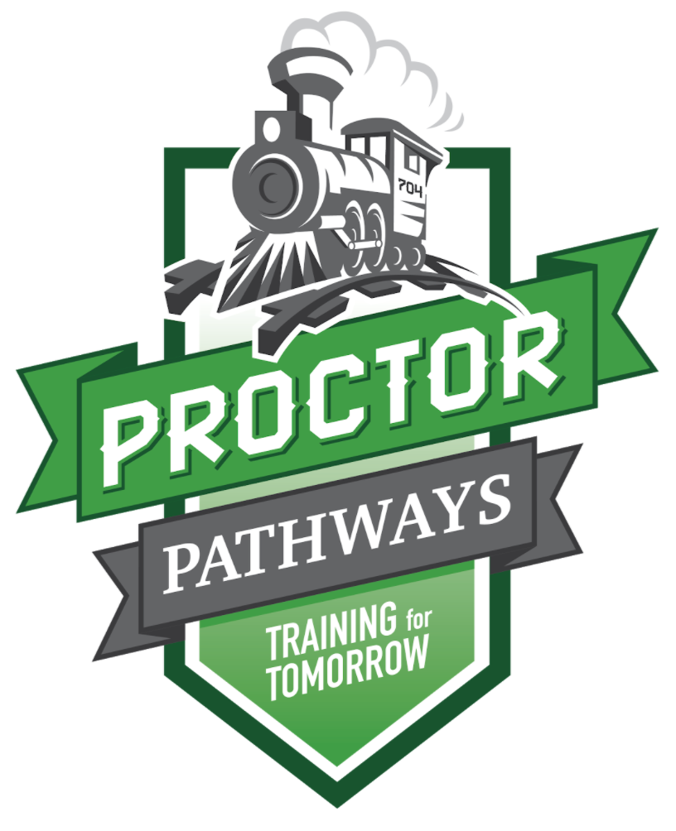
Proctor Pathways:
Proctor Public Schools provides a series of experiences within our courses students can take to be more prepared for further study, training or work opportunities within a specific career field. Students have the opportunity to job shadow, learn from guest speakers and work with real companies on real projects, while fulfilling graduation requirements.

The RailPath is a time during the school day at the high school where students have time to explore Employability Skills, build Personal Learning Plans and explore graduating with a plan.

Contact Sarah Klyve, Student Success Coordinator, for more information.

In Proctor, we believe that ALL students can learn. The MTSS framework is used to guide the support needed to meet the needs of all students.

MTSS or Multi-tiered Systems of Support is a comprehensive, evidence-based framework that aims to equitably support the academic, emotional, social, and behavioral development of ALL STUDENTS. The framework relies on data-driven, collaborative decision-making and high-quality instruction to accelerate student learning of the MN state standards.
- MTSS Academic Process
- MTSS Acceleration Process​​​​​​​
- MTSS Behavior Process

The Curriculum and Learning website is available to all staff and community members.

Professional Development

At Proctor Public Schools, we are committed to providing professional development opportunities for our staff to benefit, not only our employees, but also the parents and students of our fantastic Proctor community. The school calendar has 5 full days built in to focus on professional development at both the district level and site level. Teachers are also provided professional time in their daily schedule to continually improve their teaching and learning.

The Professional Development Website is available to all certified staff to gain critical teaching strategies and earn continuing education units (CEUs) for relicensure. Non-certified staff have access to staff development opportunities throughout the year. Contract our Staff Development Coordinator, Mark Hagemeyer with questions about your personal opportunities to learn and grow with Proctor Public Schools. Contact Hagemeyer for more information about staff development and mentorship opportunities at Proctor Public Schools.

Technology
Currently, technology performs a significant role in education. Whether it is by providing learning opportunities through multimedia in the classroom, one to one devices, or up to date information; technology has the ability to equip our students with the tools they need today to succeed for tomorrow. As well as helping students learn and grow, technology plays a substantial part in communication between students, parents, teachers, and the community. Communication within the school district is a key aspect in assisting our students to succeed. To provide these opportunities, it is critical to maintain a solid and progressive technology infrastructure.

Proctor Public Schools is a one-to-one technology district. Each student and faculty member are provided with a Chromebook to support both teaching and learning.

Technology Department Staff
Scott Fitzsimmons - Direction of Technology  - sfitzsimmons@proctor.k12.mn.us  - Hardware/equipment support  - Technology integration support  Dean Dahlvang - Director of Administrative Technology  - ddahlvang@proctor.k12.mn.us  - System integration  - Behind the scenes wizard | Dee Wilmont - District Technology Technician  - dwilmont@proctor.k12.mn.us  - Hardware support  Phil Paulson - Director of Student Information Systems  - ppaulson@proctor.k12.mn.us  - Account management  - CANVAS, Campus support  - State reporting

Learning teams are encouraged to submit a Tech Request Form for any technology software or resource that they feel supports and enhances the teaching and learning of their content area.

Activities & Athletics
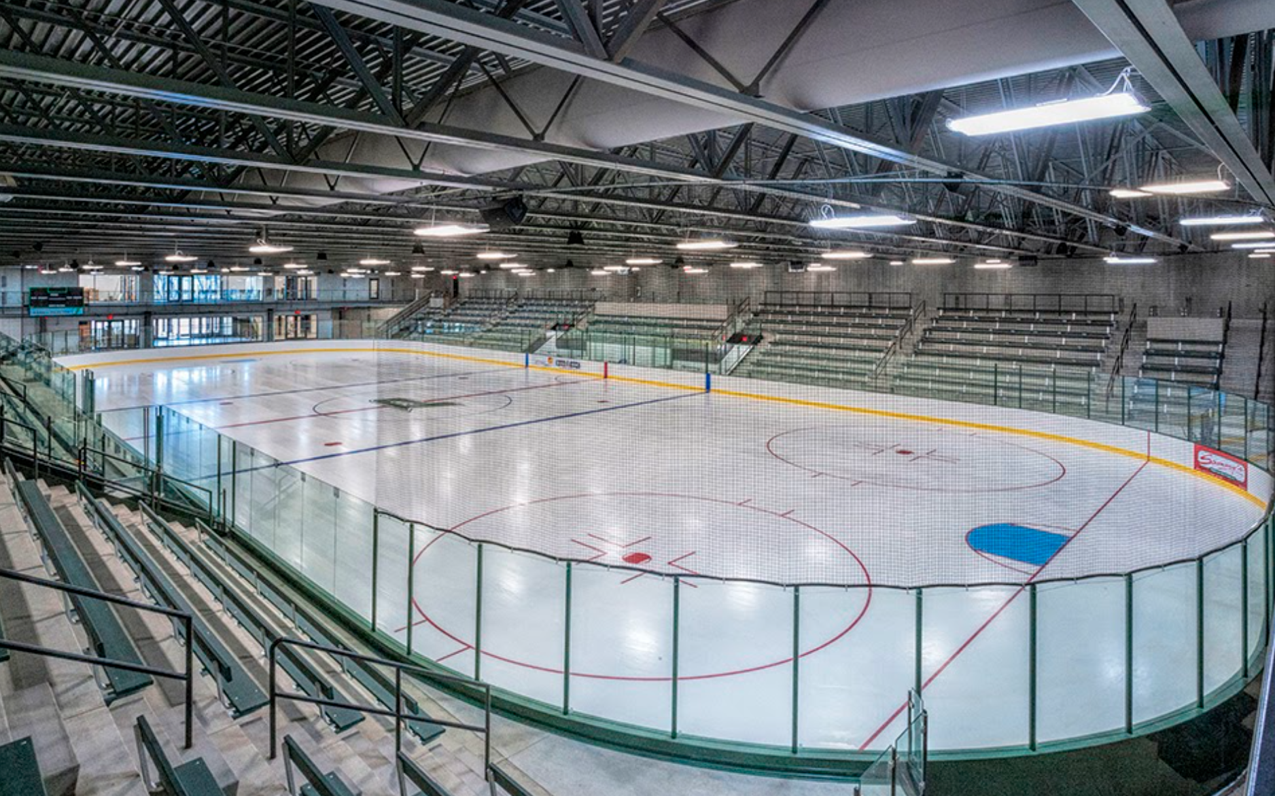
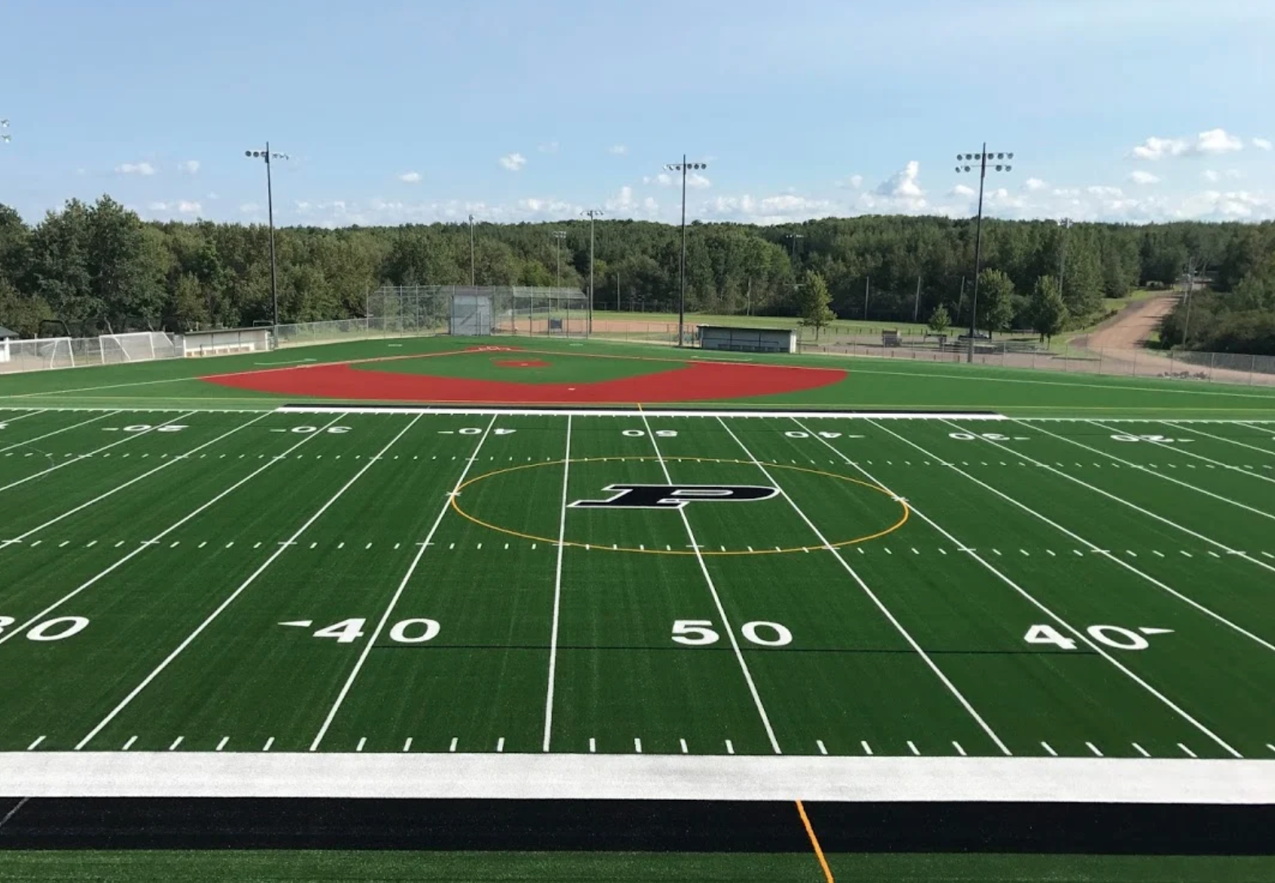
Proctor Public Schools has opportunities for our faculty and staff to be involved in our activities and athletic programs. If you are interested in coaching or supervising events, please contact our Director of Athletics and Sports Facilities, Anthony Wood.

Community Education

Proctor and Hermantown Community Education, with Proctor Public Schools and Hermantown Community Schools, services more than 24,000 residents combined. Proctor and Hermantown Community Education proudly serves all ages, from the youngest of learners through adults and senior citizens.

Proctor and Hermantown Community Education provides lifelong learning opportunities for people of all ages and abilities. We provide community-driven learning and enrichment opportunities. Each component of Community Education strives to provide a wide variety of learner-centered programs and services for learning, recreation and community involvement. Community Education focuses on building skills, promoting health and well-being, supporting student achievement and creating community.

Community Education also schedules and operates district facilities before and after school hours, on weekends, holidays and during the summer. Through community use of facilities and cooperative programming, Proctor Public Schools and Hermantown Community Schools are proud to engage with communities that value collaboration and partnership to ensure school facility use and community resources are maximized.

Transportation

Our mission is to provide the safest transportation available to all our students. Annually we train our drivers on defensive driving techniques, obstacle road courses, first aid, CPR, and student behavior management.
- Map of District Boundaries
- Bus Conduct Rules
- Bus Safety K-3
- Bus Safety 4-6

We are excited to offer our parents and students the opportunity to track your bus on it’s route using our Ride 360 App. If you are interested in learning more about Ride 360, access our Ride 360 information.

Nutrition Services

Meal Accounts:
Proctor School District uses an Individual Meal Accounting System where each staff member has their own individual account. Meal accounts are debit accounts, therefore there must be money in their account to use it. The money in the staff member account will follow the staff member to any school within the Proctor School District.

Each staff member is assigned a PIN associated with their meal account. To obtain your PIN, contact Nutrition Services at 218-520-3243.

Payment Made Easy:
For your convenience, payments can be made online to staff member meal accounts. Campus Online Payments are a reliable and secure payment processing solution that allows you to set up payment for staff member meal accounts 24/7 via the Campus Portal.
Login to your Infinite Campus portal and click on Employee Self Service to make an online payment. And if you do not have an account, please contact Philip Paulson, Director of Student Information Systems to obtain login information: ppaulson@proctor.k12.mn.us.

Alternatives to Campus Online Payments are check or cash which can be made at the elementary level by the school secretary. At the high school and middle school by the School Nutrition Coordinator located in the back side of the cafeteria. Deposits may also be mailed, but please allow 5-7 days for processing by mail:

Proctor Schools Nutrition Services
131 Ninth Avenue
Proctor, MN 55810
Lunch Prices  Adults - $4.00 Extra Entree - $1.25  Milk - $0.50 | Breakfast Prices  Adults - $2.00 Extra Entee - $1.25  Milk - $0.50

Special Education
Proctor Public Schools is proud to be a member of The Northern Lights Special Education ​​​​​​​Cooperative that provides the following services for our school:
- Proctor Public Schools Policies
- Shared Member Services
Total Special Education System TSES Documents
- MTSS to CST Referral Form

Facilities

Academic and Instructional Facilities:
The Proctor School District is committed to providing outstanding facilities for our students. We have strategically added new construction and facility upgrades to our school building over the past three decades. The Proctor District has two elementary schools and one Early Childhood Center
- Pike Lake Elementary School is located in Canosia Township. The average enrollment at Pike Lake Elementary is 275 students in grades E-5.
- Bay View Elementary School is located in Bay View Heights in the City of Duluth. The average enrollment at Bay View Elementary is 625 students in grades E-5.
- Proctor Early Childhood Center is located in the City of Proctor. The average enrollment is 100 students in B-5 throughout the day in various early childhood programs. Early Childhood is part of our Community Education programming which is a shared responsibility of the Proctor and Hermantown School Districts. Proctor Early Childhood also runs daily programming at Bay View Elementary.
The Proctor School District has one middle school and one high school.
- Jedlika Middle School is located in the City of Proctor.. The average enrollment is 480 students in grades 6-8.
- Proctor High School is located in the City of Proctor. The average enrollment is 580 students in grades 9-12.
Entering buildings after hours:

Athletic Facilities and Physical Fitness:
Proctor Public Schools provides four main athletic facilities for athletic activities and competition. Access a complete list of and description of our athletic and activity facilities.

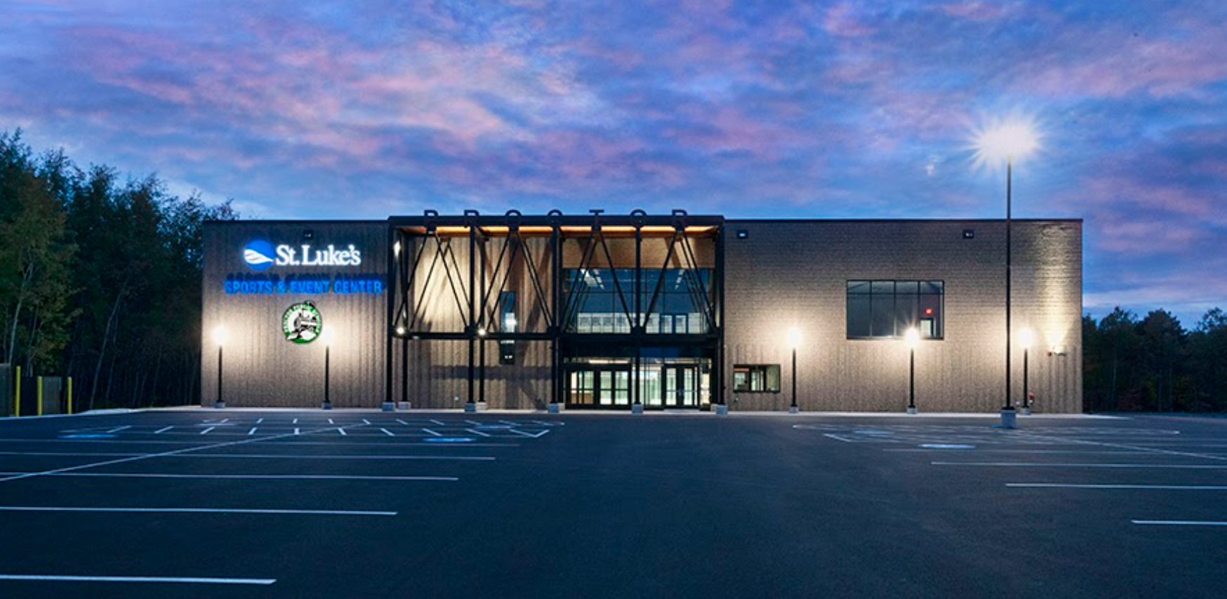
- High School Track Facilities is located on Ugstad Road across the street from the Proctor High School. Football also utilizes a practice field adjacent to the track facilities.
- Egerdahl Field is located on Pionk Drive in the city of Proctor. This facility is an artificial turf complex which provides competition space for football, soccer, lacrosse, softball and baseball.
- Rails Indoor Sports Complex is located on Boundary Avenue at the St. Louis County Fairground. The facility is an indoor, artificial turf practice facility that also hosts our varsity wrestling team practice facility.
- The St. Luke’s Sports & Event Center is located on Kirkus Street and is the site for our indoor hockey arena used by our high school teams and our youth hockey organizations. In addition to the indoor hockey arena, there are two outdoor rinks adjacent to the hockey arena.

Emergency/Safety Policies & Procedures

The Emergency Handbook is available online. Be sure to familiarize yourself with specifics regarding fire drills, lock down procedures, tornado drills, and other emergency procedures. Your immediate supervisor can answer questions regarding our Emergency Guide.

Substitute & Student Teachers

Effective 1 January 1996, Minnesota State Statute 123B.03 requires all school districts to obtain a state criminal history background check for all employees hired after 1 January 1996. Substitute teachers must complete this on their own prior to applying for a substitute position in Proctor. Student teachers acquire a background check through their university.

Substitute teachers must apply to teach in Proctor online using the online application system. Once the online application and background check have been completed their name will be added to the substitute list. Teachers are able to request a substitute teacher from the substitute list to teach in the classroom upon their absence using the absence management system.

Teachers are expected to enter an absence in the system at least 48 hours prior to the absence unless the absence is due to illness. Teachers should provide detailed instructions including daily lesson plans, essential outcomes, and resources for the day/s absent. Site principals review daily absences and may contact individual teachers if the absence daily limit has been met. Teachers must contact the site principal prior to the class/course if a class/course is not covered to identify a plan for the absence.

Teachers are notified by local universities of student teacher requests. Student teacher placements must be approved by the site principal. Teacher expectations are reviewed with the site principal and university placement coordinator.

Commonly Used Abbreviations
AASA-American Association of School Administrators  ABE-Adult Basic Education  ACT-American College Test  ADA-American Disabilities Act  ADD-Attention Deficit Disorder  ADHD-Attention Deficit Hyperactivity Disorder  AEO-Academic Excellence Online  ALC-Alternative Learning Center  ALICE - Alert, Lockdown, Inform, Counter, Evacuate  ALT-Achievement Level Tests  AP-Advanced Placement  ASL-American Sign Language  ASD-Autism Spectrum Disorder  CES-Community Education Services  CEU-Continuing Education Unit  CLP-Continuous Learning Plan  CPR-Cardiopulmonary Resuscitation  CST - Child Study Team  CTE - Career and Technical Education  DAPE-Developmental Adapted Physical Education  DCD-Developmental Cognitive Disability  DHH-Deaf/Hard of Hearing  EBD-Emotional Behavior Disorder  ECFE-Early Childhood Family Education  ECSE-Early Childhood Special Education  EDRS-Electronic Data Reporting System  ELL-English Language Learners  ESSA-Every Student Succeeds Act  ESY-Extended School Year  FAR-Formative Appraisal Review  FAS-Fetal Alcohol Syndrome  FMLA-Family Medical Leave Act  FTE-Full-Time Equivalent  GPA-Grade Point Average  IDEA-Individuals with Disabilities Education Act  IEP-Individual Education Plan  IC- Infinite Campus  IEP - Individual Education Plan  IFSP-Individual Family Service Plan  ILT - Instructional Leadership Team (Site Team) | ISD-Independent School District  LEP-Limited English Proficiency  LPR-Local Percentile Rank  LSN-Licensed School Nurse  LT- Learning Team  MAEF-Minnesota Academic Excellence Foundation  MARSS-Minnesota Automated Reporting Student System  MEIRS-Minnesota Early Indicator and Response System  MCA-Minnesota Comprehensive Assessments  MDE-Minnesota Department of Education  MNASA-Minnesota Association of School Administrators  MSBA-Minnesota School Boards Association  MSHSL-Minnesota State High School League  MTSS-Multi-Tiered System of Supports  NCLB-No Child Left Behind  NCTE-National Council of Teachers of English  NPR-National Percentile Rank  OE-Open Enrollment  OEE-Office of Education Equity  OHD-Other Health Disability  OSHA-Occupational Safety and Health Administration  PACSE – Parent Advisory Council for Special Education  PBIS - Positive Behavioral Interventions & Supports  PD - Professional Development  PIE - Partners In Education (Parent group)  PDS- Pre-observation Data Sheet  PSAT-Preliminary Scholastic Achievement Test  PSEO-Post-Secondary Education Option  SAT-Scholastic Achievement Test  SIP-School Improvement Plan  SIS-Student Information Systems  SLD-Specific Learning Disability  SRBI - Scientific Research Based Intervention  SST - Student Support Team  TAP-Tests of Achievement and Proficiency  TEAE-Tests of Emerging Academic English  TIES-Technology and Information Educational Services  TOSA-Teacher on Special Assignment  TPA-Teacher Performance Appraisal  TSIS-Total Student Information Systems  WBWF - World’s Best Workforce

