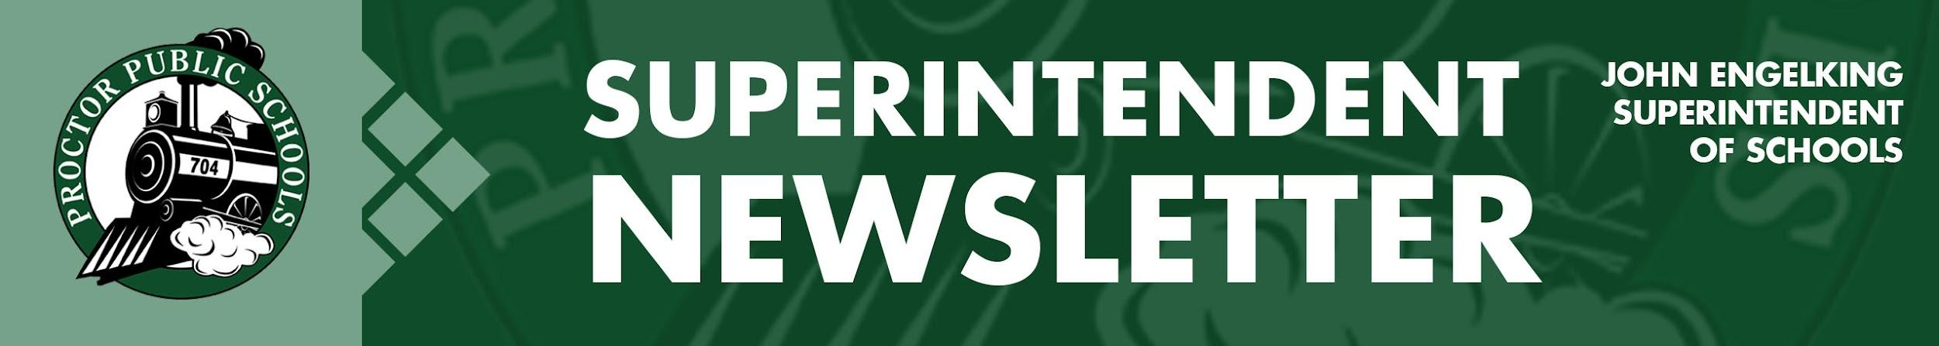

We Educate, Engage, and Inspire
June 3, 2021
Infection Rates Reported 6-3-21 for the Proctor, Hermantown, and Duluth School Districts
Updates on Infection Rates for 5/2/21 - 5/15/21 & Projections for 5/9/21 - 5/22/21
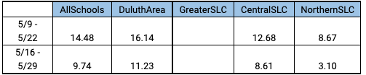

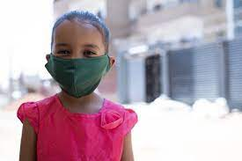

All schools in the area continue to see lower transmission and infection rates. Those more downward trends are directly related to increased numbers of individuals receiving vaccines. Although Proctor Public Schools does not require Covid vaccinations, I continue to recommend that our parents and guardians consider getting vaccinated and vaccinating their children to help end this pandemic and get our schools and businesses back on track to normalcy.
Current School-Wide Learning Models Reported To The MDE
- Elementary: PreK-5 Full in-person - five days per week
- Secondary: Grades 6-12 Hybrid - four days per week - A-B groups
- Proctor Public Schools also provides an optional Distance Learning Model for families
Summer Rail Safe Plan
Our current Rail Safe Plan will sunset on June 9th (the last regularly scheduled teacher contract day). The Proctor Public School Rail Safe Plan guided us through the year as we faced the challenges of COVID-19 in our schools. We are currently working on the new Summer Programming Preparedness Plan using the recommendations from MDH and with the assistance of St. Louis County Public Health. Most of the “requirements” from the MDH are now recommendations. Our focus will be to adhere to the current recommendation and bring a new Summer Programming Preparedness Plan to our Rail Safe Committee on June 8th during our 4:00 pm meeting. One of the recommendations I will bring forth is to shorten our quarantine time from 14 days to 7 and 10 days. Our principals will share our new plan for the summer before the start of summer school. If you have any suggestions or comments, please feel free to email me.

End of the Year Activities for Proctor Public Schools
As we wind down the 2020-2021 regular school year, our faculty, staff, and administrators are getting ready for end-of-the-year activities and programs. I thought you might be interested in all of the activities and planned events across the District.
Proctor High School
Graduation - 6:00 pm at the DECC June 6th
Jedlicka Middle School
8th-grade promotion: 1:15 pm - June 3 and June 4
Bay View Elementary
Water Balloon Celebration: 2:00 pm - June 4th
Diane M. and John A. will get water ballooned by all grade levels - students met their fundraising goal
5th-grade virtual (pre-recorded) Promotion: - June 7th
Pike Lake Elementary
Kindergarten Virtual Graduation (Google Meet 1:00 pm-2:00 pm) - June 7th

Superintendent Newsletters Over the Summer
I have tried to keep everyone up to date with COVID-related news and information across the district throughout the year. I am optimistic that Covid will not continue to be the top story for schools next year. I will continue to send newsletters to our communities on a bi-monthly basis over the summer. If there are any significant updates related to school safety, I will be sure to send notices to our communities. I hope you have an enjoyable summer and that we return to a completely normal school year in the fall.

Thank you for partnering with Proctor Public Schools.
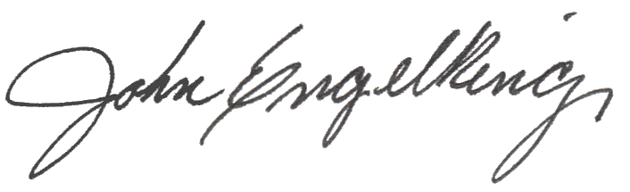

John Engelking, Superintendent
Proctor Public Schools
218-390-9860

