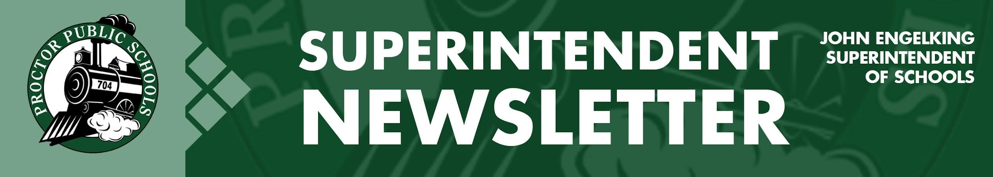

We Educate, Engage, and Inspire
June 24, 2021
Summer Activities In Full Swing
Summer school at Proctor Public Schools is well underway. Proctor Public Schools provide ample ways for our students and families to get involved in activities and learning opportunities. Students at Bay View Summer School spent the first week focusing on space. Students experienced NASA STEM activities, Ojibwe constellation stories, art, team building, and reading. Students will learn about Ojibwe Three Sisters Gardening, rock climbing, bike safety, and more in the second week. On Tuesday, June 22nd, we had draft horses and a logging demonstration, and the Duluth Police Department was on hand for bike safety. In the final week, students will get to read to miniature horses and focus on water activities. As our teachers and administrators develop activities and summer programming, our vision to educate, engage and inspire is at the forefront of our planning.
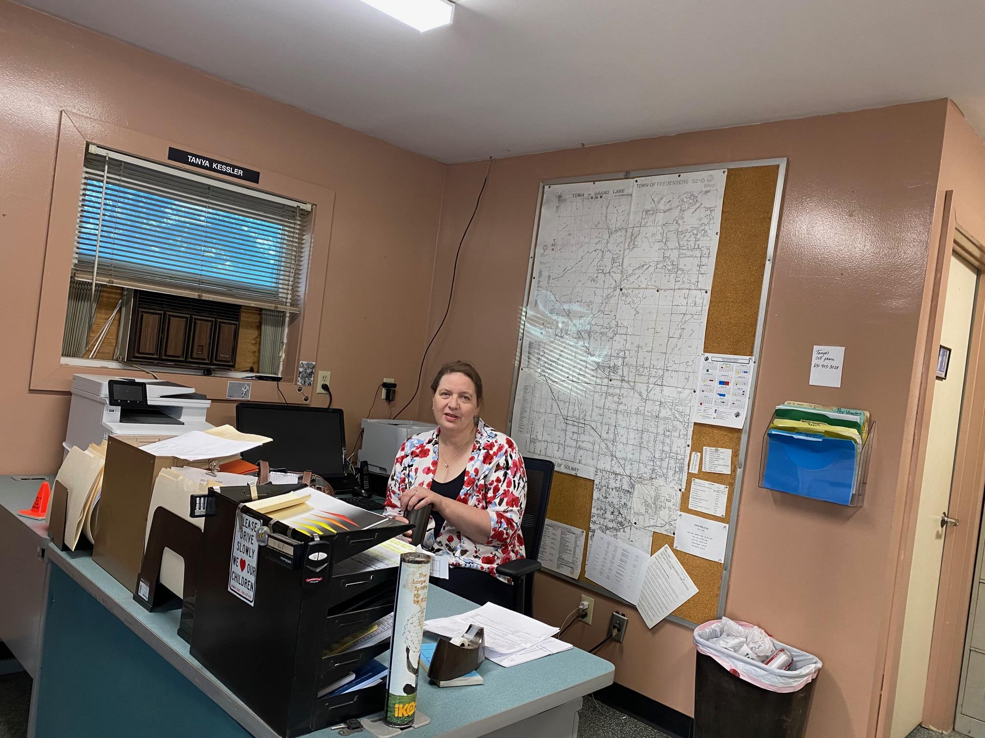

New Director of Transportation Director at the Helm
The Proctor School District is proud to introduce and welcome our new Director of Transportation, Tanya Kessler. Tanya previously worked for the Minneapolis School District as a scheduler and brings a wealth of experience to her new position at Proctor. Tanya’s goals are to focus on efficiency, consistency, accountability, and safety. I am looking forward to Tanya joining the Proctor Public School community.
Tanya Kessler

Expanding Facilities - Early Childhood and Bay View Addition
One of the focus areas and goals of the Proctor Public Schools’ Strategic Plan is to: “Ensure facilities will meet the needs of early learners and early childhood education equitably throughout the district.” As part of that goal, the District put into place action plans to evaluate projected ECFE enrollment, program offerings, and physical space needs completed in March of 2021. Our next action plan was to develop draft design plans to meet the projected early learning enrollment by April 2021. By June 2021, our action plan is to create a plan to fund necessary facility improvements and additions.

Our plan to expand early childhood education facilities is centered around needed expansion at Bay View Elementary School. In 2019, we began the process of developing initial plans for the growth of Bay View. Our goal is to build this expansion as a cost-neutral project. We want to ensure that this needed project has a minimal impact on taxes for our residents. As we continue to review our facility needs related to early childhood education and space constraints at Bay View Elementary, I will be sure to share additional information and expanded plans for funding the project. I have included an architectural sketch of a six classroom addition designed for the southwest side of our newest addition at Bay View Elementary. This planned addition has a three-story design with two new classrooms on each floor.

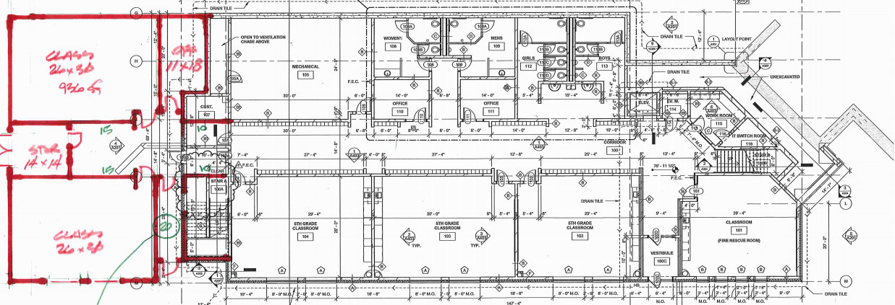

Thank you for partnering with Proctor Public Schools.
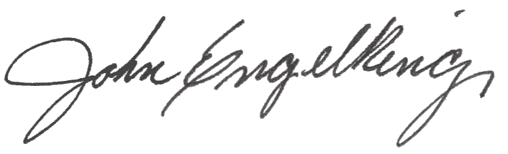

John Engelking, Superintendent
Proctor Public Schools
218-390-9860

