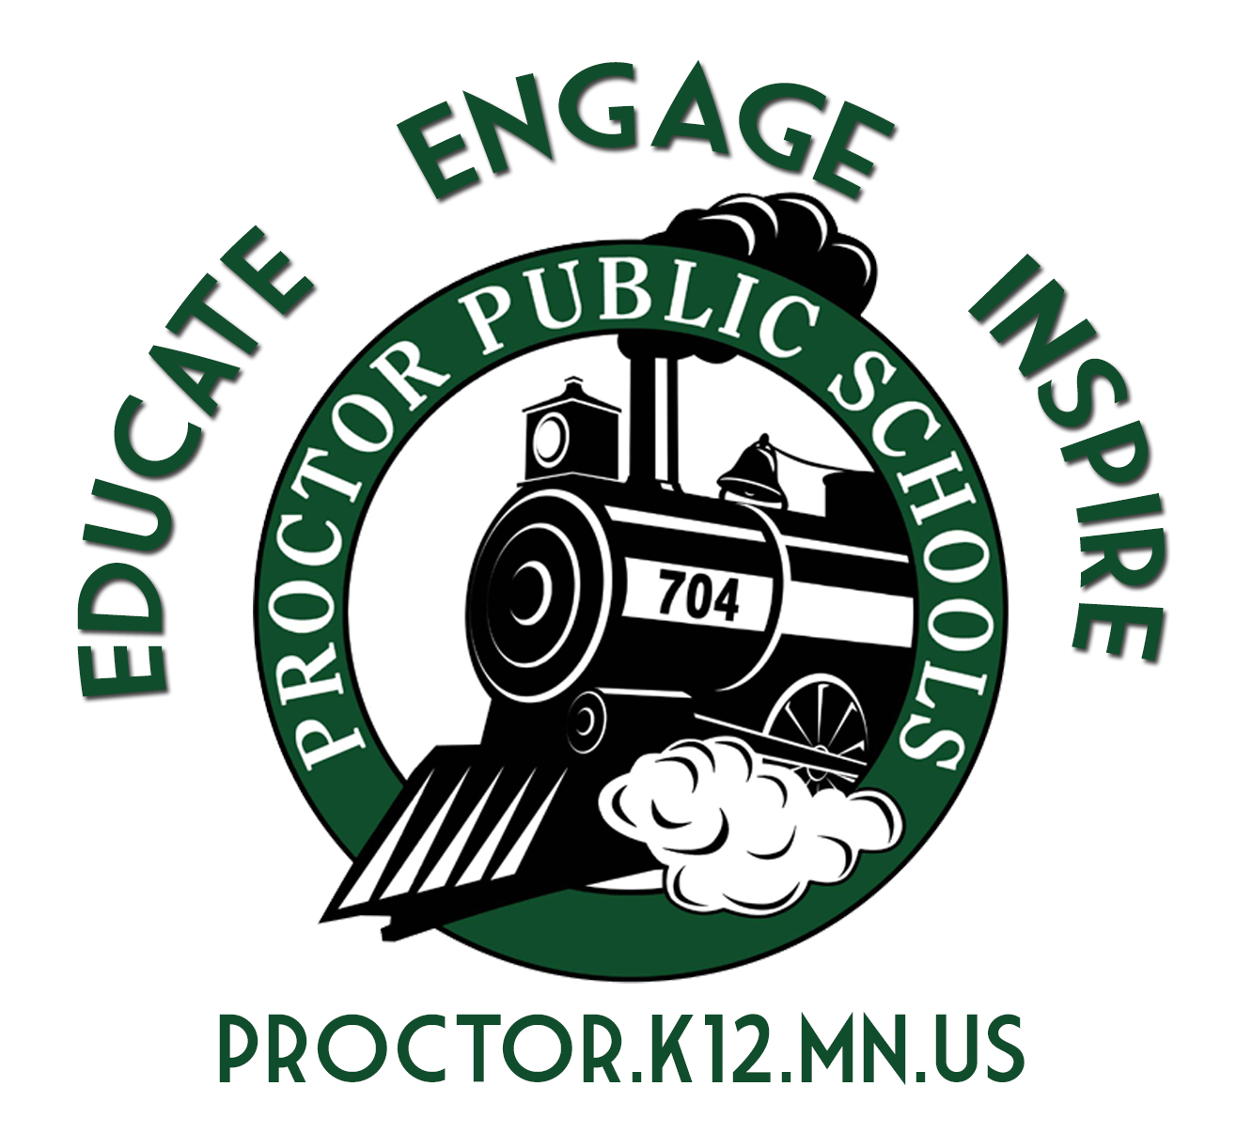
Plans to Change Learning Models
Rail Safe Planning Document
October 1, 2020

Beginning Learning Models for Proctor Public Schools on September 15, 2020:

- Elementary Schools - Hybrid A - B Days Tuesday - Friday - Distance Support on Mondays
- Middle School - Distance Learning with In-Person Support
- High School - Distance Learning with In-Person Support

Factors the Proctor School District will utilize to determine whether to move to a less restrictive learning environment:

- The biweekly infection rates for the Proctor, Hermantown, and Duluth School Districts as presented by St. Louis County Public Health in collaboration with the Minnesota Department of Health. This data is posted every Thursday.
- The capacity of our school buildings to the extent possible to socially distance at six feet.
- The capacity of our faculty and staff to fill teaching and support positions for all classes.

The infection rate guidelines from the Minnesota Departments of Education and Health
Number of Cases per 10,000 | Learning Models
0-9 | In-person learning for all students
10-19 | In-person learning for elementary students; hybrid learning for secondary students
20-29 | Hybrid for all students
30-49 | Hybrid learning for elementary; distance learning for secondary students
50+ | Distance learning for all students

Each Thursday, our administrative staff and I review the infection rates reported on the St. Louis County Public Health Dashboard. The Proctor School District will use that data point to begin considering a change to a less or more restrictive learning model. Starting October 1, 2020, that infection rate will inform the administration to consider changing learning models or staying in the current learning model. If the infection rate is trending downward, I am ready to make recommendations to change learning models and move to in-person learning for grades K-2, consistent with the recommended leaning model above. There is nothing I would like more than to bring students back to school full time. But we must balance any changes in learning models with our faculty, staff, and students’ safety. Today the infection rate reported for Duluth area schools is 22.47. As we look forward, the next two-week report will be over 30.

I am committed to making every effort to bring students back to school. The primary focus is to get our youngest learners in grades K-2 back to in-person instruction as soon as possible, and when the infection rate guidance allows. We also need to examine ways to move our secondary students to a less restrictive learning model. Our administration is re-evaluating space and social distancing constraints in addition to staffing levels. We should also consider the importance of bringing our senior class back into our schools in a hybrid model. As we evaluate our plans, I am committed to protecting our faculty, staff, and students’ safety.

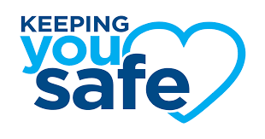
But our schools need your help. We ask that our families and communities follow the guidelines from the CDC and the MDH by avoiding large gatherings, wearing a mask, socially distancing, and frequent handwashing. Together we can make a difference in the infection rates and the spread of COVID-19. Together we can create conditions that will allow us to move to less restrictive learning models.

Thank you for your partnership in educating our students.

Be Rail Strong and Rail Safe,

John Engelking, Superintendent
Proctor Public Schools

