Superintendent Newsletter
October 8, 2020

The Notification Process of Positive COVID-19 Cases In Our Schools
Monday evening, I received a text message from Carlie Anderson, our district school nurse, at 9:30 pm. The text stated that she just received notice that one of our elementary students had tested positive for the Corona Virus. My heart sank. Our students’ and staff’s safety and health is my greatest concern during the pandemic, and I knew that we were beginning the process of contact tracing to see if any other students or staff were affected. At the same time, our students' and family’s health and well-being were in my thoughts.

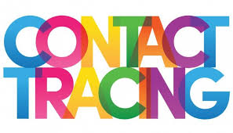
Once we were notified of a positive case, St. Louis County Public Health sprang into action, making phone calls and tracing all our students’ activity for potential close personal contact. By that evening, Public Health notified everyone who had close personal contact and recommended a 14-day quarantine or 10-day isolation of the student who tested positive. By 6:30 am the next morning, I continued my conversations with Carlie Anderson regarding contact tracing and our next steps.

The next step for me was to write a notification letter to send digitally to our school community. Shortly after that, I initiated a conference call with our principals to discuss their parents’ notifications who had children in the impacted classroom. At 8:15 am, I sent our school-specific notice to teachers, staff, and parents.

I wanted to share this process, so you know what takes place when a case is reported. I also want you to understand the fantastic job public health and our school health departments do to follow the proper protocols keeping our schools safe. I am so appreciative of their partnership, professionalism, and dedication.

For privacy concerns, we can’t provide any identifiers in our notification. However, if you haven’t been contacted by public health, our school health department, or our principals, you can feel assured that you or your children did not have any close personal contact with a positive COVID-19 case.

I hope our identified cases are few and far between, and I wish everyone a speedy recovery. If there is a positive case, we will vigilantly follow all of our protocols and notify the school community involved. For a review of our notification process, access our Rail Safe Plan.

Infection Rates Reported 10-8-20 for Proctor, Hermantown, and Duluth Schools
We have officially reached the 30 threshold in the Duluth area. The infection rate in 10,000 was 33.37 for Proctor, Hermantown, and the Duluth area schools. The high number continues to be driven by the 18-29-year-old population and Institutions of Higher Education. We are, however, seeing an increase in positive cases in our elementary-age children. At this time, the Proctor School District will not be changing any learning models.

For more information on recommended starting points for learning models, access our Rail Safe Plan or access the St. Louis County Public Health Dashboard.
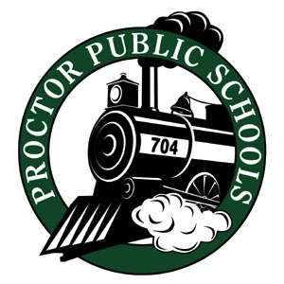

Thank you for your partnership in educating our students.
Be Rail Strong and Rail Safe,

John Engelking, Superintendent
Proctor Public Schools

