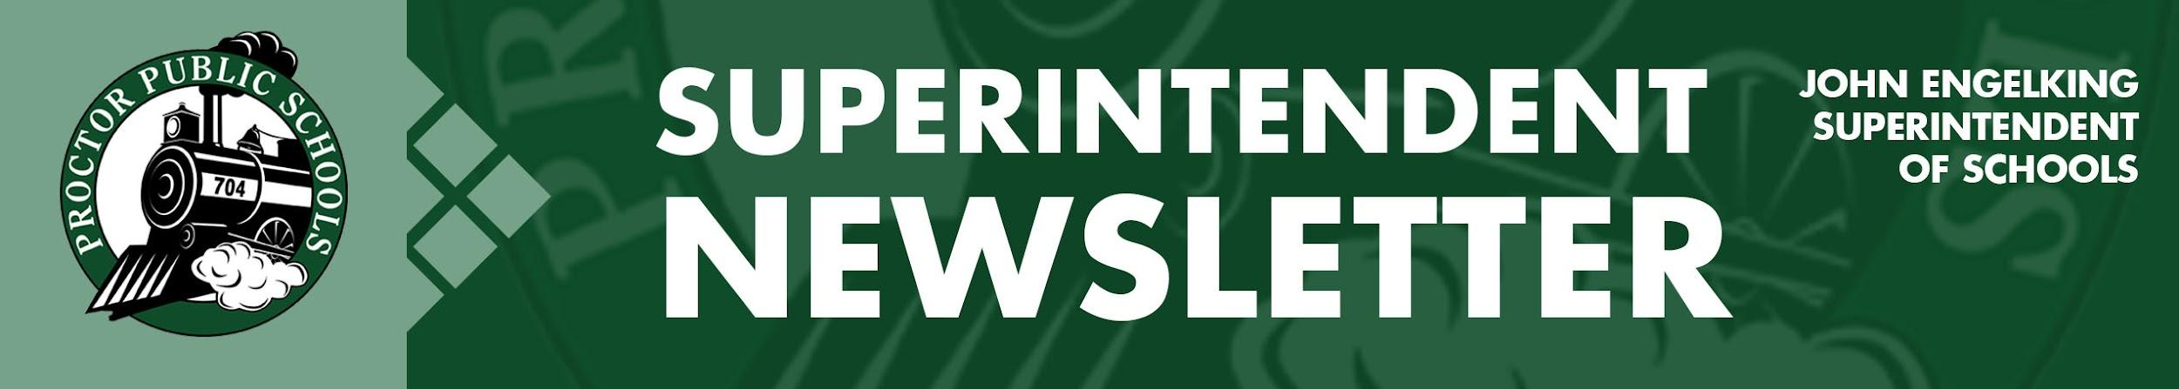
November 5, 2020

Infection Rates Reported 11-5-20 for Proctor, Hermantown, and Duluth Schools
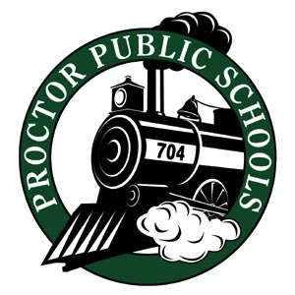
We are still above the 30 threshold for Proctor, Hermantown, and Duluth area schools. The infection rate in 10,000 reported last week was 34.12 for Proctor, Hermantown, and Duluth schools. This week the infection rate is 38.94 for the Proctor, Hermantown, and Duluth schools. It looks like we will see infection rates rise again for this week’s report. The most significant increase in infection rates is happening in greater St. Louis County School areas and all of St. Louis County.

- Updates on Infection Rates for 10/11 - 10/24
  - SLC- 39.85, PHD- 38.94, Central SLCS- 38.80, North SLCS- 42.72
- Last week Infection Rate Report:
  - SSLC- 35.51, PHD- 34.12, GSLC- 37.60

For now, I do not see any changes or recommendations coming to our area in activities from Public Health. For more information on recommended infection rate starting points for learning models, access our Rail Safe Plan or access the St. Louis County Public Health Dashboard.

We continue to be inspired to bring exciting learning opportunities and new learning environments to our students. However, this week has been a trying time for families, students, faculty, and staff. After seeing several faculty and staff with symptoms and positive test results, St. Louis County Public Health recommended that Bay View Elementary move to Distance Learning for two weeks. The decision to reset Bay View for two weeks was followed by positive cases and quarantines in our high school and middle school, which led to a recommendation to stop in-person classes and support until Monday, November 16th.

I encourage all of you to help us bring kids back to school by social distancing and stopping the spread of COVID-19. Avoid social gatherings, wear a mask with two layers, and wash or sanitize your hands often. We can get ahead of this disease by helping each other. Please use our Health Screening Tool every day.

Be well and be Rail Safe,

Thank you for partnering with Proctor Public Schools,
John Engelking, Superintendent

