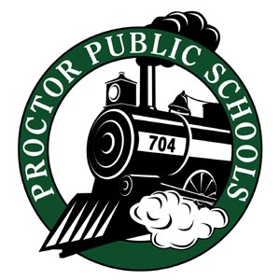
John Engelking, Superintendent of Schools
Proctor Public Schools
Independent School District 704
131 9th Avenue
Proctor, MN 55810

We Educate, Engage, & Inspire
11-12-20
Parents, Faculty, and Staff,
Over the past week, St. Louis County Public Health reported significant increases in positive COVID-19 cases. The infection rates are growing at an alarming rate.
- Updates on Infection Rates Report on 11-12-20
  - SLC- 50.69 , PHD- 54.26, Central SLCS- 41.62 , North SLCS- 60.07
- Last week Infection Rate Report:
  - SLC- 39.85, PHD- 38.94, Central SLCS- 38.80, North SLCS- 42.72

As we examine infection rates for next week, those rates are projected to be above 70 for the Proctor, Hermantown, and Duluth School region. Also, we continue to see shortages for substitutes in our classrooms and programs. Public Health has also advised that hospital beds and emergency rooms are at capacity.
Throughout this week, we held several meetings to discuss the safety of our staff and students. We have consulted with St. Louis County Public Health, the Rails Safe Advisory Committee, and the Minnesota Department of Health. They have recommended staying in Distance Learning through the Winter Break. BEGINNING NOVEMBER 16TH THROUGH JANUARY 4TH, ALL K - 12th GRADE STUDENTS WILL REMAIN IN DISTANCE LEARNING. PreK DISTANCE LEARNING WILL START NOVEMBER 23RD.
Emergency child care services for previously registered critical workers will continue throughout our distance learning model.
Each week we will review infection rates to determine if community metrics will allow us to return to a less restrictive learning model. We will continue to share information with you as we monitor community and regional infection rates. We plan to implement the following strategies:
- Implement a daily schedule designed for full Distance Learning, which combines our A-B groups to the original class schedule and a 4-day instructional week beginning November 24th. Mondays will be used to plan and connect with students and parents.
- Emphasize social and emotional health as well as maintaining academic progress
- Focus on engagement with our students and families
- Pivot back to alternating models as soon as allowed by infection rates, community spread, and staffing availability.

Your teachers and your principals will be sharing more information with you regarding Distance Learning. I know this is going to be a significant inconvenience for our families. One of my greatest concerns was that we might have an outbreak of COVID-19 that would prevent us from staying in our current learning model. That day has arrived.
We will continue to coordinate with the St. Louis County Public Health Department and the Minnesota Department of Health. We intend to keep you informed as we continue to learn how to live in this COVID-19 environment.
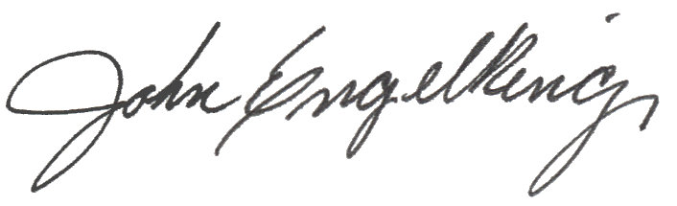
Sincerely,

John Engelking, Superintendent of Schools 218-390-9860

