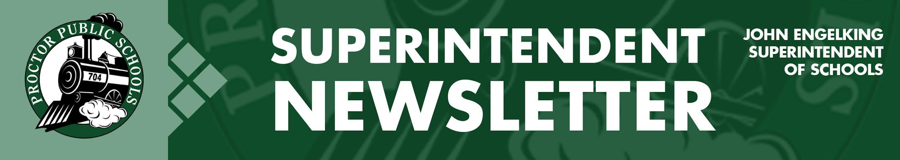
December 3, 2020
Infection Rates Reported 11-26-20 for the Proctor Schools District
Updates on Infection Rates in real-time as of November 26, 2020. St. Louis County Public Health is not providing official 14-day infection rates until next week. Until then, I am providing you with real-time rates for just the Proctor School District. The infection rate data is from a website developed by the University of Minnesota. As you see, our infection rate (225.4) is exceptionally high and is expected to remain high due to gatherings and travel over Thanksgiving weekend.
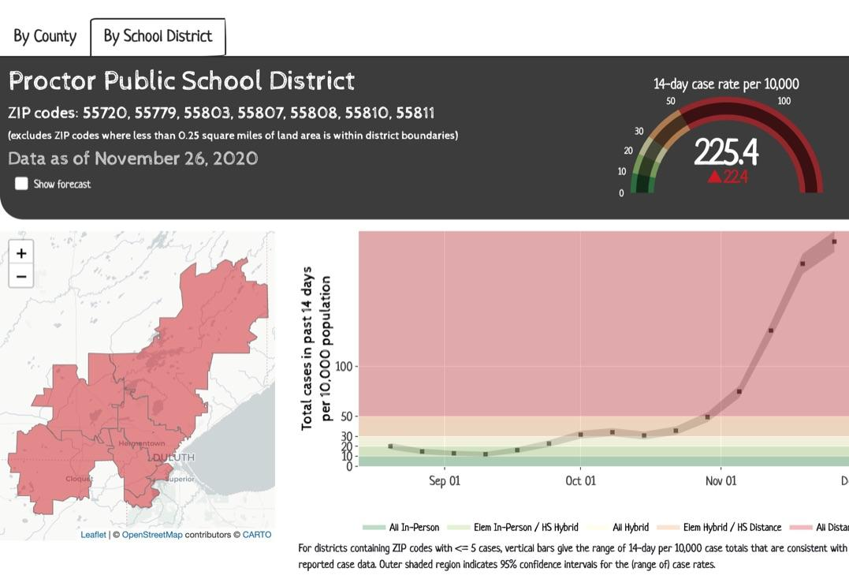

For more information on infection rates and learning models, access our Rail Safe Plan or access the St. Louis County Public Health Dashboard.

Looking Forward:
Through the lens of a growth mindset, there is hope that an end to the pandemic is on the horizon. We have such a greater understanding of how to prevent the spread of COVID-19. Although I would like to see a more disciplined approach from everyone related to social distancing and avoiding social gatherings, I think we can still work together to bring down our infection rates. Most importantly, the approval of the emergency use of COVID-19 vaccines is a game-changer, not only for us; but for the world. I know the pandemic has placed hardships on everyone. But, we can’t give up the fight, and we must be vigilant about keeping each other safe for a little while longer. Nine months ago, there was no light at the end of the tunnel. Today, there is more than light; there is a certainty that an end to the pandemic is in sight.

We still need to provide a safe way to return to schools, and we will continue to closely monitor infection rates. Although there may be a need to temporarily extend Distance Learning, I anticipate our students will be back in school this year because of our vaccines’ advancements and understanding of the disease. Help our students return to in-person learning by doing what you can to stop the spread of COVID-19.

Be well and be Rail Safe,

Thank you for partnering with Proctor Public Schools,
John Engelking, Superintendent

