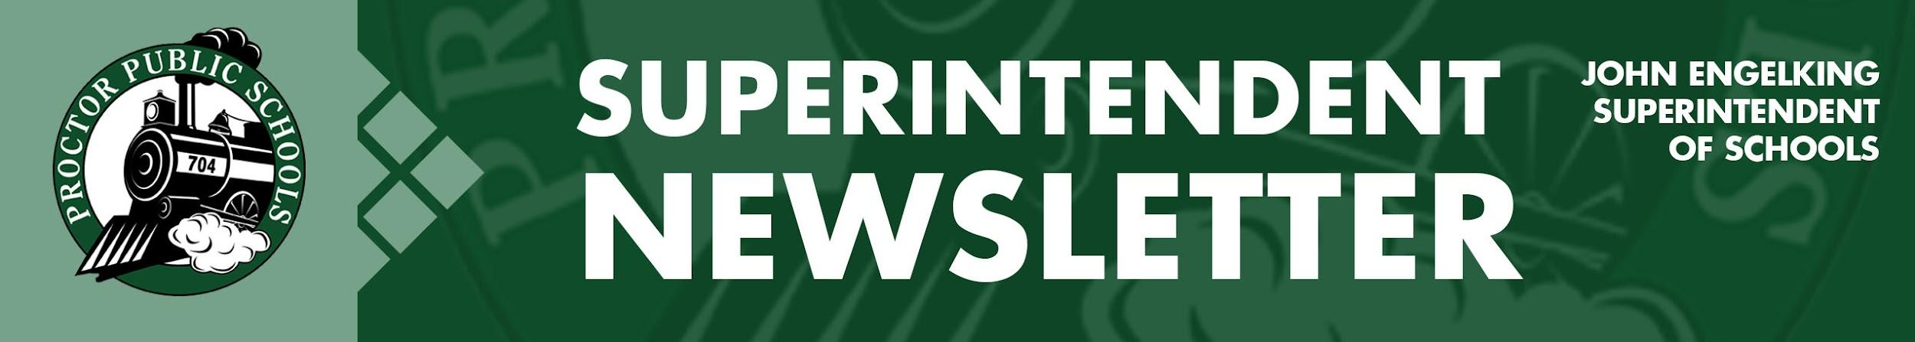
We Education, Engage, and Inspire
December 10, 2020
Infection Rates Reported 12-10-20 for the Proctor, Hermantown, and Duluth School Districts
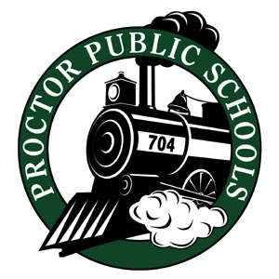
Infection rates have dropped since last week’s report. Public Health reports a plateau in our infection rates, although that plateau is still a very high number. St. Louis County Public Health is concerned about a spike in rates following the Thanksgiving Holiday. Also, there is a shortage of intensive care units in our hospitals, which means we all still need to be vigilant about helping to stop the spread of Covid.

- Updates on Infection Rates for 11/15 - 11/28
SLC- 140.94, PHD- 154.11, Central SLCS- 119.08, North SLCS- 91.65

For more information on infection rates and learning models, access our Rail Safe Plan or access the St. Louis County Public Health Dashboard.

Looking Forward:
Vaccines:
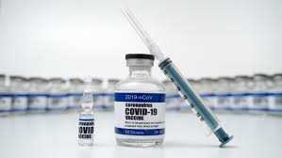
In my last email, I mention my eager anticipation of vaccines being available. Public Health reports that the first round of vaccines will be available to healthcare workers by the end of December. We are all watching when we will be able to be vaccinated as the approval process moves forward. The Minnesota Department of Health is posting updated information about vaccine availability on their website.

Youth Athletics:
On Monday, December 14th, the governor is expected to announce when youth athletics will resume. The MSHSL has proposed three possible start dates: December 21, January 4, January 18, but that decision will wait until the governor makes his announcement.

Distance Learning:
I will be monitoring health conditions and hope to bring our students back to school when infection rates are safe enough to do so. If infection rates and concerns from Public Health persist, there may be a need to extend Distance Learning until the end of January (the end of the first semester). We will be making that decision by the end of next week. I anticipate our students will be back in school this year because of our vaccines and a better understanding of the disease. Help our students return to in-person learning by doing what you can to stop the spread of COVID-19.

Be well and be Rail Safe,

Thank you for partnering with Proctor Public Schools,
John Engelking, Superintendent

Empowering all learners to achieve in a respectful, innovative, and inclusive environment

