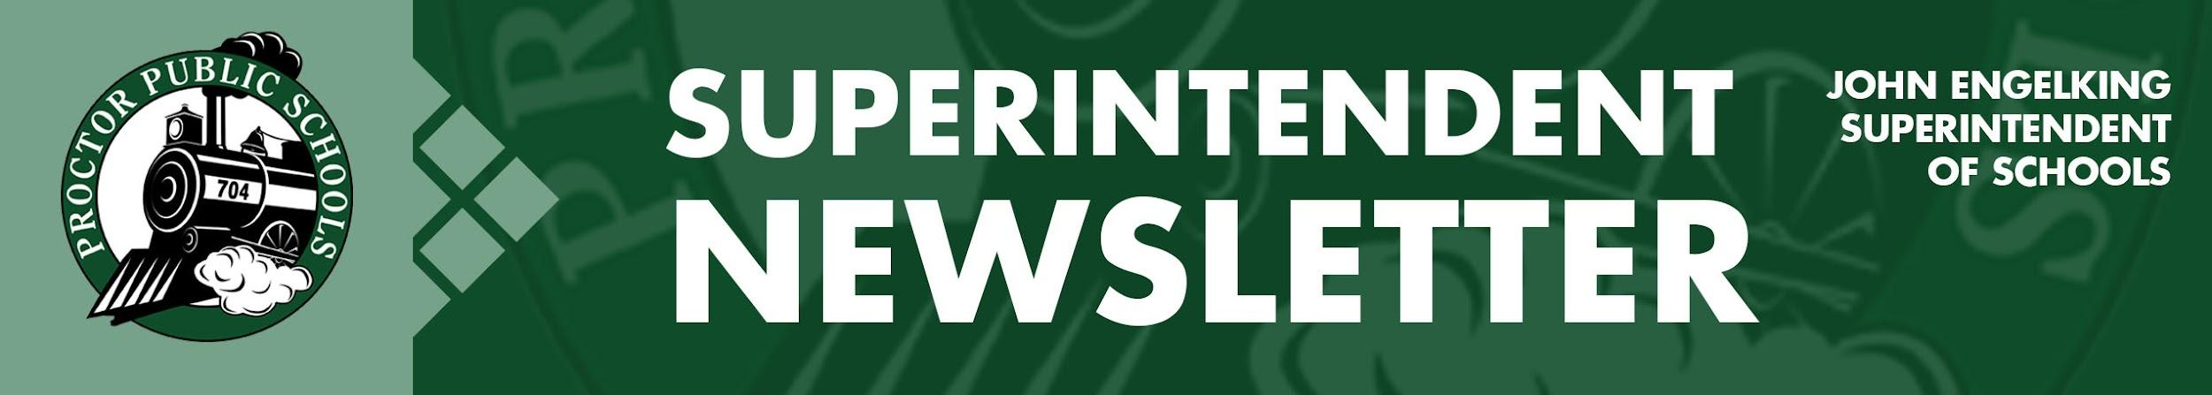
We Education, Engage, and Inspire
January 7, 2020
Infection Rates Reported 1-7-21 for the Proctor, Hermantown, and Duluth School Districts:
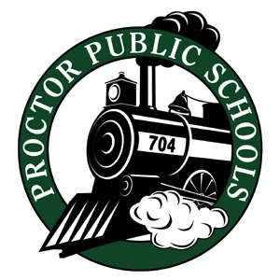
After the Winter Break, we are all excited about seeing infections continue to be on a downward trend. Much of this is due to our community’s efforts to socially distance and use recommended mitigation measures. Thank you for those efforts. I didn’t send any newsletters during the winter break because I wanted you all to enjoy some time away from school. During the break, we experienced the following Infection Rates.
- Updates on Infection Rates for 11/29 - 12/12
- SLC- 103.93 , PHD- 100.02, Central SLCS- 118.15 , North SLCS- 76.78
Updates on Infection Rates for 12/6 - 12/19
- SLC- 69.27 , PHD- 72.64, Central SLCS- 70.88 , North SLCS- 37.15
On Thursday, January 7th, St. Louis County Public Health reported the following Infection Rates.

- Updates on Infection Rates for 12/6 - 12/19
  - SLC- 50.74 , PHD- 60.58, Central SLCS- 40.69 , North SLCS- 17.36

For more information on infection rates and learning models, access our Rail Safe Plan or access the St. Louis County Public Health Dashboard.

Changes in Learning Models:
On January 4, during a Special Board Meeting, our School Board approved the following learning models pending current infection data.

Elementary Schools
Reminder - All learning model return dates are pending current infection data. Should a change occur, the public will be notified as soon as possible.
- 1-26-21 bring PreK-5 back to hybrid
- 2-8-21 PreK-2 back to full in-person
- 2-22-21 3-5 back to full in-person

Secondary, Early Childhood, and Students with IEPs
The Regional Health Consultation Approved the Following Schedule on January 7th
- January 11th: Students on IEPs will have the opportunity to return based on needs
- January 11th: Early Childhood at the Proctor Early Childhood Center and Pike Lake
- January 11th: Middle and High School Students will return to Distance Learning with In-Person Support
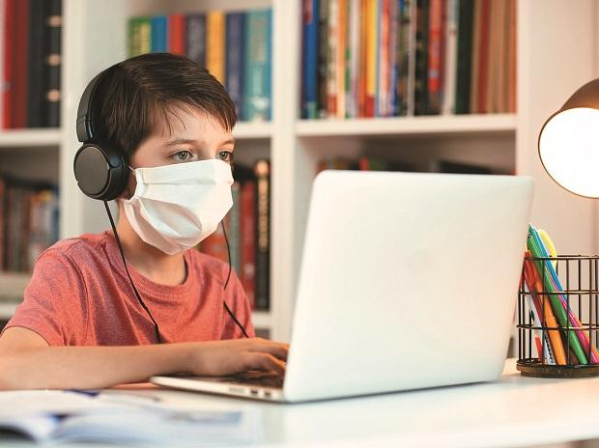
On January 7th, the Regional Health Consultation Team recommended watching infection rates until the end of January before recommending a change and potential move to a hybrid model at the middle and high school.

Be well and be Rail Safe,

Thank you for partnering with Proctor Public Schools,
John Engelking, Superintendent

