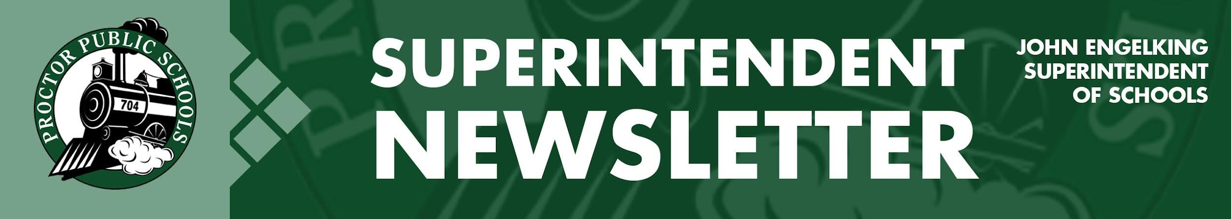

We Educate, Engage, and Inspire
January 28, 2021
Infection Rates Reported 1-28-21 for the Proctor, Hermantown, and Duluth School Districts
- SLC- 30.57 PHD- 37.86 Central SLCS- 20.19 North SLCS- 17.34
Infection Rate Trends
12-5-20 127.40
12-12-20 100.02
12-19-20 72.64
1-2-21 58.75
1-9-21 56.75
1-16-21 43.35
1-23-21 37.86

Sarah Miller reports, We are seeing a decrease in numbers and posted a single digit positive case count today. I can’t remember when this last happened!

The mitigation efforts that we continue to use are working and we need to continue to be diligent. Mask, 6 feet and wash hands. Vaccinations are just another layer in this effort and it does not mean we can lessen any of these other practices.

Vaccine Rollout for School Employees and Individuals 65 & Older Slowly Expands
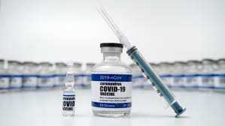
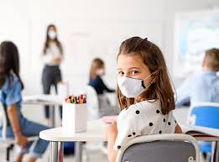
On January 18th, the MDH and the MDE introduced a Pilot Program to bring vaccinations to school employees and individuals over 65. This week our allotment of vaccines for Proctor School employees went from 10 last week to 30 vaccines. Tuesday evening (1-26-21), the Minnesota Department of Education authorized school districts across the state to send registration invitations to the next group of prioritized school employees. For Proctor Public Schools, that meant 30 additional school employees could make appointments for vaccinations. The vaccination site is still Mt. Iron Public School, but I am optimistic that local mass vaccinations for school employees will be happening soon. The method used for prioritizing staff was based on the priority consideration for vaccines provided by the MDE. Individuals 65 and older also had an opportunity to sign up for a vaccination on the Pilot Program Website.

Changing in Learning Models:
Our plan to return to less restrictive learning models has always been guided by science and recommendations from St. Louis County Public Health. At our January 25th School Board Meeting, Public Health recommended moving to a less restrictive learning model throughout the District. All schools will continue to offer a Distance Learning Model for students and families who want to stay or move to Distance Learning. The new learning models and schedules are:
    - Elementary: PreK-2 Full in Person - February 9th (continue four days per week A-B groups)
    - Elementary: Grades 3-5 Full in Person - February 22nd (resume five days per week K-5)
        - Planning Days February 4th and 5th: (The MDE requires districts to implement two planning days when moving between learning models. As prescribed by the MDE, we will have no student learning on our planning days, February 4th and 5th. There will also be no child care on February 4th and 5th)
    - Secondary: Hybrid Grades: 10, 11, 12, 6 - February 9th (continue four days per week - A-B groups)
    - Secondary: Hybrid Grades: 7, 8, 9 - February 22nd (continue four days per week - A-B groups)
        - Planning Days February 4th and 5th: (The MDE requires districts to implement two planning days when moving between learning models. As prescribed by the MDE, we will have no student learning on our planning days, February 4th and 5th. There will also be no child care on February 4th and 5th)
Principals and our transportation department will be sharing more information in the coming days. Thank you for your continued support for Proctor Public Schools. As always, I welcome your feedback and comments.

Be well and be Rail Safe.
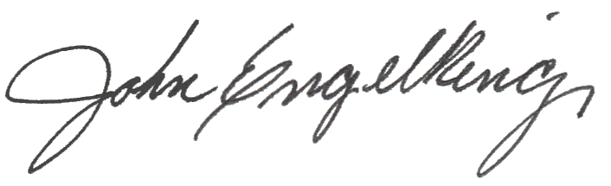

John Engelking, Superintendent

