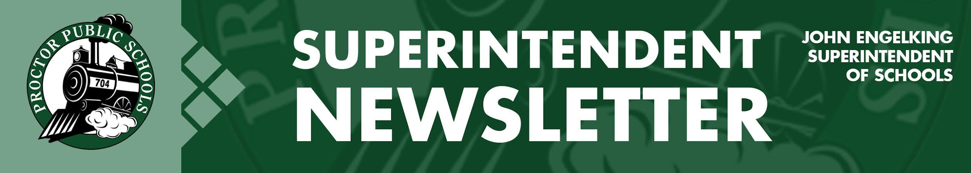

We Educate, Engage, and Inspire
March 18, 2021
Infection Rates Reported 3-18-21 for the Proctor, Hermantown, and Duluth School Districts.
Updates on Infection Rates for 2/21/21 - 3/6/21
Infection Rate Trends
12-5-20 127.40
12-12-20 100.02
12-19-20 72.64
1-2-21 58.75
1-9-21 56.75
1-16-21 43.35
1-23-21 37.86
1-30-21 29.04
2-6-21 16.48
2-13-21 13.23
2-20-21 10.83
2-27-21 11.07
3-6-21 12.90

- SLC- 14.38 PHD- 12.90, Central SLCS- 18.78, North SLCS- 8.05
We continue to watch infection rates closely and are hopeful that the current trend in decreasing infection rates will continue. Thanks to our parents and community members, we have made outstanding progress.
Current Learning Models
- Elementary: PreK-5 Full in-person - five days per week
- Secondary: Grades 6-12 Hybrid - four days per week - A-B groups

A FREE Opportunity to Join in The Trust Edge Book Read
We need the Proctor School District’s help to reinforce trust throughout our district. We created an atmosphere where we had all stakeholders committed to a common goal during the strategic planning process - providing the best educational opportunities for our most valuable resource, our children. During the pandemic, we may have lost some of that momentum. The school board would like to engage everyone in a book study of The Trust Edge. David Horsager’s book will guide us as we have frank, honest conversations about what it takes to reinforce and maintain trust. By the way, Davie Horsager is from Minnesota. This will only work if we have community and staff involvement. We will examine the pillars of trust and what that means for our district. If you want a book and want to engage in this process, please contact Lori Johnson in the district office. All meetings and discussions will be held virtually, so you won’t need to travel or worry about social distancing. We currently have 20 trusted individuals signed up. Join us; you’ll be glad you did.
Watch David Horsager talk about clarity on YouTube.

Ride 360 App Tracks Your Child’s Bus
Traversa Ride 360 provides access for parents to view routing information for their children. Because we recently installed GPS tracking in our buses, we will be able to update you on our bus locations. Parents receive estimated arrival times, so they know when to send their child out to wait for the bus. We are just completing final tests to ensure everything is working correctly. Shortly after spring break, parents and guardians will be provided access and download information.

We are also looking for ten to fifteen families who might want to help us with our pilot roll-out. If you have a child who rides one of our buses and would like to have early trial access to the Ride 360 App, please email Phil Paulson, our Director of Student Information Systems. Thanks in advance for your willingness to help.

When to Return to 4 Days of in-Person Learning at the Secondary Site
As infection rates decline, our Rail Safe Team is considering returning in-person learning four days per week. Because we still must offer Distance Learning, our secondary faculty and staff will continue to use Mondays to plan and prepare for our Distance Learners. Following our Rail Safe Committee Meeting, which included our Regional Health Support Team, Public Health recommends that we consider April 12th as the target date to return to in-person learning at the secondary schools.

Be well and be Rail Safe.
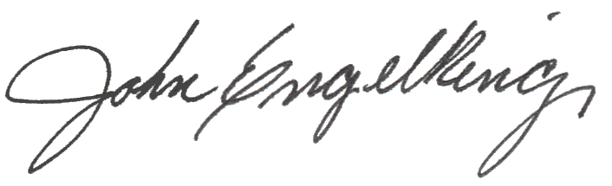

John Engelking, Superintendent

