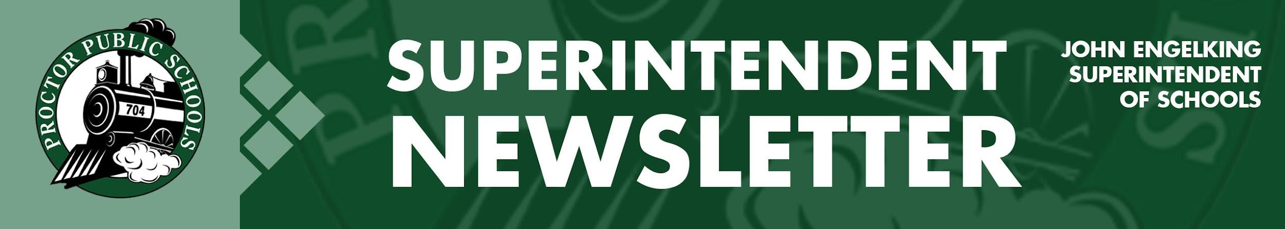

We Educate, Engage, and Inspire
March 25, 2021
Infection Rates Reported 3-25-21 for the Proctor, Hermantown, and Duluth School Districts.
Updates on Infection Rates for 2/28/21 - 3/13/21
- SLC- 16.03 PHD- 12.65, Central SLCS- 23.0, North SLCS- 13.62
Current Learning Models
- Elementary: PreK-5 Full in-person - five days per week
- Secondary: Grades 6-12 Hybrid - four days per week - A-B groups

PHD Infection Rate Trend
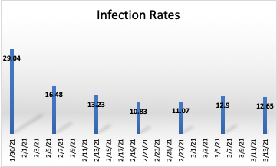
We continue to watch infection rates closely and are hopeful that the current trend in decreasing infection rates will continue. We are noticing that the Proctor, Hermantown, and Duluth region might see a slight increase bringing our infection rate to around 14.5 for next week.

The northern and southern schools in St. Louis County are seeing increases in infection rates. Most of that increase is being traced to travel and sports-related activities. The other concern is the presence of more contagious variants of Covid-19. This doesn’t change how we approach COVID-19 positive cases; it just means we need to continue to be diligent with all mitigation strategies as we have seen rapid transmission and higher attack rates with the B117 variant.
On the positive side, I am encouraged by the number of vaccines administered throughout Minnesota and our schools. Currently, all of our school employees either are vaccinated or have been offered the opportunity to be vaccinated.

Spring Break Guidance and Testing for Students:
Proctor Public Schools is highly recommending that students take advantage of Covid-19 testing. Testing is especially important if families and students are traveling over spring break. Learn more on how Proctor Schools can help you get tested by accessing our recent Health Service Memo.

In-Person Learning at the Secondary Site
Following our Rail Safe Committee Meeting last week, our Regional Health Support Team recommended we consider the week of April 12th as a target date to return to in-person learning at our secondary schools. If infection rates remain low following our spring break, we plan to follow that recommendation and return to 4 days of in-person learning on April 13th. We all want to return to normal, but we still need to realize that we are dealing with a global pandemic. We plan to watch infection rates and communicate closely with St. Louis County Public Health and their recommendations leading up to April 13th.

Be well and be Rail Safe.
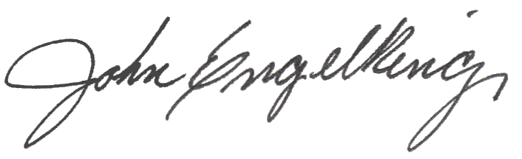

John Engelking, Superintendent

