We Educate, Engage, and Inspire
April 22, 2021 Infection Rates Reported 4-15-21 for the Proctor, Hermantown, and Duluth School Districts.
Updates on Infection Rates for 3/28/21 - 4/10/21
- SLC- 38.51, PHD- 44.52, Central SLCS- 31.61, North SLCS- 20.43
Projections on Infection Rates for 4/4/21 - 4/17/21
- SLC- 38.76, PHD- 39.19, Central SLCS- 42.56, North SLCS- 19.82

Following discussions with the Minnesota Department of Education, the Minnesota Department of Health, and St. Louis County Public Health, the priorities and recommendations for Proctor Public Schools are to remain in our current learning models. Those recommendations to stay in our current learning models were discussed in our April 21st Rail Safe Committee Meeting. Our committee agreed that staying in our current learning model is the best decision. I will recommend continued vigilance in contact tracing and no change in our current models at our April 26th School Board Meeting.

Current School-Wide Learning Models Reported To The MDE
- Elementary: PreK-5 Full in-person - five days per week
- Secondary: Grades 6-12 Hybrid - four days per week - A-B groups
- Proctor Public Schools also provides an optional Distance Learning Model for families

Patti Myre Begins Transition from ISD 704 Finance Clerk to Retirement
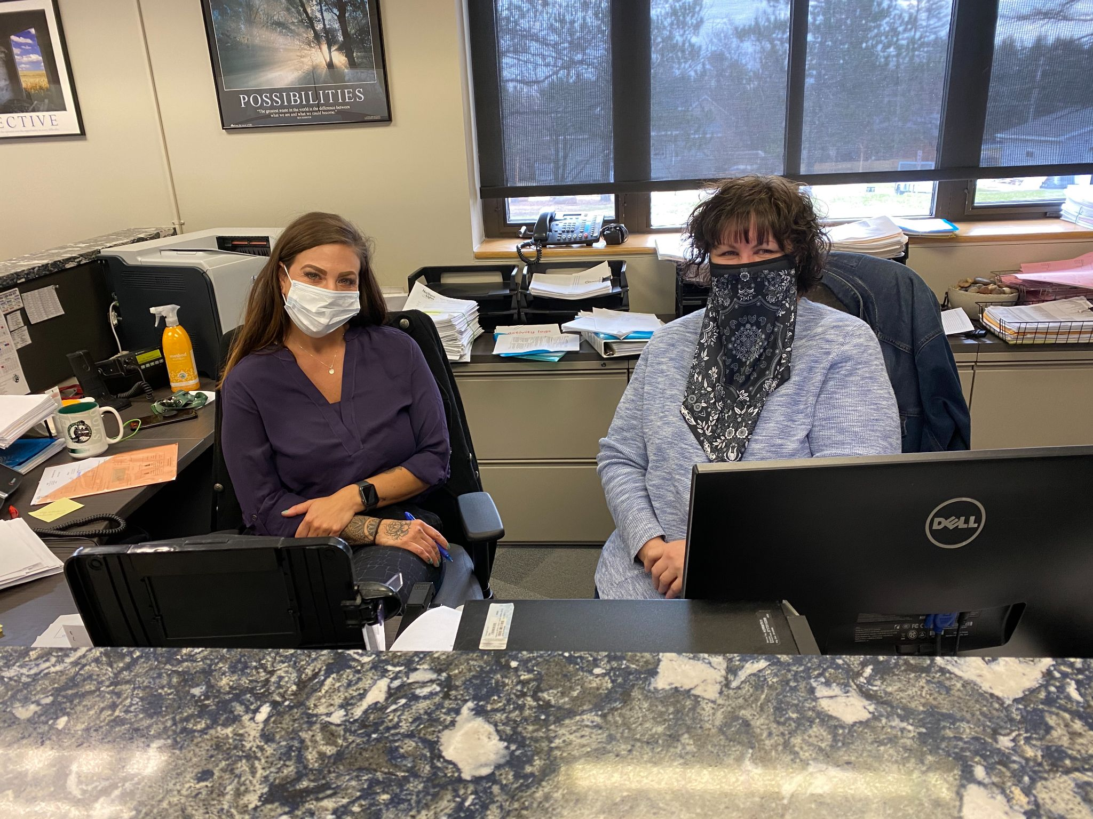
Twelve years ago, I met Patti when I began my role as superintendent of schools at Proctor. She impressed me then and continues to impress me with her abilities and her welcoming personality. Patti’s presence and sense of humor make collaboration with our District staff a joy. Patti has dedicated 25 years of service to our District, and for that, I am so grateful. Her last day with Proctor Public Schools will be May 28th. Until then, Patti is training in our new Finance Clerk, Amber Lowell. Amber is currently our head cook for the District and has a background in various business-related experiences.
If you get a chance, stop by to meet Amber and to thank Patti for all she has done to make our District a great place to learn and work. I would like to thank Patti Myre for her friendship and commitment to our District. Good Luck, Patti. (Pictured left to right, Amber Lowell and Patti Myre).

Student Vaccination Opportunities
St. Luke’s COVID-19 Vaccine Clinic in Duluth welcomes anyone 16+ to schedule or walk-in for an appointment. St. Luke’s is offering the Pfizer COVID-19 vaccine. You don’t need to be a St. Luke’s patient or a Minnesota resident. The Clinic is located at 915 East First Street, on the corner of 9th Avenue E. and E. 1st Street in downtown Duluth. You can walk in during business hours (Tuesday – Friday, 7:30 am – 4:30 pm) or call 218.249.4200 to make an appointment.
If you’re under 18, you will need to bring in a vaccine consent form signed by a parent or legal guardian or be accompanied by a parent or legal guardian. The form is available for download at www.slhduluth.com/COVIDVaccine
Be well and be Rail Safe.
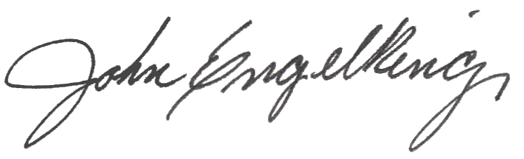

John Engelking, Superintendent

