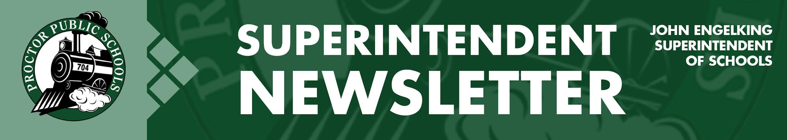

We Educate, Engage, and Inspire
May 6, 2021
Infection Rates Reported 5-6-21 for the Proctor, Hermantown, and Duluth School Districts
Updates on Infection Rates for 4/11/21 - 4/24/21
- SLC- 31.96, PHD- 28.38, Central SLCS- 40.06, North SLCS- 26.01
Projections on Infection Rates for 4/18/21 - 5/1/21
- SLC- 27.27, PHD- 23.47, Central SLCS- 34.11, North SLCS- 27.87
This week and into next week’s projections, we see a plateau and a slight reduction in infection rates. Following discussions with the Minnesota Department of Education, the Minnesota Department of Health, and St. Louis County Public Health, the priorities and recommendations for Proctor Public Schools are to remain in our current learning models.
Current School-Wide Learning Models Reported To The MDE
- Elementary: PreK-5 Full in-person - five days per week
- Secondary: Grades 6-12 Hybrid - four days per week - A-B groups
- Proctor Public Schools also provides an optional Distance Learning Model for families
Planning for Summer School is Underway
After a year of COVID-19 and changing learning styles, we recognize that we need to do all we can to help any student catch up with learning they may have missed. Our goal is to provide outstanding targeted instruction and support for all students in reading, math, STEM, art, and team building. We also plan to provide accelerated enrichment.

What do we believe that will ground our decision-making?
- We believe we can create a program that will be irresistible to parents.
- We believe with targeted and available funding; we can create a stellar program.
- We believe that we can continue the established relationships with our students throughout the summer.
- We believe the students that participate will transition more ready to learn in the fall.
When?
- Preschool - 4 weeks beginning the Tuesday after Memorial Day - half day 8:30-11:30 - week 1 Tues-Friday, week 2-4 Mon-Thursday
- Elementary - 8:00-11:00 academic focused, 12-3:00 enrichment - 2 or 3 weeks in June and 2-3 weeks in August (8:30-10:00 & 10:30-12:00) Monday-Thursday
- Middle School - 5th quarter - 9 weeks
- High School - 3 weeks in June, three weeks in July - 3 shifts, two in the morning and one in the afternoon - Mon-Thurs. 2-hour blocks
Watch for more information and details from your school leaders regarding summer school!
The Trust Edge Book Club
It’s never too late to join the group! I think you will find this examination of David Horsager’s eight pillars of trust enlightening. We still have room, and remember, you receive a copy of The Trust Edge book. Our last meeting was the first time we had a chance to meet and have spirited discussions about improving trust throughout the District. Feel free to access our webpage resources.

Thank you for partnering with Proctor Public Schools.
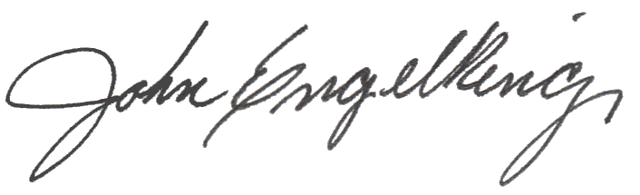

John Engelking, Superintendent

