September 13, 2021

Dear Parent or Guardian,

We are pleased to see the children of San Benito County return to in-person school instruction. It has been a long and difficult journey to protect our community and children against COVID-19. This return to school is important for their well-being, development, learning and social skills. Unfortunately, we are not yet fully out of the pandemic and have not achieved the levels of community immunization to reach herd immunity, where too few people remain unvaccinated for the virus to spread. The Pfizer vaccine has been approved by the FDA and promises eventual approval for use in young children. Once approved, we shall rapidly immunize children to protect them from the virus.

Children are at risk of viral exposure from adults or other children who are carriers of the virus. The virus can live in people’s noses and throats and be spread for a period of time even if they have been vaccinated – the vaccine prevents serious illness and death from the COVID-19 virus, but not spreading it. The Delta variant is very easily transmitted from person to person, at least 10 times more easily than prior variants. The risk of children acquiring the infection, and of outbreaks in schools, remains real, and we must remain vigilant. As important as returning to in-classroom learning is, equally important is keeping our children healthy.

Public Health shall closely monitor infections and outbreaks in school settings, and will rapidly institute quarantine, contact tracing and other measures to interrupt further spread of the virus in that school. We hope the current surge of the Delta variant will soon start to decline as it has in other regions. There are effective ways to keep our schools safe for our children to learn. Each of us - school administration, teachers, parents, and students - can help limit the spread of the virus. Below are frequently asked questions that may be helpful. Any San Benito County resident 12 years and older who gets fully vaccinated after August 9, 2021, is eligible to receive $200 cash incentive. To schedule a vaccination appointment visit www.myturn.ca.gov. Should you have additional questions, please contact us at: www.sbccovid19.us or call 831-636-4113.

Sincerely,
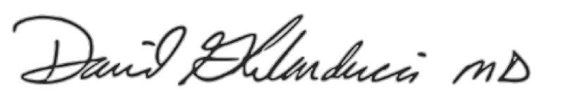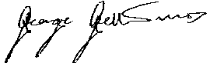
David Ghilarducci MD, FACEP, FAEMS George Gellert MD, MPH, MPA, FABPM
Interim Health Officer Deputy Health Officer

FAQ: COVID-19 Vaccines, Delta and Keeping Schools Healthy

Why are masks required in schools? Masks are an effective way to limit the spread of COVID-19 between students. Since our youngest are not yet eligible for vaccination, this is the first line of protection for them and their families. Please teach your children how to wear a mask and help them understand why wearing it is so important.

Should my child be vaccinated? Yes. If your child is eligible (currently 12 years old or older), they should be vaccinated as soon as possible. The vaccines are very safe with over 4 billion shots given around the world, and very protective.

Should my family be vaccinated if I have a child in school? Yes, all eligible people in your family should be vaccinated as soon as possible. The Delta variant is extremely contagious and there is much increased risk that the virus can be brought into your home.

I’ve heard it’s possible to become infected, even if vaccinated - why should I get vaccinated? The Delta variant can infect people who have been vaccinated. But if vaccinated and you get infected, the symptoms are mild or none at all. COVID-19 vaccines are safe and effective - every COVID-19 hospitalization or death today is a preventable hospitalization or a preventable death.

If I have had COVID-19 before, do I need to get vaccinated? While prior infection provides temporary, low-level protection, it’s not enough. Vaccination provides highly effective protection against the powerful Delta variant. Please don’t wait - get vaccinated today!

Additional information can be found at: https://schools.covid19.ca.gov/

