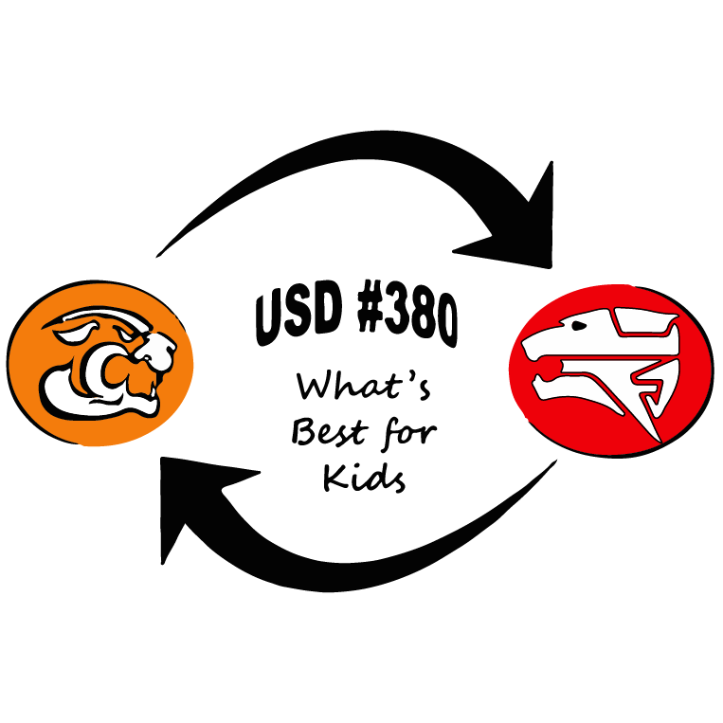

District Plan for Safe Return to In-Person
Instruction and Continuity of Services

USD 380 will begin the 2021-2022 school year with full on-site learning. Students
will attend school in person in accordance with the board approved district
calendar.

PART I.
Describe how the district will maintain the health and safety of students, educators, and other staff and the extent to which it has adopted policies, and a description of any such policies, on each of the following safety recommendations established by the CDC:

(A) Universal and correct wearing of masks.
At the current time there is no directive to require masks. The requirement of USD 380 to wear a mask ended on April 19, 2021. USD 380 will continue to allow students and staff who chose to wear masks.

(B) Modifying facilities to allow for physical distancing (e.g., use of cohorts/podding).
USD 380 has no directive to use special cohorts, podding, or hybrid learning measures in an effort to return to pre-pandemic operations. We currently utilize grade levels to track and monitor where students are at any given time and with whom they interact. USD 380 facilities are open to the public after a request has been approved. Visitors to the buildings will be allowed as per usual protocol.

(C) Handwashing and respiratory etiquette.
USD 380 has always encouraged proper handwashing, even before the pandemic, and will continue this practice. Time for will be allowed for handwashing breaks. Students will continue to be taught proper respiratory etiquette, and hand sanitizer will continue to be available in all USD 380 schools.

(D) Cleaning and maintaining healthy facilities, including improving ventilation.
During the 2020-2021 school year, ventilation improvements were made in all USD 380 facilities to improve air quality by reducing viral and bacterial particles through the addition of ionizers in the HVAC systems. New roof-top HVAC units are continually replaced on a cycle approved by the board of education. Updating of the HVAC systems impacts the ability to regulate air flow and other environmental requirements associated with healthy buildings. Furthermore, the custodial staff works diligently to ensure the cleanliness and sanitation of the facilities with updates made to the cleaning mechanisms in the 2020-2021 school year such as automatic walk-behind floor scrubbers and UV bacterial disinfectant lights.

(E) Contact tracing in combination with isolation and quarantine, in collaboration with the State, local, territorial, or Tribal health departments.
USD 380 will work with the Marshall County Health Department to conduct contact tracing, isolation, and/or quarantining for any infectious disease as required by Federal, State, or local laws or regulations. USD 380 will continue to work with families to address student absences, make-up work, and any other school-related issues resulting from absenteeism.

(F) Diagnostic and screening testing.
USD 380 does not do diagnostic testing or screening in Nemaha County. Testing can be done in Marshall County. Positive student/staff cases will be monitored and tracked with a district-based system. The district will continue to work with Marshall County Health Department, Nemaha County Community Health Officer, and the Kansas Department of Health and Environment as needed.

Nemaha County will not test or quarantine students who are a close contact at school. Marshall County will use the following quarantining and testing protocols:

Quarantine Protocol USD 380 Marshall County
Any student who is considered a close contact may return to school if they wear a mask for 10-days. They may choose to opt into the Testing Protocol.
Note: A limited amount of school contacts have developed the disease, but home contacts have more consistently shown infection than school contacts.

Students with Vaccination or Proof of COVID Recovery within Past 6-Months
**Unless Showing Symptoms
- Will Not Need to Quarantine, per County Health Quarantine Guidelines
- Will Not Need to Wear a Mask
- Will Not Need to Opt-in to Test-to-Stay/Test-to-Play

Close Contacts May Return to School by using One of the Three Protocols
- Wear a Mask for the Duration of the Quarantine Period.
- Opt-in to Test-to-Stay/Test-to-Play Program.
- Follow County Health Quarantine Guidelines.
* By following Option 1 or 2 students would still be in quarantine outside of school and would need to go directly home after school and/or practice.
**Extra-Curricular Activity Participants Must Opt-in to Test-to-Learn/Test-to-Play Option to Participate in Practice or Competition during the Limited Quarantine Period
Household Contacts May Return to School by using One of the Two Protocols
- Opt-in to Test-to-Stay/Test-to-Play program.
  - Including Wearing a Mask for the Duration of the Quarantine Period
- Follow County Health Quarantine Guidelines.
* By following Option 1 students would still be in quarantine outside of school and would need to go directly home after school and/or practice.

Lunch
Masks will be worn through the line. Once seated, masks may be removed to eat.
After the meal is eaten, the mask will be put back on even when sitting at the table.
PE
Masks will be worn at all times if PE is indoors. Masks are not required during PE if class is outdoors, and 6-feet of social distance can be maintained.

Music
Masks will be worn at all times if Music is indoors. Masks are not required during Music if class is outdoors, and 6-feet of social distance can be maintained.

Positive Students must follow County Health Quarantine Guidelines.
(G) Efforts to provide vaccinations to school communities.
The opportunity to receive vaccination was afforded to all staff in the spring of 2021. Vaccination of students and staff will NOT be required by the district. If boosters are needed, or if parents of previously unvaccinated students desire for them to receive the vaccine, plans with the County Health Departments will be coordinated for administration dates similar to the annual flu vaccine administrations.

(H) Appropriate accommodations for children with disabilities with respect to health and safety policies.
USD 380 will provide reasonable, necessary, and appropriate accommodations to its policies and practices for students with disabilities as determined by individual student needs and in accordance with an individual’s documented accommodations and/or individualized education plan (IEP). Parents or guardians of students requiring accommodations should contact the applicable building administrator(s) to request information on plans for students with disabilities.

(I) Coordination with State and local health officials.
USD 380 has a strong relationship with our County Health Officials. We will continue to meet frequently and discuss cases numbers in the county and determine next steps as needed.

Part II.
Describe how the district will ensure continuity of services, including but not limited to:

(A) Services to address students' academic needs
USD 380 was in session, face-to-face, during the entirety of the 2020-2021 school year. Because of this, there was no discernable gap in learning with assessment data concluding no decisive loss in learning. MTSS and Student Improvement Teams will continue to identify and correctly place struggling students with the supports and learning needs that best meet their individual needs.

(B) Students' and staff social, emotional, mental health
USD 380 committed a large investment to update social and emotional curriculum that will help staff teach and monitor the social and emotional health of the students. The district recently purchased an Employee Assistance Plan, New Directions, which allows staff and their families to visit medical professionals to receive mental health assistance at no cost. We continue to offer social-emotional support to our students and staff using the counseling staff and school social worker.

(C) Other needs, which may include student health and food services.
Free meals will be made available for all students during the 2021-2022 school year. USD 380 will monitor and communicate with local agencies regarding new data and any related health requirements.

