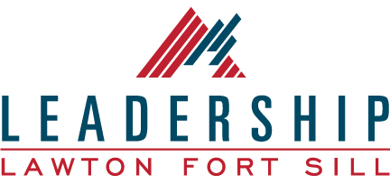

JUNIOR LEADERSHIP LAWTON FORT SILL
2021 PROGRAM INFORMATION

Junior Leadership Lawton Fort Sill class size will consist of no more than 25 students selected from the Lawton community. These slots will be dedicated to students who are currently in their junior year of high school. The program has been developed to foster individual student’s leadership potential. Participants will be prepared for their leadership roles in society through education and practical training. Much training will be through seminars with community leaders and through team-building activities throughout the year. Participants are responsible for paying $25 in tuition. If tuition is a barrier to participation, there are opportunities for scholarship. For details, contact the Junior Leadership Lawton Fort Sill chairperson. Contact information is listed below.

The application process is as follows:
- Applications are due Tuesday, September 14, 2021.
- Applications will be delivered by email to your high school counselor or Student Activities Director.
- Once all applications are received, the selection committee will review the applicants and may schedule interviews, if necessary.
- Selected applicants will be notified Monday, September 20, 2021.

If selected, students will be required to attend class activities on the following dates:
- Orientation-Virtual with parents
- October 20, 2021-Class Retreat
- November 17, 2021
- January 19, 2022
- February 16, 2022
- March 23, 2022
- April 20, 2022
- May 4, 2022

Questions concerning the application/selection process can be addressed to: Jonna Turner jbrown@cameron.edu or Lynn Cordes lcordes@lawtonps.org, JrLLFS Committee

