September 14, 2021

Dear Families,

I hope this letter finds you well.   As we progress further into the school year, I would like to invite families to our annual Title 1 Parent Meeting on Wednesday, September 22nd at 4:00pm, in the gym.

The purpose of this meeting is to share information related to Bowie Unified School District’s Title 1 Program.

Today all students received a copy of the Parent Involvement Policy and Student-Parent-Teacher Compact.  Be sure to sign and return the Student-Parent-Teacher Compact as soon as possible.  During the meeting on September 22nd, I will answer any questions you may have related to Title 1, including these two documents.

If you have any questions, please contact me at [Dan.Erickson@bowieschools.org](mailto:Dan.Erickson@bowieschools.org) or (520) 847-2545.

Best,

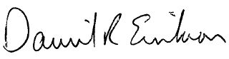

Daniel R. Erickson  
Superintendent  
Bowie Unified School District