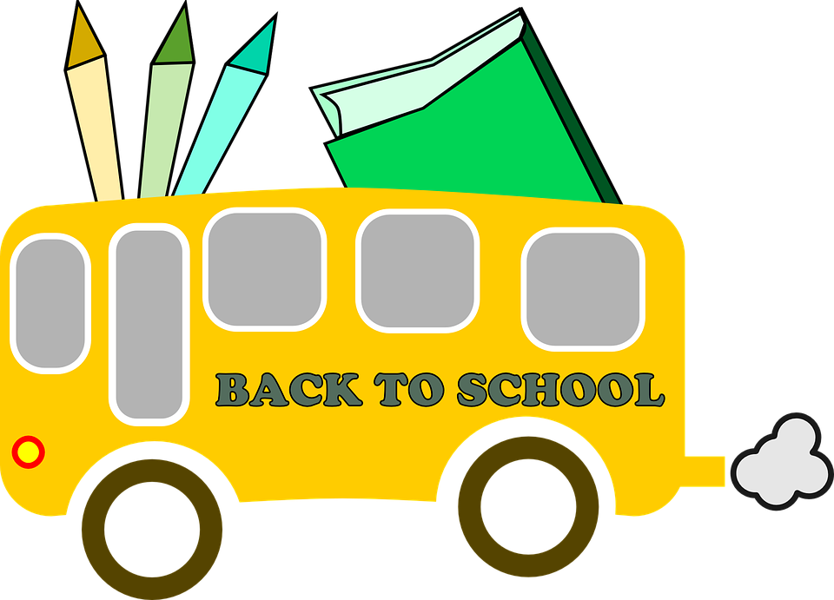

kindergarten Supply List

Dear Grown-Ups,

Welcome to kindergarten at Sharp Elementary! We are looking forward to getting to know you and your family this year. Kindergarteners develop fundamental work habits, appropriate social behavior, problem solving and decision making skills, and of course academic skills. In order to experience a smooth and successful year, there are a number of supplies we are asking each child to bring in on the first day of school.

- 1 - Pack of colored pencils (12 pack)
- 1 - Pack of crayons (24 count)
- 4 - Fine tip Expo markers (not ultra fine)
- 1 - 4 oz. bottle of white Elmer's liquid glue
- 1 - 1 inch white binder
- 4 - glue sticks
- 1 - 24 count package of non-mechanical pencils (Ticonderoga brand is a favorite!)
- 3 - boxes of tissues
- 1 - pair of over-the-ear headphones (not earbuds) for classroom & technology use
- 1 - large pink eraser
- 1 - 3 oz. container of Play-doh
- 1 - art smock (an old, large t-shirt works best)
- Extra set of clothes (including socks and underwear)

- If your last name begins with the letters A-M please send in:
  - 1 - box of sandwich Ziploc bags
  - 1 - bottle of hand sanitizer
- If your last name begins with the letters N-Z please send in:
  - 1 - box of gallon Ziploc bags
  - 1 - bottle of hand pump soap

Please place all supplies into a large reusable shopping bag with your child’s name on it. We will return the bag at the end of the first week. Do not place supplies in backpack.

We are looking forward to working together with you to make your child’s kindergarten year a terrific one! Enjoy the rest of your summer! If your family is unable to obtain any of the supplies listed, please let us know and we will be happy to work with you.

Educationally yours,
Sharp Kindergarten

