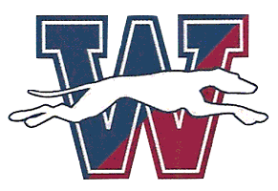
Windham High School
2021-22 Cross Country Schedule

Tuesday September 14 @ East Lyme, Stonington, Woodstock 3:45p
Tuesday September 21 @ Norwich Tech, Windham Tech TBA
Friday September 24 @ Harry Geraghty Invitational TBA
Tuesday September 28 @ Griswold, East Lyme 4:30p
Tuesday October 05 @ Lyman Memorial, Ledyard 4:30p
Saturday October 09 @ Wickham Park Invitational TBA
Tuesday October 12 @ St. Bernards, Montville 4:00p
Thursday October 21 @ ECC Championships 1:00p
Saturday October 30 @ Boys Class M (Wickham Park) 9:15a @ Girls Class SS (Wickham Park) 3:40p
Friday November 05 @ CT State Open TBA

