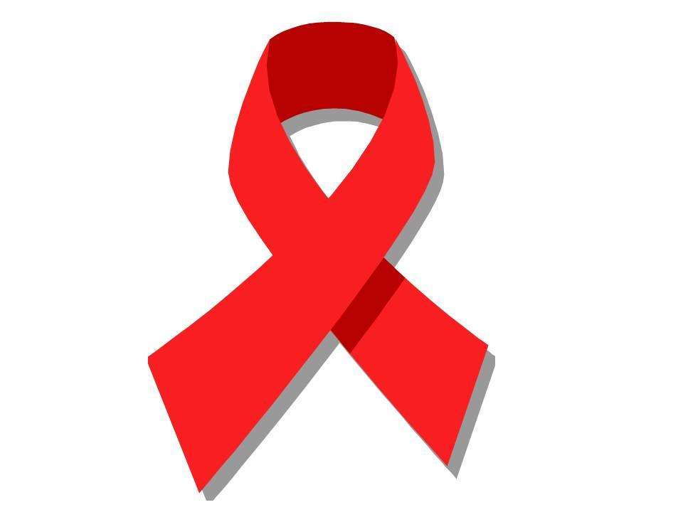

RED RIBBON WEEK 2022
October 24th – October 28th

Monday - Team Up for Kindness
WEAR YOUR FAVORITE SPORTS JERSEY

Tuesday- I’m a Jean-ius - I’m Drug Free
WEAR JEANS

Wednesday- Follow Your Dreams - Stay Drug-Free
PAJAMA DAY!

Thursday- Put A Sock On Drugs
CRAZY SOCK DAY

Friday- Band Together Against Drugs show your school spirit
WEAR SCHOOL COLORS

