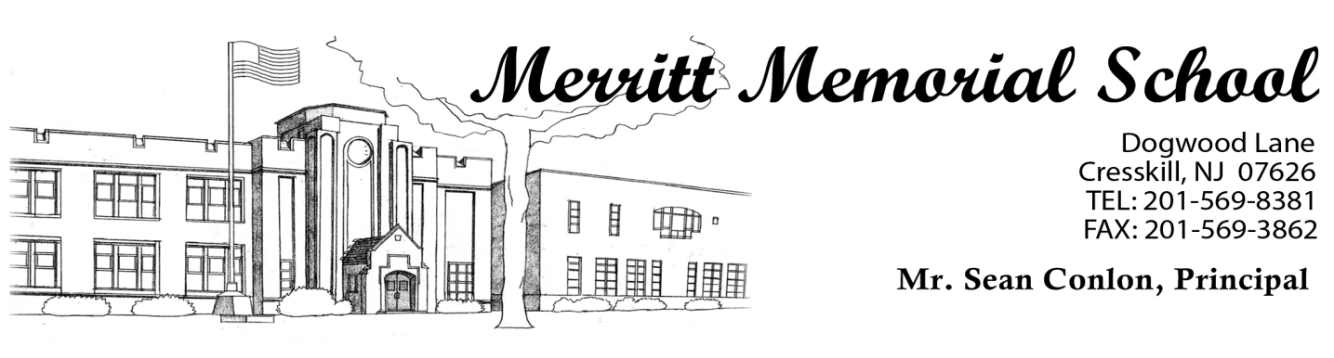

May 11, 2022

Dear Parents,
This year as a part of the health curriculum, Merritt School will provide a program for upper grade children to understand growth changes which occur in boys and girls as they mature. Students in Grade 4 will participate. Separate programs will be held for the boys and girls.
The Board of Education, however, recognizes the parental right of conscience outlined in N.J.S.A. 18a-35-4.6. This allows any student whose parent or guardian presents to the school principal a signed statement that any part of instruction in health and family life education is in conflict with his/her conscience, moral or religious beliefs, to be excused from that portion of the course where such instruction is being given. The children will be viewing the videos during the Month of May.
If you have any questions, please do not hesitate to either contact our school nurse, Mrs. Riley at 201-569-8381.

Sincerely
Sean Conlon
School Principal
Merritt Memorial School

