Piggott Public Schools
Elementary Comprehensive School Counseling Plan 2021-22

PIGGOTT PUBLIC SCHOOLS MISSION
The Piggott School District in partnership with parents and community provides a quality educational environment which guides all students to learn the skills and acquire the knowledge necessary for them to meet the challenges of an ever-changing world.

AMERICAN SCHOOL COUNSELOR ASSOCIATION (ASCA) NATIONAL MODEL
School counseling programs are collaborative efforts benefiting students, parents, teachers, administrators, and the overall community. School counseling programs should be an integral part of students’ daily educational environment, and school counselors should be partners in student achievement. As a result, the American School Counselor Association (ASCA) created the ASCA National Model, which is a framework for a comprehensive, data-driven school counseling program -a model implemented by the Piggott Elementary School Counseling Program.
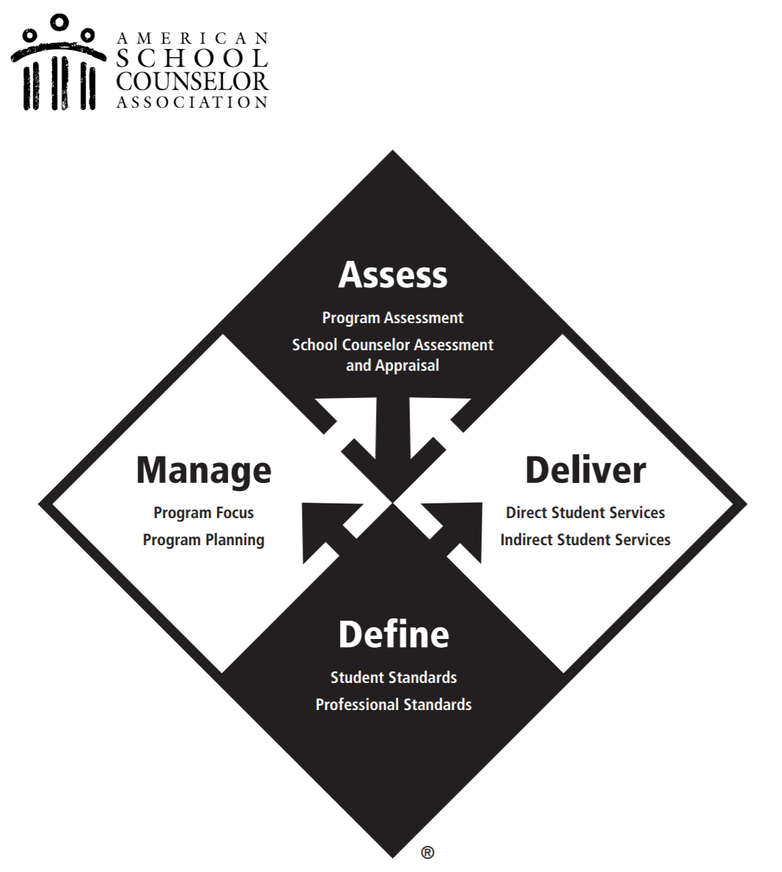
PIGGOTT ELEMENTARY SCHOOL COUNSELOR INFORMATION barbara.batey@piggottschools.net 870-598-2546

FOUNDATION (DEFINE)
The Piggott Elementary School Counseling Program is a comprehensive program that provides all students the opportunity for optimum growth and development. It is with this and the Piggott School District mission statement that the Piggott Elementary School Counseling Program has adopted the following elementary comprehensive school counseling model.

BELIEF STATEMENTS
- Piggott Elementary School Counselor believes that ALL students can learn and achieve academic greatness when encouraged and nurtured in a respectful environment.
- Piggott Elementary School Counselor believes that nurturing ALL students’ social and emotional well-being will encourage academic development and future success.
- Piggott Elementary School Counselor believes it is our role to provide a data driven, developmental counseling program to meet the needs of ALL students through a classroom counseling curriculum, individual student planning, responsive services, and system support.
- The Piggott Elementary School Counseling Program will promote the following: an understanding of and respect of self and others; problem-solving and decision-making; emotional-management skills; skills for learning; and the influence of academic habits on career success.

VISION STATEMENT
The vision of Piggott Elementary School Counseling Program is that every student will acquire the academic and social-emotional skills, post-secondary preparation, and career exploration to reach their fullest educational potential. Through a comprehensive school counseling program that ensures ALL students are prepared academically, intellectually, and emotionally, students gain the knowledge and skills essential for life-long learning in an ever-changing society, which is additionally accomplished in partnerships with parents, educators, and the community.

MISSION STATEMENT
Piggott Elementary School Counselor provides a comprehensive, developmentally age-appropriate school counseling program that is aligned with state and national school counseling standards. School Counselors address the social-emotional, academic, career development needs of all students. School Counselors work collaboratively with families, staff, and community partners to prepare students to become effective 21st century learners, achieve success in school, and meet the challenge of an ever changing world.

STANDARDS AND COMPETENCIES
ASCA School Counselor Professional Standards and Competencies (2019)
https://www.schoolcounselor.org/getmedia/a8d59c2c-51de-4ec3-a565-a3235f3b93c3/SC-Competencies.pdf

ASCA Ethical Standards for School Counselors (2016) https://www.schoolcounselor.org/getmedia/f041cbd0-7004-47a5-ba01-3a5d657c6743/Ethical-Standards.pdf

ASCA Mindsets and Behaviors for Student Success: College- and Career- Readiness Standards for Every Student (2014)
https://www.schoolcounselor.org/getmedia/7428a787-a452-4abb-afec-d78ec77870cd/mindsets-behaviors.pdf

G.U.I.D.E. for Life
https://sites.google.com/pdarkansas.net/guideforlifecurriculum/home

Behavior: The Forgotten Curriculum, A RTI Approach for Nurturing Essential Life Skills

MANAGEMENT (MANAGE)
The Piggott Elementary School Counseling Program understands that to effectively deliver services and address the developmental needs of all students, the program must provide organizational assessments and tools designed to manage school counseling programs. As a result, Piggott Elementary School Counselors utilize the management resources and recommendations of the American School Counselor Association (ASCA).

PROGRAM ASSESSMENT
Piggott Elementary School Counselor develops program goals from data review and are based on identified gaps in schools. For the 2021-2022 school year, the elementary counselor will provide interventions to reduce chronic absenteeism for a targeted group (as identified by each individual counselor in his/her specific school) of students in grades 3-6.
Upon completion of the program goal at the end of the 2021-2022 school year, all Piggott Elementary School Counselors will provide a building-specific results report under the section titled Action Plans.

Along with developing annual outcome goals, the Piggott Elementary School Counselor use other tools, listed below in this section, to manage the comprehensive school counseling program. One specific tool, deemed best practice to complete, is the Comprehensive School Counseling Self-Assessment. These assessments can be obtained from each specific counselor upon request.

In the state of Arkansas, School Counselors take part in the Arkansas Teacher Excellence and Support System (TESS).

TESS Smart Card for Counselors
TESS Rubric for Counselors
TESS Examples of Artifacts for Counselors

ELEMENTARY SCHOOL COUNSELOR USE OF TIME
Piggott Elementary School Counselors use SCUTA to develop a data-driven, evidence based school counseling program. SCUTA follows the ASCA National Model recommendations and offers confidential, comprehensive documentation and a use of time analysis system.

ANNUAL ADMINISTRATIVE CONFERENCES
It is considered best practice for counselors to have an annual administrative conference. It is an imperative way to share information and for the counselor to advocate for school counseling programs and how they impact students.

DATA USE IN COUNSELING
Piggott Elementary School Counselor utilizes data to drive the elementary comprehensive school counseling program. This is accomplished by analyzing data from student and staff needs assessments. Additional data can also be accessed through school/Cognos (e.g., attendance reports), and the ADE Data Center (e.g., district and school report cards/school profile data).

ACTION PLANS
Upon the completion of the 2021-2022 school year, the Piggott Elementary School Counselor will provide interventions to reduce chronic absenteeism for a target group of students in grades 3-6. This is the 2021-2022 school year goal.
CALENDARS
The Piggott School District Elementary Annual Calendar includes all major school counseling activities coordinated, or in which collaboration is provided, by the school counselor(s). Please note that monthly topics and lessons delivered to students are subject to change based on the individual and unique needs of each elementary school. The Piggott Elementary School Counselor can provide an individualized Scope and Sequence specifically tailored to his/her school upon request.

Piggott School District Elementary Annual Calendar
August | Counselor Orientation  Open House/Back to School Night | January | Goal Setting, Growth Mindset
September | Feelings, Empathy, Respect for Others | February | Kindness, Compassion, Relationship Building
October | Empower Me, Healthy Choices, Safety | March | Self Esteem, Self-Regulation, Coping Skills
November | Conflict Resolution  Character Education | April | Stress Management, Academic Skills  State Testing
December | Bullying/Cyberbullying | May | Careers, End of the Year  Middle School Transition Events  4th Grade Youth Power Play
*Lessons subject to change based on needs

Samples from Piggott School District Elementary Annual Calendar:
- Bullying Prevention/Protocol
  - A.C.A. § 6-18-514 defines that “all public school students have the right to receive their education in an environment that is reasonably free from substantial intimidation, harassment, or harm or threat of harm by another student, in person or by electronic means.” As such, Piggott Elementary School Counselors provide lessons to students on defining, identifying, and reporting bullying. Although bullying is specifically listed above as a main focus point for the month of December, the timeline for the implementation of this lesson varies by school need (e.g., in many cases, the topic of bullying is a continual topic throughout the school year).
  - In addition to this, all Piggott Schools adhere to ACT 1029 which amends previous anti-bullying legislation and addresses anti-bullying continuing education and procedures/requirements for reporting. Counselors work with their school administration in the reporting and investigative procedures.
  - Piggott Elementary School Counselors utilize resources available from the Division of Elementary and Secondary Education on Anti-Bullying and Violence Prevention.
- Counselor Orientation/Transitions
  - Piggott Elementary School Counselor provides a Counselor Orientation in a variety of ways (unique to each school; specifics pertaining to individual counselors/buildings available upon request): Back to school/Faculty In-Service presentations, Back to School events, etc. The purpose of these is to provide staff, students, parents, and stakeholders with information on the role of the school counselor and the school counseling program (e.g., topics may include but are not limited to: confidentiality, mandated reporting, program data, etc.).
    - Open House- Students will meet teachers and counselor before the school year starts.
    - High School Transitions: Collaboration with the High School building in transitioning rising 6th graders from elementary school includes, but is not limited to: Parent Information Nights, 7th Grade Orientation/High School visits, 6th question and answer with Jr High Counselor.
  - Suicide Prevention- Piggott Elementary School Counselors provide developmentally appropriate suicide prevention and protocols for reporting. In many cases, suicide prevention is tied in with the classroom topic of safety (e.g., we don’t only report to an adult when we need help/are in trouble, but when our peers are in need of support as well). Counselors also address suicide prevention with various social emotional supports (e.g.; self-esteem, self-regulation, coping skills, etc.).
  - Protocols for reporting: Person aware of the threat or harm to self must report to school counselor and school administration immediately. The student is to remain under direct supervision.
  - Piggott Elementary School Counselor also utilizes resources available from the Division of Elementary and Secondary Education.

SHARING DATA RESULTS
Piggott Elementary School Counselor shares data results with school administration, staff, students, parents, and stakeholders in a variety of ways.

DELIVERY (DELIVER)
Act 190, The School Counseling Improvement Act, states that school counselors must spend at least ninety percent (90%) of their time each month, on student contact days, providing direct and indirect counseling services to students. Piggott Elementary School Counselors provide services in the following areas:

DIRECT COUNSELING- 90% of time spent
- Classroom Core Curriculum Lessons (intentional, planned and developed based upon the needs of the students)- Tier 1
  - Classroom Core Curriculum Lessons shall be limited to forty-minute class sessions, not to exceed three (3) per day and not to exceed ten (10) per week, as specified in ACT 190
  - Helps all students build skills and competencies that are age-appropriate and focused on the counselor/school/district mission and vision
  - Addresses social/emotional needs, career exploration, and academic growth
  - Supports students to develop an understanding of the relationship between classroom performance and success in school and beyond
  - Examples: Empower Me/Safety, Bullying, Conflict Resolution, Career Exploration
  - G.U.I.D.E. for Life Essential Skills -five guiding principles that support students in thriving at school, home, on the job, and in the community.
    - Growth: Manage Yourself
      - Develop problem solving skills, practice mindfulness, persevere
    - Understanding: Know Yourself
      - Increase self-awareness, know your strengths and weaknesses, develop critical thinking skills
    - Interaction: Build Relationships
      - Treat others with respect, communicate effectively, seek out and offer help when needed
    - Decision Making: Make Responsible Choices
      - Consider safety in situations, think through potential consequences, put your best self forward
    - Empathy: Be Aware of Others
      - See other perspectives, value the feelings of others, appreciate diversity
  - Behavior- An RTI Approach for Nurturing Essential Life Skills

- Small Group Counseling- Tier 2 or 3
  - Groups are formed based on identified gaps, teacher, parent or student referrals
  - Meet regularly over a specified amount of time
  - Can address academics, social skills, and emotional needs
- Individual Counseling- Tier 2 or 3
  - Obstacles to learning
  - Family/Peer/Teacher concerns
  - Social/Emotional needs
  - Setting goals
- Other Responsive Services
  - Designed to meet students’ immediate needs and concerns
  - Crisis
  - Conflict resolution

INDIRECT COUNSELING- 90% of time spent
- Consultation and Collaboration
  - Occurs on behalf of the student and addresses student’s behavior, academics, or attendance
  - Can include parents or guardians, school staff, and community agencies
- Referrals
  - Referring a student for mental health services, child maltreatment reports and parent or guardian communications
- Participating on Decision Making Teams
  - Serving as a contributing member of decision making teams
    - Can include but not limited to: Section 504, Response-to-Intervention, English Language Learners, Parental Involvement/Family Engagement, Positive Behavior Intervention Support (PBIS), Gifted and Talented

ADMINISTRATIVE ACTIVITIES- No more than 10% of time spent on this
- Coordination of Programs and Data Input
  - Assisting in the coordination of programs will vary by individual building expectations. Some of these programs may include, but are not limited to: Parental Involvement, Piggott Family Literacy Programs, Positive Behavior Intervention Support , English Language Learners
  - Elementary School counselor generally does not participate in data input, but is familiar, with help from their building level registrar, with pulling data and reports (attendance) from eSchool and Cognos.
  - Information for a specific school counselor can be obtained upon request.
- Chairing Committees and Meetings
  - Varies among schools; Chairing committees and meetings including, but not limited to: Parental Involvement, Positive Behavior Intervention Support, English Language Learners, and Response-to-Intervention.
  - Information for specific school counselors can be obtained upon request.
- Duties
  - Supervising students in common areas such as the hallway, cafeteria, or bus line (information for specific school counselor can be obtained upon request).
  - Other duties as assigned (Morning Announcements, Birthday Recognition, Ambassadors, National School Counseling Week, Providing for Needy Students).

ACCOUNTABILITY (ASSESS)
Accountability and evaluation of the Piggott Elementary Comprehensive School Counseling Program are absolute necessities. A comprehensive school counseling program is multifaceted and designed with continuous evaluation and modification in mind. This is all accomplished with the use of tools for evaluating the program, tools for sharing out results, and school counselor reflections. The main purpose in collecting this information is to guide future actions within the program and to improve results with our students.

TOOLS FOR EVALUATING THE COMPREHENSIVE SCHOOL COUNSELING PROGRAM
Piggott Elementary School Counselors use various types of tools for evaluation of the comprehensive school counseling program. Through the implementation of needs assessments, feedback from small counseling groups, review of goal setting action plan results, etc., school counselors are able to identify and meet the needs of their students and address how these can change due to specific counseling interventions.

TOOLS FOR SHARING RESULTS
Piggott Elementary School Counselors share data results with school administration, staff, students, parents, and stakeholders in a variety of ways.

SCHOOL COUNSELOR REFLECTION
The Piggott Elementary School Counseling Program understands that to effectively deliver services and address the developmental needs of all students, the program must provide organizational assessments and tools designed to manage school counseling programs. The Piggott Elementary School Counselor will compare pre-survey data and post-survey data gathered from students and teachers to identify areas of strength and reflect on the comprehensive school counseling program and identify areas for growth. As a result, Piggott Elementary School Counselor utilizes the management resources and recommendations of the American School Counselor Association (ASCA).

ADDITIONAL RESOURCES

REFERENCES
American School Counselor Association (ASCA)
https://www.schoolcounselor.org

ACT 190 - THE SCHOOL COUNSELING IMPROVEMENT ACT OF 2019

DIVISION OF ELEMENTARY AND SECONDARY EDUCATION - GUIDANCE AND SCHOOL COUNSELING

