Creating a Parent Account on the Portal
Directions are for creating a new account. If you previously had an account, then these steps will not work a second time. Please contact dbond@schleyk12.org.
Parents,
Please realize that the goal of Schley County School District is to safeguard your child’s data.
- Visit the site below to lookup your parent activation key:
https://gacloud2.infinitecampus.org/campus/K12_Custom/cParent/index.jsp?appName=schley
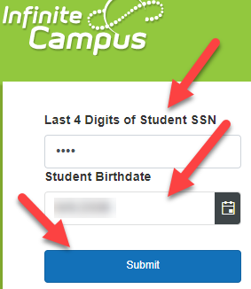
Enter the last 4 digits of STUDENT SSN
Student Birthdate
Then click on Submit

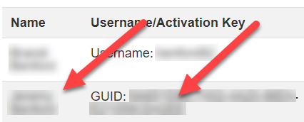

- Next COPY the GUID beside the name of the parent account you are creating.
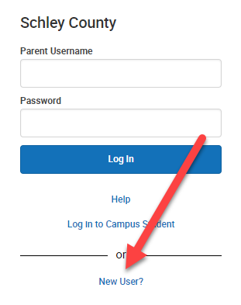
- Visit: https://gacloud2.infinitecampus.org/campus/portal/parents/schley.jsp

- Click on New User
- Enter the Activation Key provided from step 2 above.
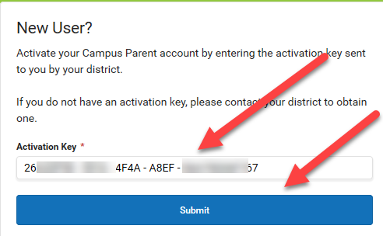

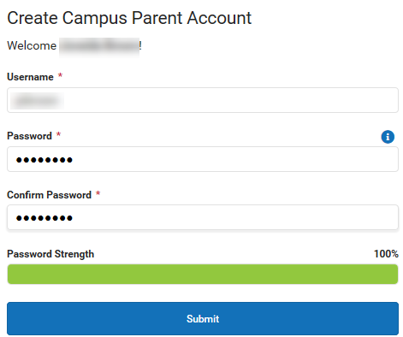
- Create Campus Parent Account by entering a Username you will remember and a secure password.

- Click submit and then return to Login. New feature requires
an email address on initial login.

- You will be able to see grades and other pertinent information on each of your children.

