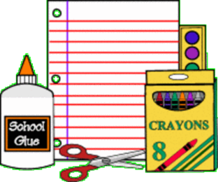 Apple Springs 2018-2019
Kindergarten School Supplies
1 backpack
6 boxes of Crayola brand 24 count crayons
1 spiral notebook
1 blue MEAD brand plastic folders (with prongs)
1 red brand plastic folders (no prongs)
1 pkg. washable markers
12 glue sticks
1 pencil box (no large boxes)
2 boxes of tissues
10 #2 pencils (made in U.S.A. only)
1 set washable watercolors
1 pr. blunt scissors
2 pkgs pencil top erasers
1 pkg. baby wipes
1 box Ziploc baggies (quart or gallon)
Please write child’s name on backpack, markers box, pencil boxes, notebook, and watercolors.
Write name on the back of the plastic folders

