2020 SEPTEMBER
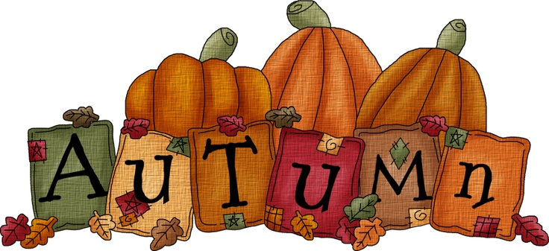
Sunday | Monday | Tuesday | Wednesday | Thursday | Friday | Saturday
 |  | 1 | 2 | 3 | 4 | 5
6 | 7Office Closed | 8 | 9 | 10 | 11 | 12
13 | 14Food &  Nutrition | 15Clover Buds | 16Red Devil  Seniors  Extension Meeting  Room @ Noon | 17 | 18 | 19
20Shooting  Sports  2020 Orientation  Dub Day Arena  Pavilion 3 p.m. | 21 | 22 | 23 | 24 | 25 | 26
27Community  Clean Up | 28Food &  Nutrition | 29 | 30 | UPTON COUNTY 4-H  UPDATE |  | www.Scheduleidea.com

