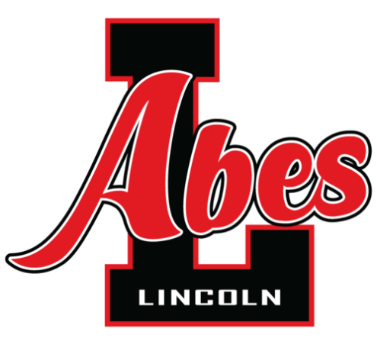
Lincoln Senior High School

22900 Federal Avenue, Warren, Michigan 48089
Telephone: (586) 758-8307 Facsimile: (586) 353-0146

Rigorous Academics, Respectful Behavior, Relentless Effort!

August 9, 2021

Dear Lincoln Abes Family,

Finally, I have the privilege of welcoming our students back to school full-time and in-person! The first day of school will be Monday, August 30 from 7:25am-10:51am. Detailed information from the district regarding any additional protocols such as mask requirements will be provided as soon as possible.

This year, the focus at Lincoln High School will be to assist our students as they transition back to traditional in-person learning both academically and socially. Our administrators, teachers and support staff will be well prepared to help students regain any skills that were weakened during the pandemic and we are fully committed to accomplishing this in a safe, clean and healthy environment. Please carefully review the documents that are included with this mailing, as well as future items that you may receive from the school or your child’s Advisory teacher, so that you are aware of any policy or procedure changes. Note that not all information, such as our bell schedule, will be posted online in an effort to maintain the utmost safety of our students, so please hang on to any documents that you might want to refer to throughout the school year.

Several forms will need to be completed and returned to school, before your child can begin attending classes. 9th and 10th graders will return their forms at Abe’s Day on August 25. 11th and 12th graders will return their forms on the first day of school, August 30th. These are the forms that MUST be returned:

- Student Data Form (GREEN)
- Household Survey (PINK)
- Power School Parent Portal Agreement (WHITE)
- Media Release Form *Only included if the form was not already on file

These additional documents are also included. Please review carefully.

- LHS Bell Schedule
- LHS Calendar
- ABEs Citizenship Expectations
- Electronics Policy

Important Upcoming Events!

August 25, 1:00-3:00pm, LHS Auditorium - ABE’S DAY for 9th and 10th grade students. Turn in your forms, receive your schedule, tour the school, learn about all extracurricular clubs and sports!

August 26, 7:00pm, LHS Football Stadium – First home football game

August 30, 7:25am-10:51am – First day of school for all students. 11th and 12th graders will report to the gymnasium to turn in forms and receive their schedule. 9th and 10th graders will report to their Advisory class.

September 9, 5:30pm-7:00pm, Lincoln High School – Open House. A brief presentation from administration will take place at 5:45pm with a second opportunity at 6:40pm in the auditorium.

We look forward to welcoming you back! Sincerely,

Lincoln High School Administaration
Mrs. Billie Sczepaniak, Principal
Mr. Steve Filiccia, Assistant Principal
Mr. Michael Harris, Assistant Principal/Athletic Director

