Very Special

Arts Festival

Art Festival at UNCP

Returning in 2023!

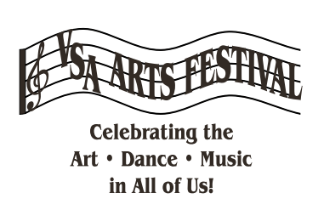

Goals for our programs
It is our goal to provide quality extracurricular activities that promote inclusion and equity in our schools. strengthens academics.

