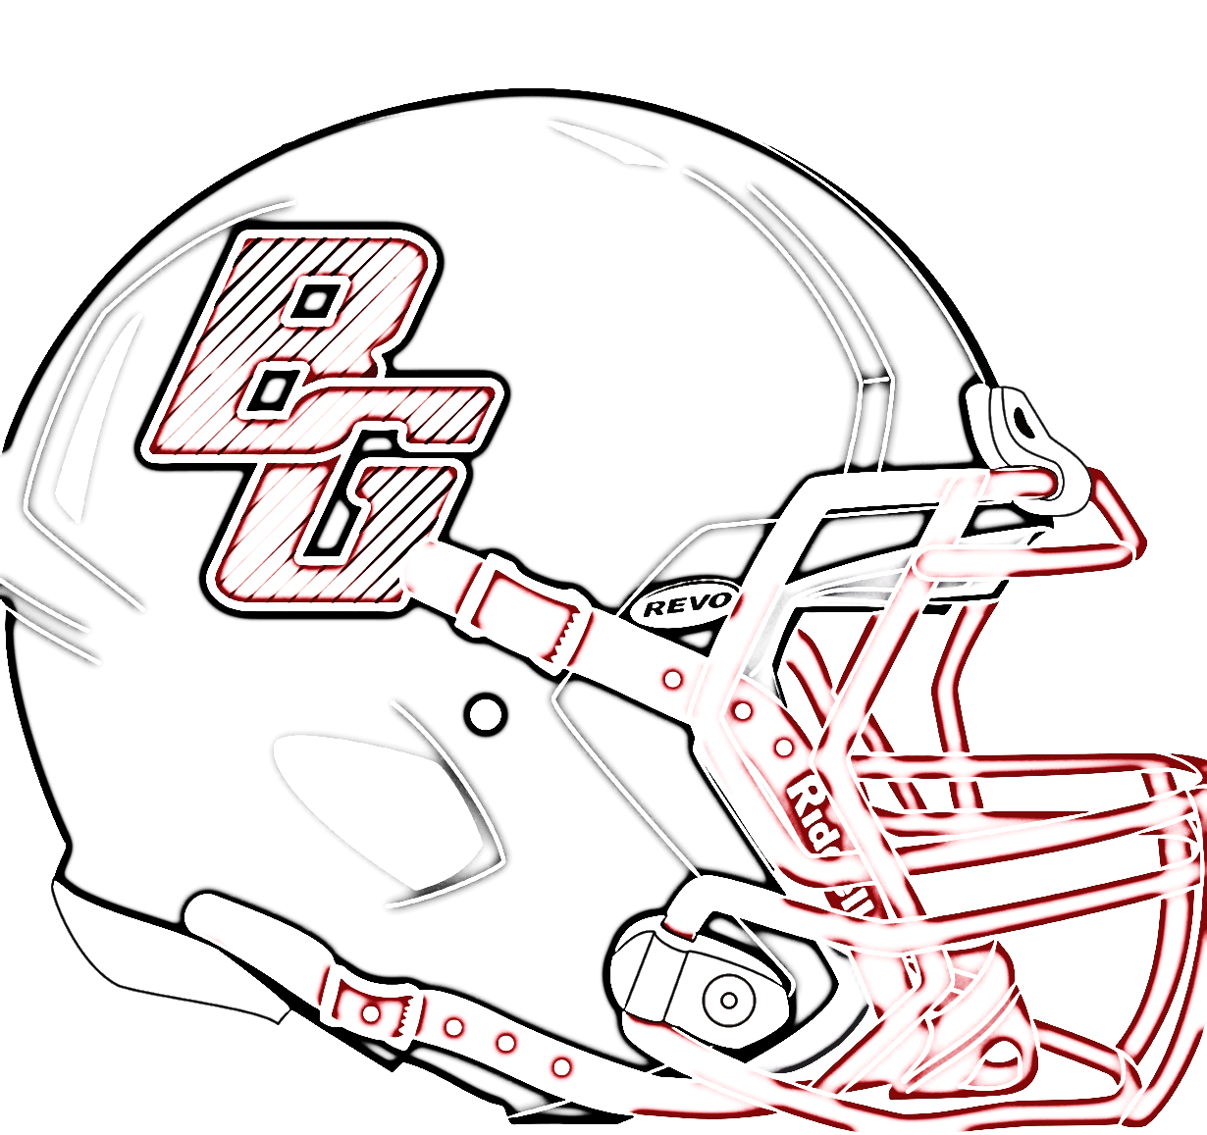
Attention All incoming 7^{th -} 8th Graders wanting to play Football
Football

Jr High Football Camp will be May 22-25 8am-9:30am @ Bowling Green High School Cost of camp is $10
Per MSHSAA Rule no student from St. Clement going into Jr. High may attend (7th-8th).

If you’re interested email Coach Bibb at
cbibb@bgschools.k12.mo.us or
call, or email me
Kevin Krietemeyer 217-779-0712
kkrietemeyer@bgschool.k12.mo.us

Name:
Cell:
Shirt Size: S M L XL
Shirt Sizes need turned in ASAP money can be turned in on the day of Camp.

