Good Day,
I wanted to start off by telling you that this email from Tyler caught me off guard today as I was told that this phase would not happen for another year. (see at the bottom of the page)
I know you have much on your plate right now and this is not great timing, but I want you to practice in TRAIN as Tyler is suggesting and watch this first overview video.
Tyler has excellent videos for learning 360, but unless you work in the TRAIN site and practice these techniques, you will not have a grasp of the new format.
I will field any and all questions you have once you watch this first video and go into the TRAIN site and practice.

1. The TRAIN site is not live data. We roll over our Live data every Sunday night so that anything that you do in TRAIN (mess up) will not count. Try anything you want in TRAIN because that is what it is there for. Below is the link to get to TRAIN.

https://sdm.sisk12.com/mvtrain360x3/login

Please note that you can tell if you are in TRAIN (and not LIVE) because you should see Train right in the middle of the page. Next click the 360 Login to start your adventure.

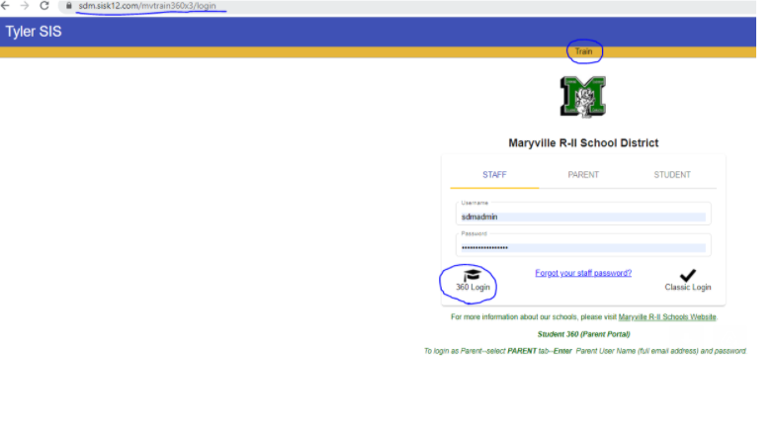

2. Here is the video that helps you watch an overview of the Classroom Summary.
https://www.tylertech.com/SIS-Videos/v9/c360%20classroom%20summary/index.html

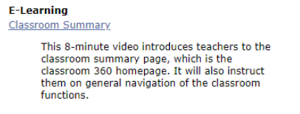

3. If you are more adventurous and wish to explore more documentation on 360, below are the directions:
A. Log onto TRAIN and click the 360 Login.
B. Look to the upper left and make sure you are in the right Site. If not, click the down arrow to find your site.
C. For help documentation, click the question mark.
D. Find Gradebook and expand. Under this category you will find the e-Learning videos.

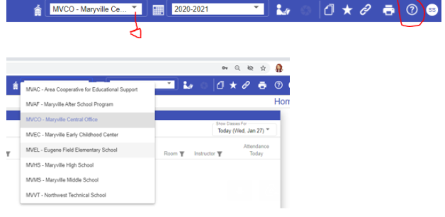

Help Documentation:
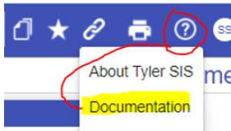
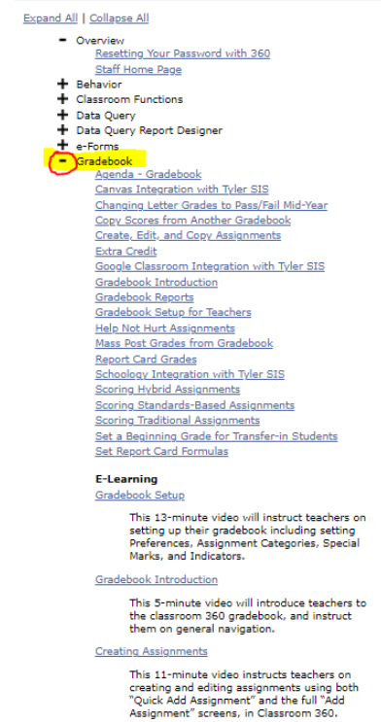
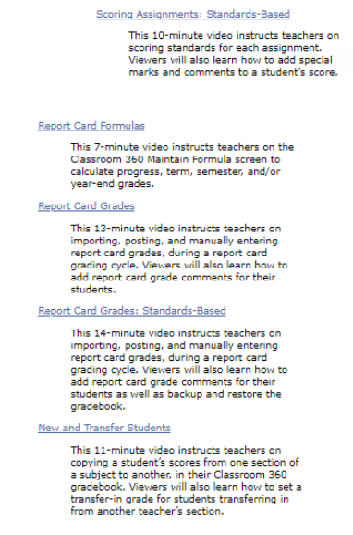
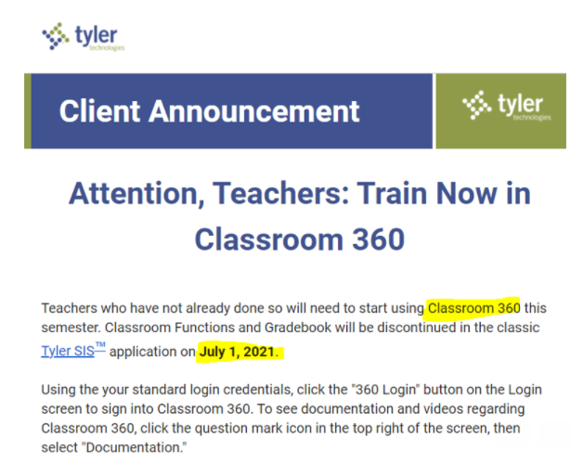

I will be happy to take any feedback or if you come across any issues, please do not hesitate to contact me.

