Creating and Sharing a Doc
Maryville Google Apps Site -- www.google.com/a/maryviller2.com

Google Drive/Docs – drive.google.com

Accessing Your Drive

Using one of the links above, you can log into Google Drive or to your Google Apps account.
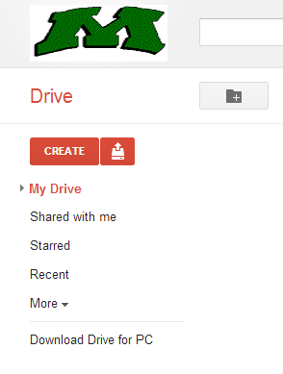
  - If you use drive.google.com, you will need to use your full email address as your username – {username}@maryviller2.com.
  - If you log into your Google Apps account, you can click on “Drive” in the black navigation bar at the top of the Google Apps homepage.
Creating A Document
- When you are in your Drive account, you will see a “Create” button on the left side of the screen under the R-II “M”.

- Click on “Create” and choose “Document”.
(Your other options are Presentation, Spreadsheet, Form, Drawing, and Folder

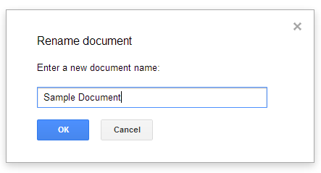
- A new page will open with a blank document. Click in the upper left corner where is says “Untitled document” and name your document in the box that pops up.

- Type your document.

- Google automatically saves your work. Look for “All changes saved in Drive” at the top of the document to be sure your most recent changes are saved.

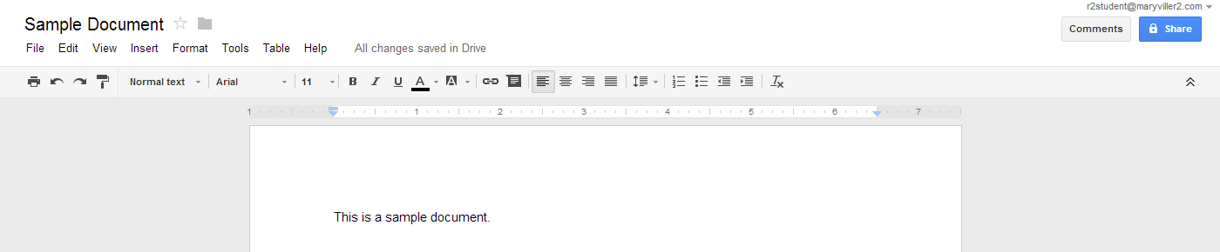
- When you are done, click on the blue “Share” button in the upper right corner of the screen.

- A box will pop up that shows
  - A link to your document that you can copy and paste to share in an email.
  - Who currently has access to this document.
  - A box that allows you to give access to someone new.

- Click in the “Add people” box and type in the name, email address or group name of those people you want to share your document with.

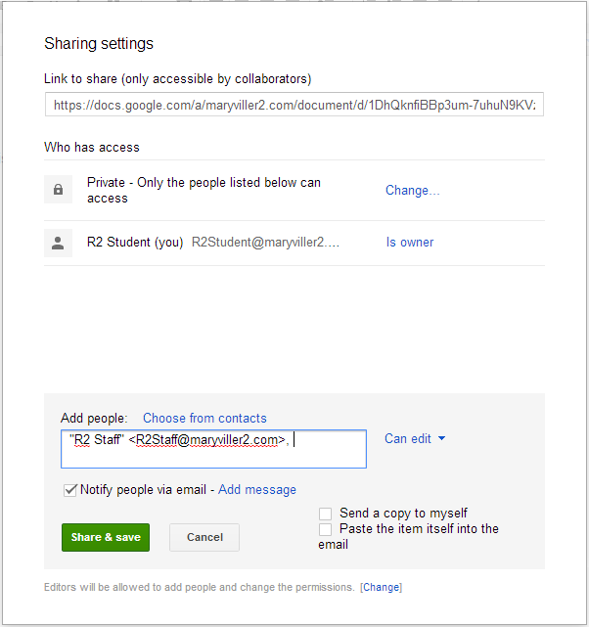
- You can choose the level of access the person you are sharing your document with by clicking on the drop-down to the right of the “Add people” box, and choosing between “Can edit”, “Can comment”, and “Can view”. If you are working in a group and everyone needs to make changes, choose “Can Edit”. If you don’t want the person you are sharing with to be able to make any changes to your document, click “Can view”. “Can edit” is the default setting.

- If you leave the check in the box next to “Notify people via email, an email will be sent to whomever you have shared your document with notifying them that they now have access to the document.

- Click the green “Share and save” button at the bottom of the box and your document is now shared. The person you have shared with will be able to access your document in their Google Drive account.

When you are done with using your Google Apps account, you must remember to log out.

