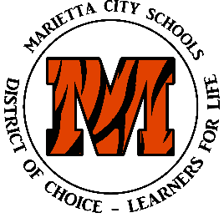
MCS FALL TESTING SCHEDULE FOR 2019-2020

Grade | Test | Test Dates
K | KRA | 8/21/19-11/1/19. Deadline is 11/1/19.  Language and literacy portion to meet TGRG requirement. Deadline is also 11/1/19
1 | STAR Window (Reading Diagnostic) | 9/16/19-9/27/19
2 | STAR Window (Reading Diagnostic)  Iowa Test of Basic Skills  CogAt | 9/16/19-9/27/19  11/4/19 - 11/8/19  10/28/19-11/1/19
3 | STAR Window (Reading Diagnostic)  Ohio State Test-ELA (Online) | 9/16/19-9/27/19  10/21/19- 10/25/19 (includes make ups)
4 | STAR Window | 9/16/19-9/27/19
5 | Iowa Test of Basic Skills  CogAt  STAR Window | 11/4/19 – 11/8/19  10/28/19-11/1/19  9/16/19-9/27/19
9-12 | Ohio State Tests- EOC Retakes  Algebra I, Geometry, Biology,  American History, ELA I, ELA II,  American Government | 12/2, 12/3, 12/4,  12/5, 12/6, 12/9  12/10
- Guided Reading Data due by 9/30/19

