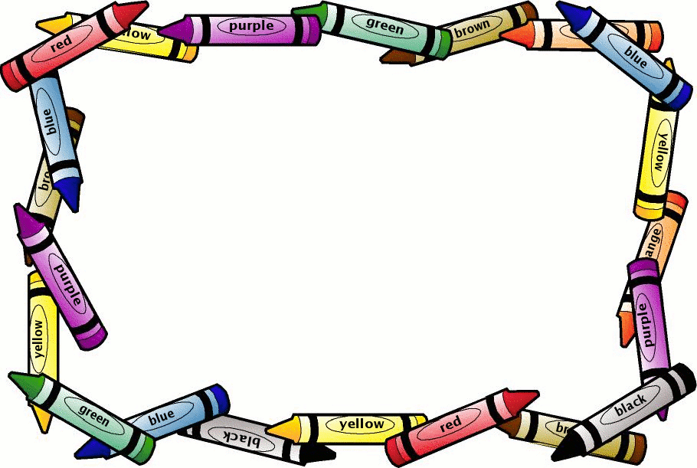
5th Grade Supply List
Highland Middle School

For Students to keep with them at all times all year:
- Pencil Zippered Pouch
- Pencils (Keep most pencils at home and have 3-5 sharpened in pencil pouches ready to use daily. Refill throughout the year, as necessary. Ticonderoga has the best quality.)
- Highlighters
- Sharpener
- Erasers
- Pens (Any color)

PAPER PRODUCTS & FOLDERS
- 3 Composition Notebooks (100 pages each)
- 1 Pocket Folders with Brads

ART SUPPLIES:
- 24 Pack Crayons
- 10 Pack Markers
- Bottle of liquid glue (No sticks, please)

6th Grade Supply List
Highland Middle School

For Language Classroom:
Pencils, Erasers, Red Pen, Glue, Scissors, Composition Notebook, Wide Ruled Paper, Highlighters

For Math Classroom:
Pencils, Erasers, Plastic Pocket Folder with Brads

For Science & Social Studies Classroom:
Pencils, Erasers, Composition Notebook

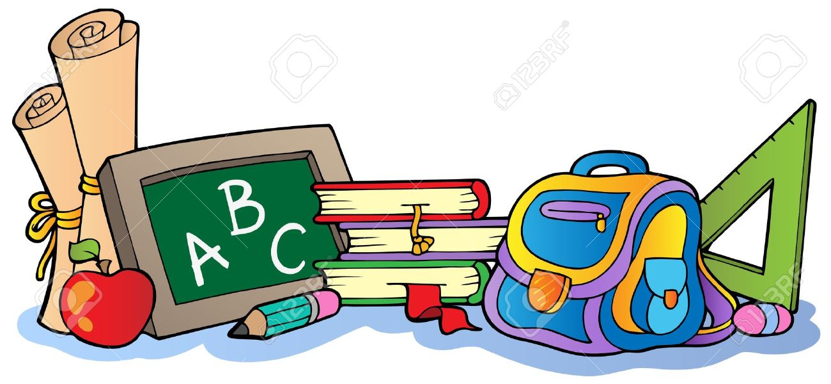

7th Grade Supply List
Highland Middle School

Science
Hand held pencil sharpener
#2 pencils

Math
Composition notebook--not spiral
bound
Loose Leaf paper
Highlighter
Large pink eraser
#2 pencils-NOT MECHANICAL
Red pen

Social Studies
1 plastic folder with pockets and
prongs
Pens & #2 pencils
Loose-leaf paper

Language Arts
composition notebook
loose leaf paper
One 3-prong pocket folder
#2 pencils
Highlighters
Black or blue pens

If you take Art Expo
Sketch Book of your Choice

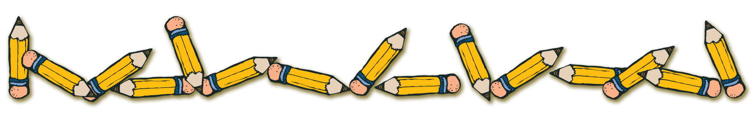
8th Grade Supply List
Highland Middle School

For Math Class:
Pencils, Red Pen, Highlighter, Composition Notebook (not spiral bound)
For English Class:
Plenty of Loose Leaf Paper or Notebook, pencils, your choice of folder to keep up with handouts
For Social Studies:
1” binder with tab dividers or folder with brads and pockets, pencils, colored pencils, loose-leaf ruled paper
For Science:
Composition Notebook or Spiral notebook, pencils or pens, glue sticks, your choice of folder to keep up with handouts
For Tech:
1” binder with tab dividers or folder with brads and pockets, Divider Tabs, Loose Leaf Ruled Paper, Pencils, Blue/Black pens

In Addition, for Art Expo or Adv Art Expo only:
Sketch Book of your Choice

