DISTANCE LEARNING RESOURCES
GRADES K-5 READING
Additional resources may be added to this document in the coming days.
PreK - 8  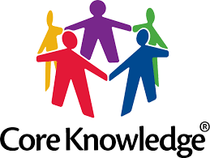  CORE KNOWLEDGE  https://www.coreknowledge.org/curriculum/download-curriculum/  The Core Knowledge Foundation provides open access to content-rich curriculum materials for preschool through grade 8, including the Core Knowledge Curriculum Series™. | K - 12  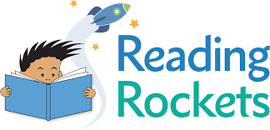  READING ROCKETS  https://www.readingrockets.org/books  Reading Topics A-Z  Children’s Books and Authors | K - 3  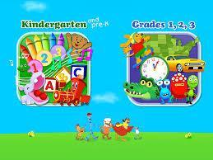  STARFALL  https://www.starfall.com/h/  Language Arts  Seasonal
PreK - 6  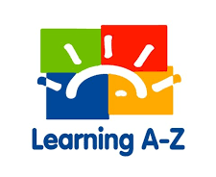  LEARNING A-Z  https://www.learninga-z.com/site/lp2/covid19?fbclid=IwAR3bw9AR4pW9wfHmfb5WiL6kRdEXIU4PiR9CXVTFWwacB4W3-PjkjN1KWek  Learning A-Z subscriptions give children full access to literacy resources from home, or any place with an internet connection. | Birth - 8  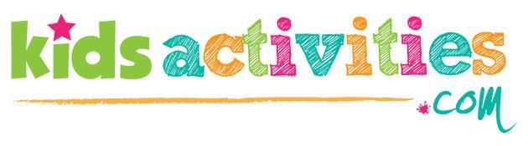  KIDS ACTIVITIES  https://kidsactivitiesblog.com/135609/list-of-education-companies-offering-free-subscriptions/?fbclid=IwAR0MoD_3cAB5HwcQ-RP7zVMAASkgLs6HZ2LXpiTNfieIujnN7sdcLrwry2M  List of education companies offering free subscriptions due to school closings | K - 12  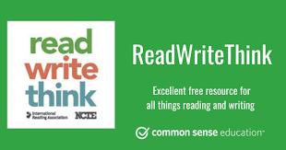  CORE KNOWLEDGE  http://www.readwritethink.org/parent-afterschool-resources/  Engaging ways to introduce your child to reading or to encourage your teen to write. Age-appropriate book suggestions and materials created by experts to be fun, educational, and easy to use outside of school.
Early Learners  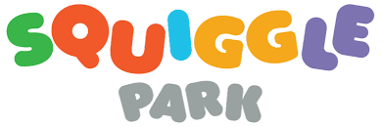  SQUIGGLE PARK  https://www.squigglepark.com/teachers/  A world filled with fun games for kids that is effective in building mastery of pre-reading skills through practice and play. Simple to use dashboards for teachers to track student progress and inform instruction. The games are designed to be played both in the classroom and at home, helping align the time children are playing to the reading outcomes they are expected to meet in their learning. | Read Alouds for Ages 4-7  STORYLINE ONLINE  https://www.storylineonline.net/  Storyline Online is available 24 hours a day for children, parents, caregivers and educators worldwide. Each book includes supplemental curriculum developed by a credentialed elementary educator, aiming to strengthen comprehension and verbal and written skills for English-language learners. | K - 2  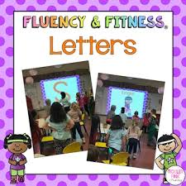  FLUENCY and FITNESS LETTERS  https://fluencyandfitness.com/reading-2/  Fluency and Fitness help students review essential K-2 reading topics while providing a moving break. Each video helps students review one skill and includes a variety of exercises.
K - 6  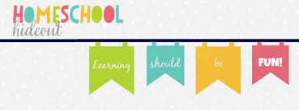  150+ EDUCATIONAL SHOWS ON NETFLIX  https://homeschoolhideout.com/educational-shows-on-netflix/?fbclid=IwAR0CGZwzFYJ5Sf7MRNyvf9c3IorhBxcxMQMUsTLXbfGSVFAFjZvK1J3zKAE  150+ Educational Shows on Netflix | EL K - 12  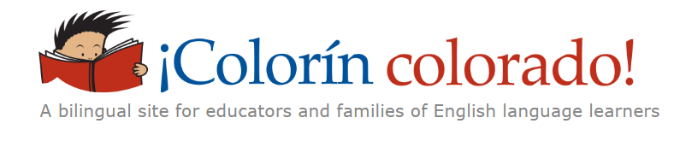  COLORIN COLORADO  https://www.colorincolorado.org/  Resources for educators and families of English learners. | 2 - 12 Readability  NEWSELA  https://newsela.com/  Teachers and students can access engaging articles in a variety of content and topic areas with the option to change the level of readability. Each article offers a check for understanding piece.
K - 5  VOOKS  https://www.vooks.com/teacher-appreciation?msclkid=411f3b2237d518cadec2654f299c7f0a&utm_source=bing&utm_medium=cpc&utm_campaign=USA%3A%20Vooks%20Branded%20Campaign&utm_term=vooks%20com&utm_content=Vooks%20com  “Vooks brings children's books to life with animated illustrations, read-a-long text and narrated story.”  -Vooks.com | All Ages  SWITCHBOARD  https://switchboardta.org/blog/a-round-up-of-multilingual-resources-on-covid-19/  A round-up of multilingual resources on COVID-19 | All Ages  VIRTUAL MUSEUM TOURS  https://www.parents.com/syndication/museums-with-virtual-tours/?utm_source=emailshare&utm_medium=email&utm_campaign=email-share-article&utm_content=20200314  Parents Magazine Article
K - 3  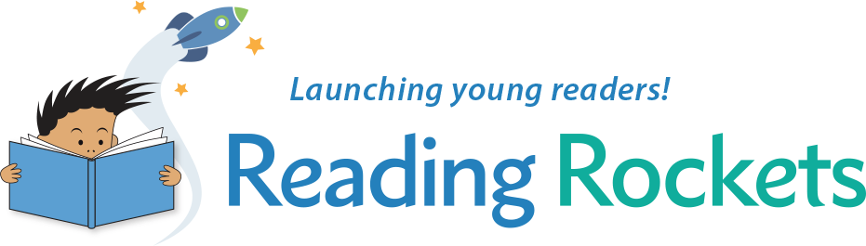  READING ROCKETS  https://www.readingrockets.org/article/read-aloud-daily-practical-ideas-parents  Read aloud practical ideas for parents | K - 12  WRITE SHOP  https://writeshop.com/10-ideas-for-creative-book-reports/  Book project ideas | EL K - 12  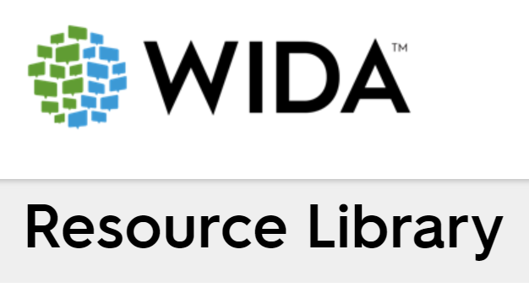  WIDA RESOURCES  https://wida.wisc.edu/resources  WIDA ELD Standards  Can Do Descriptors  Family Engagement  Academic Vocabulary Development
EL K - 12  ESL GALAXY  http://www.esl-galaxy.com/  ESL resources for teachers and students. Includes vocabulary and grammar exercises, ESL worksheets, etc. | EL K - 12  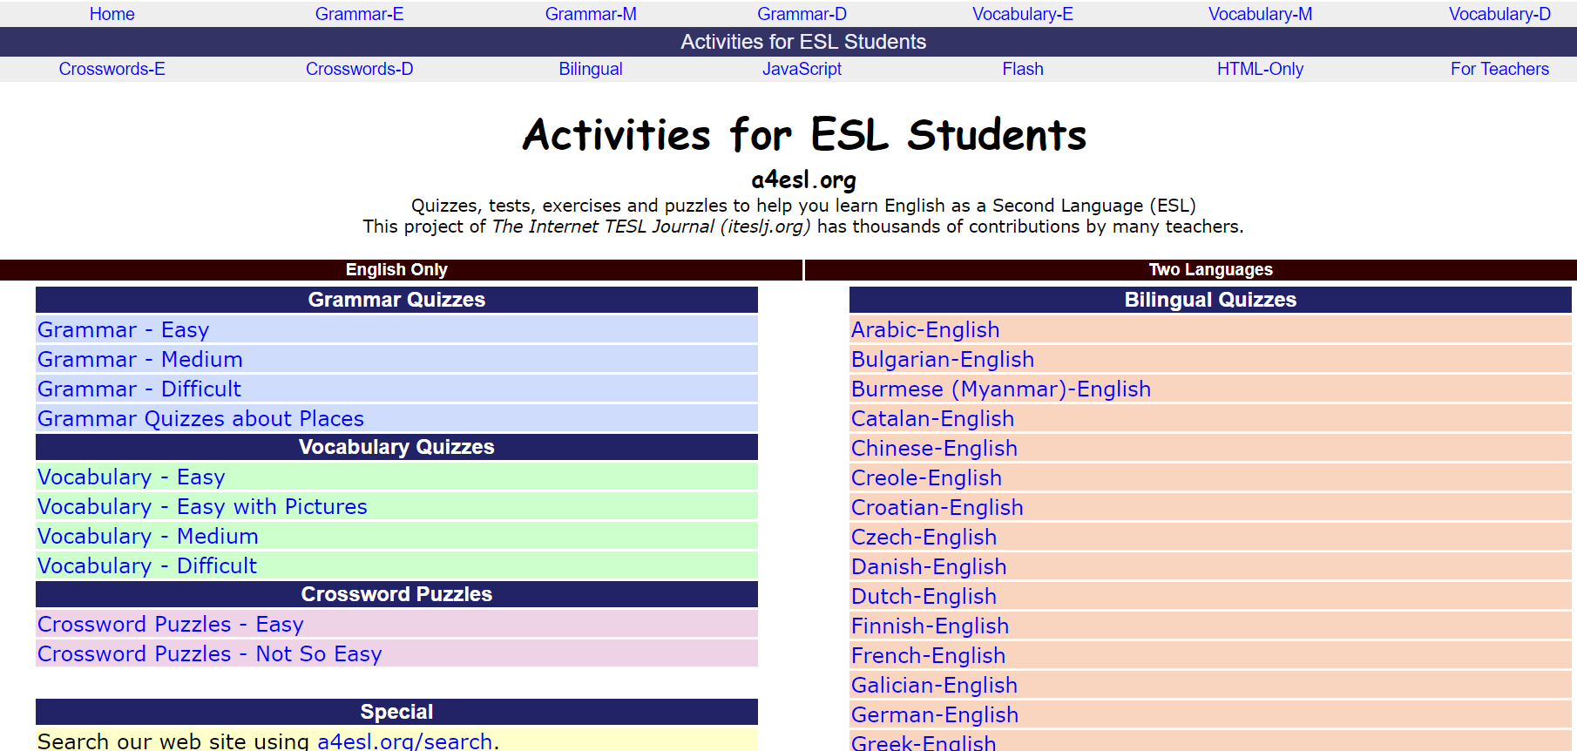  ACTIVITIES for ESL STUDENTS  http://a4esl.org/  Activities for EL students  Quizzes, tests, exercises, etc. (bilingual quizzes) | EL K - 12  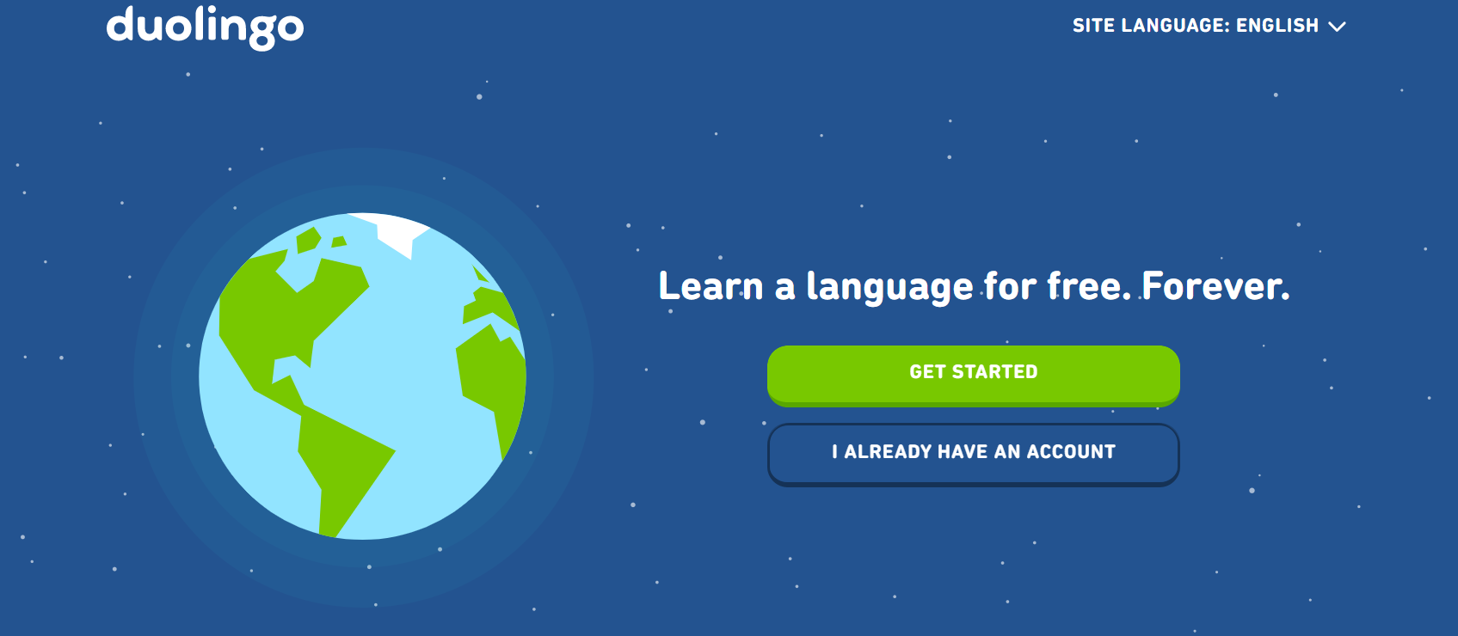  DUOLINGO  https://www.duolingo.com/  Free language learning, with app available
K - 2  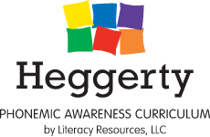  HEGGERTY  https://www.heggerty.org/  Phonological Awareness Curriculum  In response to COVID-19, they are offering free phonemic awareness support videos and lesson plans.  Family Instructional Videos  https://www.youtube.com/watch?v=lroKByqjBd0&feature=youtu.be | EL K - 12  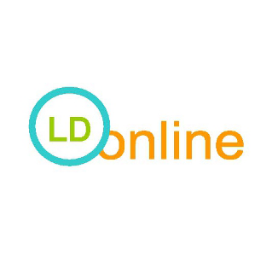  LEARNING DISABILITIES ONLINE  http://www.ldonline.org/article/English_Language_Learners_with_Special_Needs%3A_Effective_Instructional_Strategies  Effective Instructional Strategies for English Learners with special needs. | K - 5  SEUSSVILLE  https://www.seussville.com/  Read, play games, and hang out with Dr. Seuss and his friends
EL K - 12  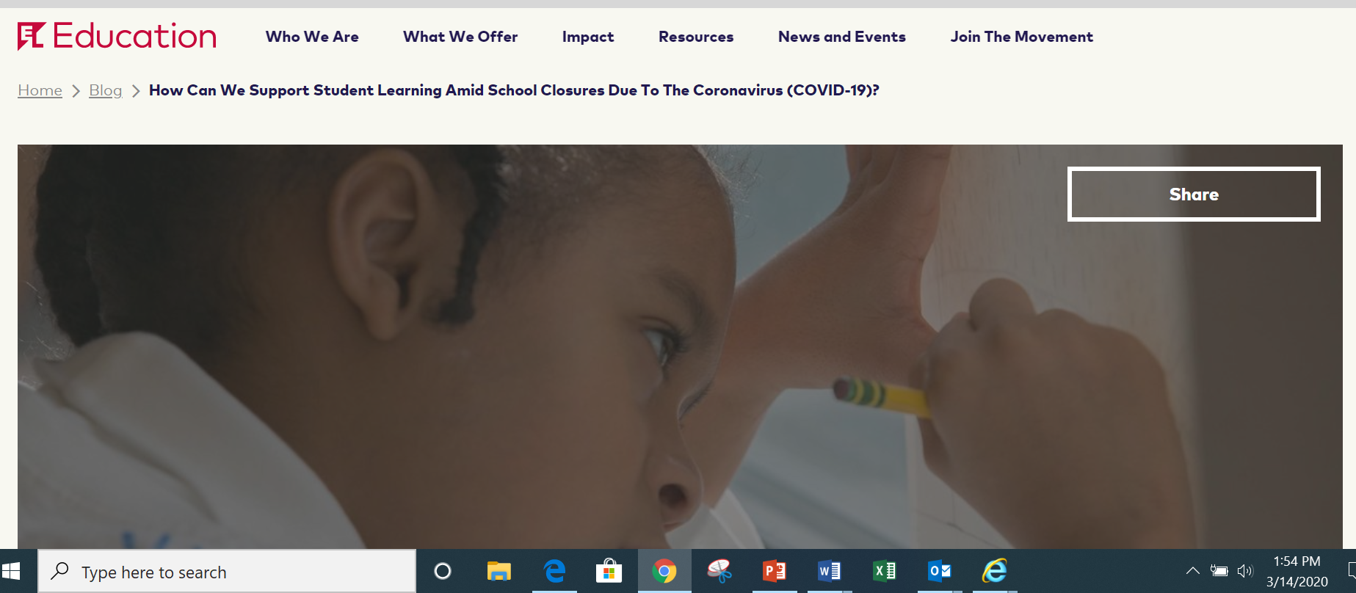  EL EDUCATION  https://eleducation.org/news/how-can-we-support-student-learning-amid-school-closures-due-to-the-coronavirus-covid-19  Multiple resources for educators to support student learning amid school closures due to COVID-19 | K - 12  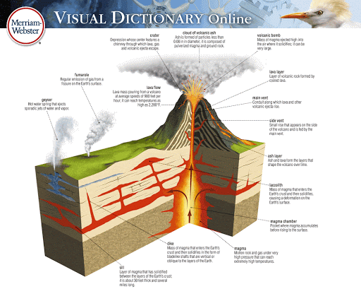  MERRIAM-WEBSTER  http://www.visualdictionaryonline.com/  Visual Dictionary | K - 5  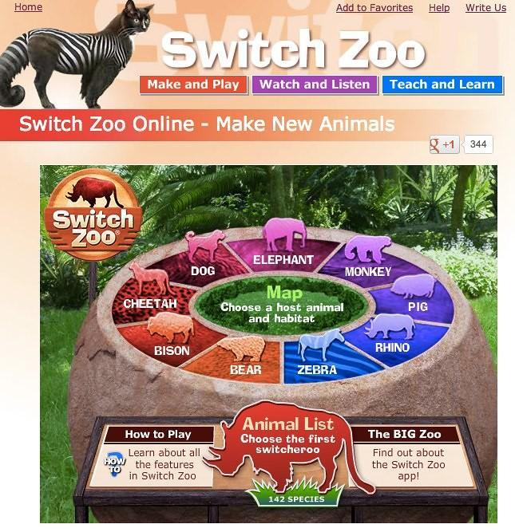  DUOLINGO  https://www.switchzoo.com/  Watch, listen and play games to learn all about amazing animals
K - 12  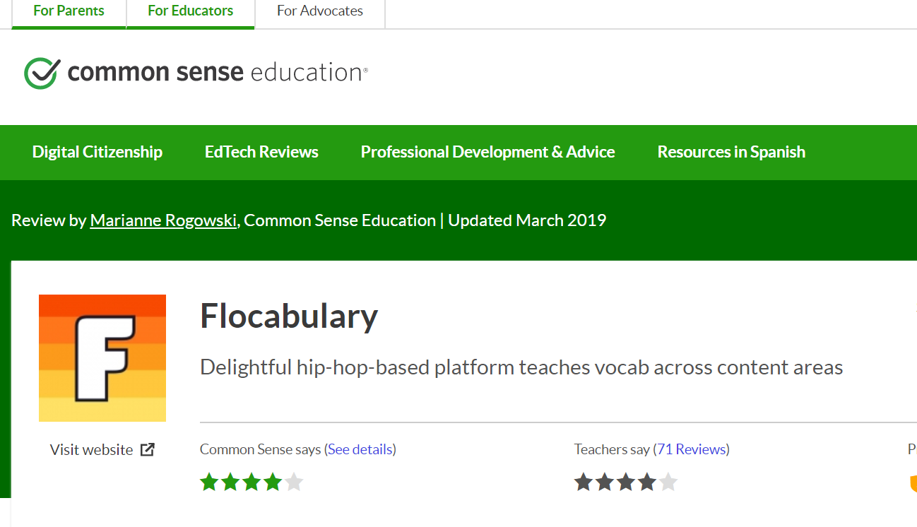  COMMON SENSE EDUCATION FLOCABULARY  https://www.commonsense.org/education/website/flocabulary  Hip-hop platform for vocabulary learning across content areas  -Especially helpful for ELs | PreK - 9  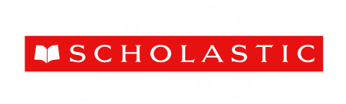  SCHOLASTIC  https://www.scholastic.com/teachers/teaching-tools/articles/resources/scholastic-learn-at-home--free-resources-for-school-closures.html#  Day-by-day projects to keep kids reading, thinking, and growing. | K - 8  NATIONAL GEOGRAPHIC KIDS  https://kids.nationalgeographic.com/  Learn all about geography and fascinating animals
PreK - 8  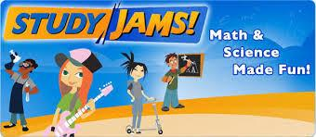  STUDY JAMS  http://studyjams.scholastic.com/studyjams/jams/math/multiplication-division/multiples.htm  Introduce and reinforce math and science topics with visuals (videos/slideshows). | K - 8  ABCYa!  https://www.abcya.com/  Practice math and reading skills while playing fun games! | K - 12  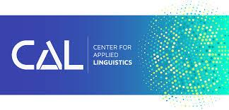  CENTER for APPLIED LINGUISTICS  http://www.cal.org/areas-of-impact/english-learners  CAL provides strategies and practical hands-on tools to help educators develop effective classroom activities.
K - 8  FUNBRAIN  https://www.funbrain.com/  Play games while practicing math and reading skills. | K - 5  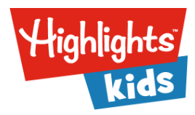  HIGHLIGHTS KIDS  https://www.highlightskids.com/  Read, play gas, and conduct cool science experiments! | Ages 4 - 12 (EL)  ENGLISH 4 KIDS  http://www.english-4kids.com/links.html  This website features tons of lessons, games, worksheets, and flashcards to review vocabulary, grammar, and spelling skills.
Ages 12 and Under (EL)  EPIC!  https://www.getepic.com/  Digital library for students (bilingual resources). | K - 12  SMITHSONIAN LEARNING LAB  https://learninglab.si.edu/?fbclid=IwAR0_hUo1rb-VmnVbTDA3oPkXoOQ1bujmaCOmDHIkxlPXqMoAtPQ4W42CiWY  The Smithsonian Learning Lab puts the treasures of the world's largest museum, education, and research complex within reach. The Lab is a free, interactive platform for discovering millions of authentic digital resources, creating content with online tools, and sharing in the Smithsonian's expansive community of knowledge and learning. | Grade 3  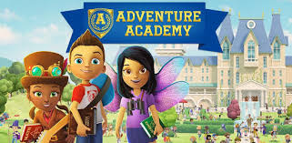  ADVENTURE ACADEMY  Link to Adventure Academy  Extensive curriculum to gain essential skills in reading, writing, and language development.
PreK - 5  EDUCATION.COM  https://www.education.com/games/ela/reading/  Reading practice with these interactive animated reading games. Whether your child is just beginning their reading journey or wants to take the leap to reading independently, these reading games offer challenges in everything from letter recognition to sight words to story ordering and reading comprehension. | PreK3 - 6  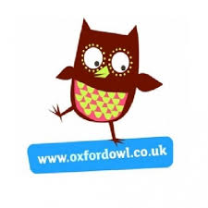  OXFORD OWL  https://www.oxfordowl.co.uk/for-home  Free resources to support learning at home: Advice and support for parents, educational activities and games, free eBook library for 3-11 year olds. | PreK - 1  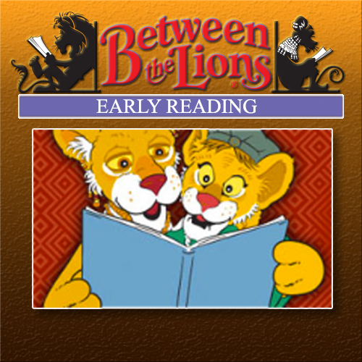  PBS BETWEEN THE LIONS  https://aptv.pbslearningmedia.org/collection/btl07-ex/#.Xm1dC6hKjIU  Segments selected from Between the Lions, the series that helps kids "Get Wild About Reading!" This special collection provides a set of early Reading/Language Arts resources, organized by early elementary and preschool literacy skills.
K - 6  WONDEROPOLIS  http://wonderopolis.org/  Welcome to Wonderopolis®, a place where natural curiosity and imagination lead to exploration and discovery in learners of all ages. Each day, we pose an intriguing question—the Wonder of the Day®—and explore it in a variety of ways. | 3 - 7  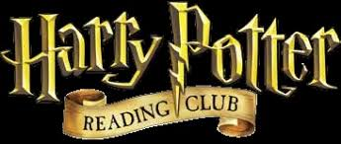  HARRY POTTER READING CLUB  http://hpread.scholastic.com/  Every month four Harry Potter activities are unveiled that students can use to engage in creative writing, art, or critical thinking. | K - 5  GONOODLE  https://family.gonoodle.com/activities/consonant-swag  GoNoodle helps teachers and parents get kids moving with short interactive activities.
2 - 8  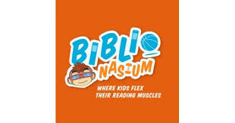  BIBLIONASIUM  https://www.biblionasium.com/#tab/content-popular-series  https://biblionasiumblog.files.wordpress.com/2019/01/Getting-Started-Parents.pdf  Safe, social reading community where kids can flex their reading muscles. | K - 5  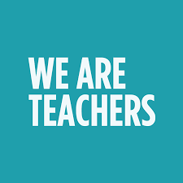  WE ARE TEACHERS  https://www.weareteachers.com/kinesthetic-reading-activities/  21 kinesthetic reading activities | K - 8  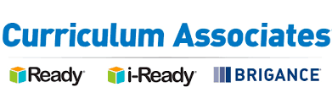  CURRICULUM ASSOCIATES  https://www.curriculumassociates.com/supporting-students-away-from-school  Printable at-home activity packs are designed to provide students with valuable self-directed exercises and practice during extended absences from school. Each pack is designed to reinforce key concepts for a given grade.
Ages 2 - 7  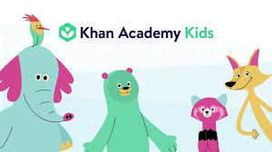  KHAN ACADEMY KIDS  https://learn.khanacademy.org/khan-academy-kids/  Khan Academy Kids is a free, award-winning online education program for children ages 2 - 7. Our mobile app was designed by child development experts at Stanford University and engages kids in core subjects like early literacy, reading, writing, language, and math, while encouraging creativity and building social-emotional skills. It is age-appropriate, personalized based on where your child is at, and engaging.  More information on how to use Khan Academy Kids for remote learning: https://khankids.zendesk.com/hc/en-us/articles/360040315632-How-to-use-Khan-Academy-Kids-for-remote-learning | PreK - 5  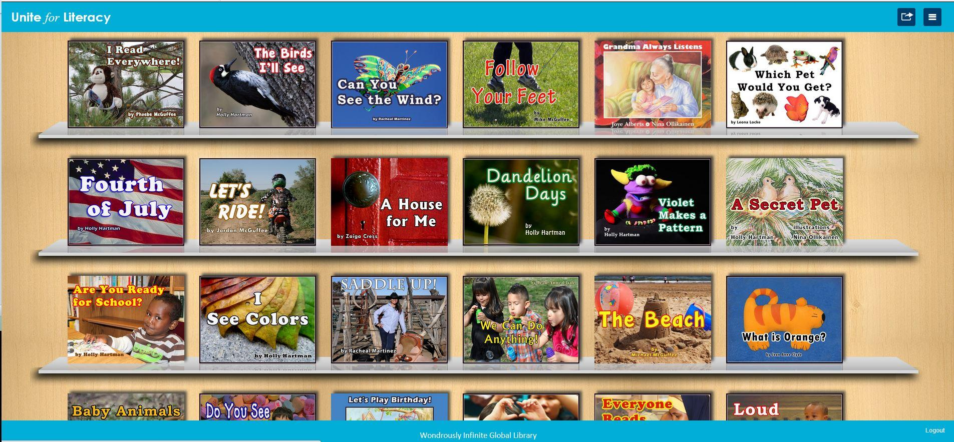  UNITE for LITERACY  https://www.uniteforliteracy.com/  At Unite for Literacy, we picture a world where all children have access to an abundance of books that celebrate their languages and cultures and cultivate a lifelong love of reading. Our projects build home libraries and support families to develop a daily habit of reading, both of which are key factors in growing lifelong readers. | K - 6  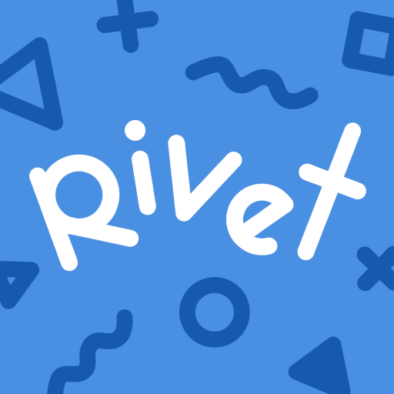  UNITE for LITERACY  https://rivet.area120.com/  Reading practice has never been easier with Rivet, a reading app with over 3,500 FREE leveled books for kids
K - 12  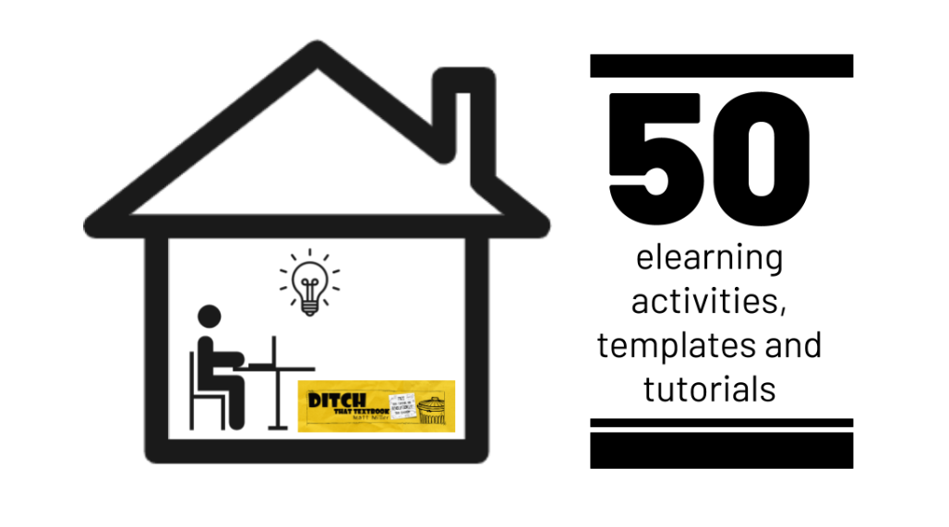  UNITE for LITERACY  https://ditchthattextbook.com/elearning-activities/  50 elearning activities, templates and tutorials.They'll help you create elearning activities that lend themselves to powerful learning when students are away from school. | K - 8  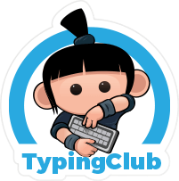  TYPING CLUB  https://www.typingclub.com/  TypingClub is the most effective way to learn how to type. It is web based, and highly effective. TypingClub is (and will always be) free for both individuals and schools. | K  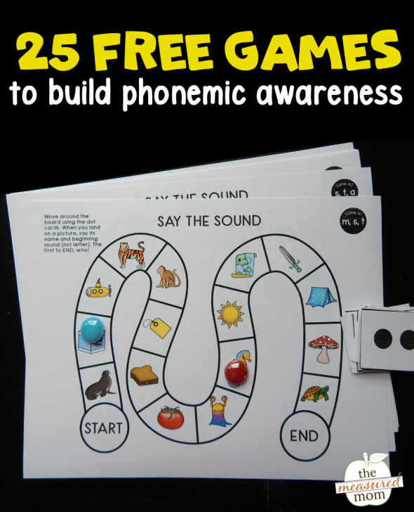  PHONEMIC AWARENESS GAME  https://www.themeasuredmom.com/phonemic-awareness-games/  Your young learners will love this set of simple board games that build phonemic awareness!
K - 6

INTO the BOOK

https://reading.ecb.org/

Into the Book includes:
- a student website featuring interactive reading comprehension activities.
- a teacher website featuring video clips, posters, teacher guides, lesson plans and a matrix linking each activity with Common Core State Standards in English Language Arts.
- a professional learning website featuring resources from Behind the Lesson, an unscripted professional learning series, as well as information on how to use Into the Book to meet Educator Effectiveness System and Professional Development Plan requirements.
- nine 15-minute classroom videos teaching children how to be strategic readers.
- the Behind the Lesson video series including nine 10-minute professional development videos that model effective ways of teaching the learning strategies.

K - 2  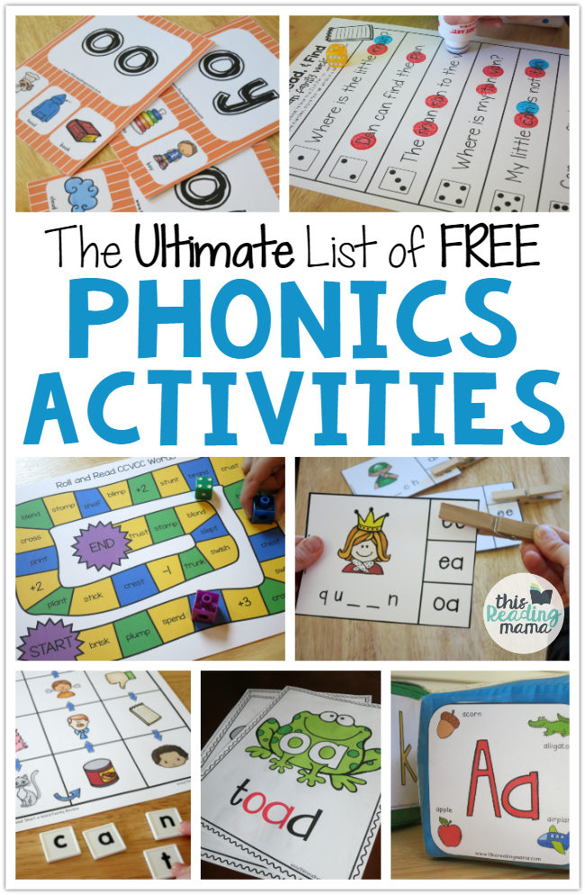  FREE PHONICS ACTIVITIES  https://thisreadingmama.com/ultimate-list-free-phonics-activities/  The free phonics activities & printables organized by skill. | K - 5  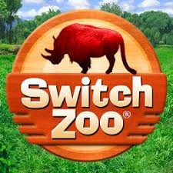  SWITCH ZOO  https://switchzoo.com/  Watch, listen and play games to learn about amazing animals. | K - 3  BRAINPOP JR.  https://jr.brainpop.com/  Gently encourages young learners to ask questions and form their own ideas.
PreK - 6  THIS READING MAMA BLOG  https://thisreadingmama.com/new-here/  Reading resources with free printables. | K - 8  BRAINPOP  https://www.brainpop.com/  BrainPOP makes rigorous standards accessible and engaging for all through an ever-growing range of lessons across the curriculum designed to empower students to build knowledge and skills for life. | EL K - 8  BRAINPOP ELL  https://ell.brainpop.com/  Proficiency-based English language learning program appropriate for all ages
EL K - 12  ACHIEVE 3000  https://www.achieve3000.com/  Provides differentiated grade level lessons in social studies and science. It scaffolds lessons to support ELs in language development, phonics, and fluency. It also provides a framework for skills progress. | EL K - 12  MY OWN  https://www.myon.com/index.html  Some LEAs are using this with their ELs. The can get books at their reading level and they can also listen to the books to aid in language development and fluency | EL K - 6  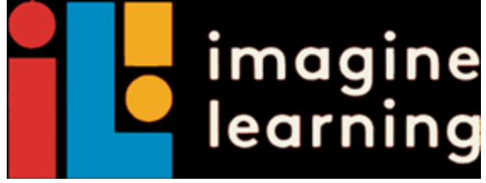  IMAGINE LEARNING  https://www.imaginelearning.com/  Imagine Language & Literacy is an adaptive learning solution that accelerates reading and language proficiency for students in grades PreK–6. Designed to supplement core literacy instruction, Imagine Language & Literacy provides instruction and practice in all four domains of literacy—reading, writing, listening, and speaking.
EL K - 6  RAZ-KIDS  https://www.raz-kids.com/?_ga=2.98142943.1167074233.1584289666-1264447592.1584289666  Personalized digital reading practice from differentiated books at 29 levels of difficulty. Students can record themselves reading. Includes Spanish books, songs, nursery rhymes and poetry. | EL K - 6  RAZ-PLUS  https://www.raz-plus.com/?_ga=2.68389457.1167074233.1584289666-1264447592.1584289666  Access thousands of resources, including leveled books, skills practice, ELL, Spanish, and more, all mapped to standards. Extend your lessons and deepen meaning with supporting digital activities, assessments, and easy-to-use lesson plans. | TIME MAGAZINE for KIDS  https://time.com/tfk-free/?fbclid=IwAR0LlKtp8D3nekejht47kZtyVx_rD2TxwzI140Jn71idBXiRxcm-kgmTbbY  TIME FOR KIDS DIGITAL LIBRARY FREE FOR THE REST OF THE SCHOOL YEAR. Free access to a library of four grade-specific digital editions of TIME for Kids and Your $ financial literacy magazine.
EL K - 12  AUDIBLE  https://www.audible.com/ep/freetrial?source_code=MSNGBWS0805169033&device=d&cvosrc=ppc.bing.audible&cvo_campaign=279209967&cvo_crid=77172076752913&Matchtype=e&msclkid=d515bde8e7be1a816430e386bd19232a&gclid=CK7p0Pr1nOgCFdRHgQod8OQAjQ&gclsrc=ds  online audible digital library | K - 5  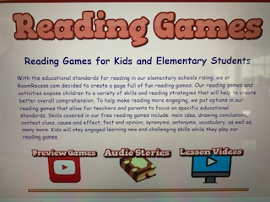READING ROOM RECESS  www.roomrecess.com  Audio stories, lesson videos, and games for grades K-6 | PreK - 6  READING IS FOR EVERYONE!  https://www.capstonepub.com/sites/reading_is_for_everyone/  A plethora of resources for you to access anytime, anywhere. These resources include things like:  Printables and educational activities for kids (STEAM, Makerspace, Drawing, Reading and more!)  Free Access to PebbleGo and Capstone Interactive eBooks  Resources for parents including Questions of the Day and Adventures Activities
TEACHER CREATED MATERIALS  https://www.teachercreatedmaterials.com/teachers/free-home-learning/  Over 500 free teacher created resources | TVA STEMready  http://www.tvastem.com/high-school-lessons/  Provides K-12 lessons for teachers in every discipline of science about STEM topics. | EL Ages 12 and Under  EPIC  https://www.getepic.com/  online audible digital library
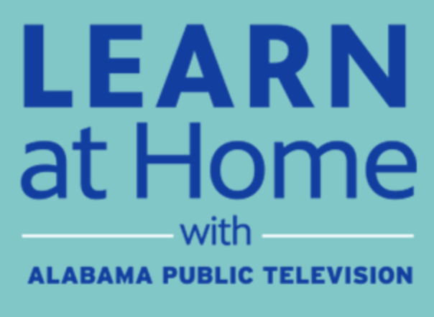  APT EDUCATION  https://aptv.org/education/  With Alabama school districts closed due to concerns over COVID-19, Alabama Public Television is here to support your education needs. While students are away from the classroom, we are broadcasting and sharing online educational resources and materials that support distance learning, including our award-winning Learning Adventures! In addition, the education broadcast is streaming each weekday from that site, providing an additional point of access to the education content. | STEM TEACHING TOOLS  https://aptv.pbslearningmedia.org/  APT and PBS have curated FREE, standards-aligned videos, interactives, lesson plans, and more for teachers like you. | EVERFI  https://everfi.com/k-12/parent-remote-learning/ (parent portal)  100+ game-based, interactive lessons Self-paced digital lessons equip your child with skills for life: character development, mental wellness, financial readiness, career exploration  https://everfi.com/k-12/teacher-remote-learning/ (teacher portal)
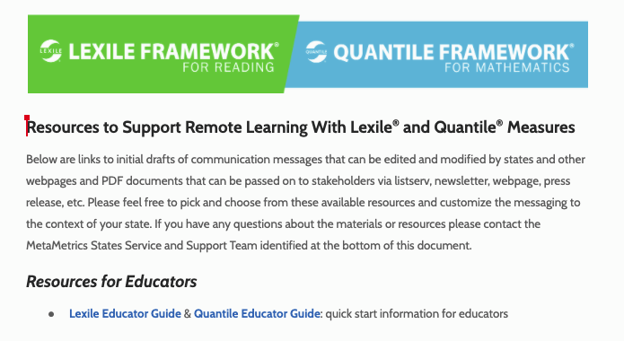

LEXILE & QUARTILE FRAMEWORKS INDEX PAGE

https://docs.google.com/document/d/1q9wcJC-winFbEajDnVQLJ-ynLIJpN_aAv6J10grUXc0/edit#heading=h.h8kb1gfplzyu

Links to initial drafts of communication messages that can be edited and modified by states and other web pages and PDF documents that can be passed on to stakeholders via listserv, newsletter, webpage, press release, etc.

