DISTANCE LEARNING RESOURCES
GRADES K-5 ELA
Additional resources may be added to this document in the coming days.
KHAN ACADEMY  https://www.khanacademy.org/  Khan Academy is on a mission to give a free, world-class education to anyone, anywhere. Their personalized learning resources are available for all ages. Video learning segments are followed by practice activities. | LEARN ZILLION  https://illuminations.nctm.org/  Cloud-based curriculum for K–12 students, focusing on supporting both traditional and blended classrooms. | edcite  https://www.edcite.com/  Teachers can help students prepare for ACAP Summative Assessment with digitally enhanced questions and multi-select questions. Teachers can utilize the question bank on the site for any subject matter or build their own questions.
COMMONLIT  https://www.commonlit.org/  CommonLit is a website that promotes annotation, text dependent writing, and discussion. It also offers paired reading teacher and parent resources. | COMMON SENSE EDUCATION  https://www.commonsense.org/education/search?contentType=flows  Common Sense Education provides educators and students with resources to harness the power of technology for learning and life. It provides excellent resources, lesson plans, and different assessment tools and creative assignments. | THE NEW YORK TIMES  https://www.nytimes.com/section/learning  The New York Times provides articles and questions, writing prompts, and lesson plans in all areas that coordinate with The New York Times Learning Network for Teens.
READ THINK WRITE  http://www.readwritethink.org/classroom-resources/  Read Write Think is sponsored by the National Council of Teachers of English and provides educators with access to the highest quality practices in reading and language arts instruction. | SHARE MY LESSON  https://sharemylesson.com/  Share my Lesson has over 420,000 free lesson plans and activities curated collections for early childhood through high school. | TIME MAGAZINE for KIDS  https://time.com/tfk-free/?fbclid=IwAR0LlKtp8D3nekejht47kZtyVx_rD2TxwzI140Jn71idBXiRxcm-kgmTbbY  TIME FOR KIDS DIGITAL LIBRARY FREE FOR THE REST OF THE SCHOOL YEAR. Free access to a library of four grade-specific digital editions of TIME for Kids and Your $ financial literacy magazine.
TEACHER CREATED MATERIALS  https://www.teachercreatedmaterials.com/teachers/free-home-learning/  Over 500 free teacher created resources | 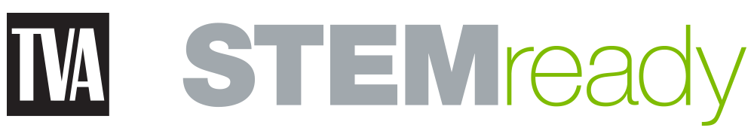  TVA STEMready  http://www.tvastem.com/high-school-lessons/  Provides K-12 lessons for teachers in every discipline of science about STEM topics. | TEACHER VISION  https://www.teachervision.com  Teacher Vision has over one million educators that have created teaching resources designed to help students succeed.
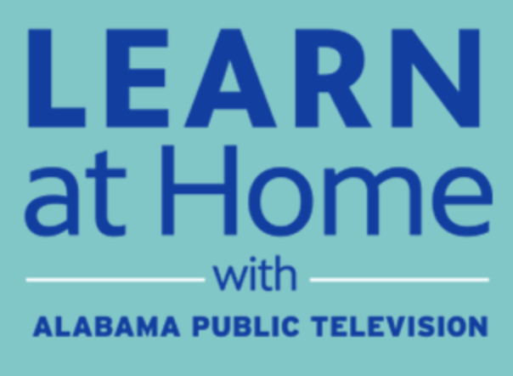  APT EDUCATION  https://aptv.org/education/  With Alabama school districts closed due to concerns over COVID-19, Alabama Public Television is here to support your education needs. While students are away from the classroom, we are broadcasting and sharing online educational resources and materials that support distance learning, including our award-winning Learning Adventures! In addition, the education broadcast is streaming each weekday from that site, providing an additional point of access to the education content. | STEM TEACHING TOOLS  https://aptv.pbslearningmedia.org/  APT and PBS have curated FREE, standards-aligned videos, interactives, lesson plans, and more for teachers like you. | EVERFI  https://everfi.com/k-12/parent-remote-learning/ (parent portal)  100+ game-based, interactive lessons Self-paced digital lessons equip your child with skills for life: character development, mental wellness, financial readiness, career exploration  https://everfi.com/k-12/teacher-remote-learning/ (teacher portal)
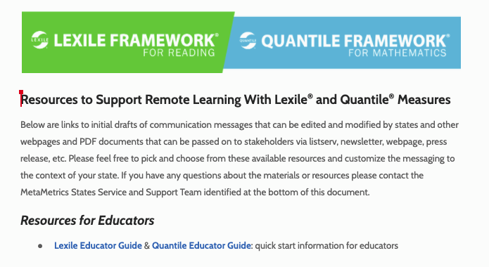

LEXILE & QUARTILE FRAMEWORKS INDEX PAGE

https://docs.google.com/document/d/1q9wcJC-winFbEajDnVQLJ-ynLIJpN_aAv6J10grUXc0/edit#heading=h.h8kb1gfplzyu

Links to initial drafts of communication messages that can be edited and modified by states and other web pages and PDF documents that can be passed on to stakeholders via listserv, newsletter, webpage, press release, etc.

