DISTANCE LEARNING RESOURCES
GRADES K-2 SCIENCE
Additional resources will be added to this document in the coming days.
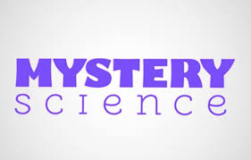  MYSTERY SCIENCE  https://mysteryscience.com/school-closure-planning  Free, easy science for remote learning. Anyone can use free of charge; no login needed. | EDUCATION.COM  Education.com’s K Resources  Printable Worksheets, Online Games, Guided Lessons, and MORE | GENERATIONGENIUS  GenerationGenius Website  Next Generation Science Videos for K-5.
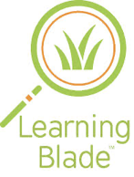  LEARNING BLADE  http://www.learningblade.com/AL  Learning Blade sends students on engaging missions that both interest and excite them. Within each mission you will find a wide variety of lessons, each one tied back to a career, tool or technology of a STEM related field. | KATE MESSNER  https://www.katemessner.com/  Read, wonder, and learn! Favorite authors and illustrators share resources for learning anywhere. | 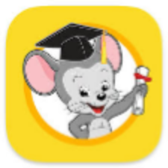  ABCmouse  ABCmouse.com  One month free trial: reading, math, science, art, and colors
edcite  https://www.edcite.com/  Teachers can help students prepare for ACAP Summative Assessment with digitally enhanced questions and multi-select questions. Teachers can utilize the question bank on the site for any subject matter or build their own questions. | USA TODAY  Link to Article  13 things to keep kids entertained | 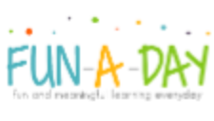  FUN-A-DAY  https://fun-a-day.com/14-fun-engineering-activities-for-kids/  Fun and meaningful learning. Everyday engineering activities for kids.
BIG DIY  https://bigdiyideas.com/35-fun-diy-engineering-projects-kids/  35 Fun DIY Engineering Projects for Kids | SWITCHEROO ZOO  https://switchzoo.com/  Watch, listen and play games to learn about amazing animals! | QUIZLET  https://quizlet.com/  Students can create study flashcards, play learning games, practice skills, collaborate with other students, and more.
LEARN ZILLION  https://illuminations.nctm.org/  Cloud-based curriculum for K–12 students, focusing on supporting both traditional and blended classrooms. | KHAN ACADEMY  https://www.khanacademy.org/  Khan Academy is on a mission to give a free, world-class education to anyone, anywhere. Their personalized learning resources are available for all ages. Video learning segments are followed by practice activities. | 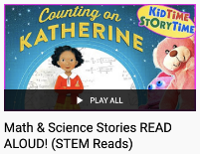  STEM READS  https://www.youtube.com/playlist?list=PL3gBRxwlIAz1f_vok6I4q7qiOE6MzD6vS  Math & Science Stories Read Aloud!
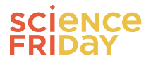  SCIENCE FRIDAY  https://www.sciencefriday.com/educate/  Science Friday partners with educators and scientists to create free STEM activities, lessons, and resources for all learners. | TEACHER CREATED MATERIALS  https://www.teachercreatedmaterials.com/teachers/free-home-learning/  Over 500 free teacher created resources | CADRE  http://cadrek12.org/  PreK-12 education researchers offer online curriculum, modules, simulations, apps and general resources to support virtual student learning.
NATIONAL GEOGRAPHIC  https://www.nationalgeographic.org/education/classroom-resources/learn-at-home/  A collection of activities for educators and parents to implement with K–12 learners. | TVA STEMready  http://www.tvastem.com/high-school-lessons/  Provides K-12 lessons for teachers in every discipline of science about STEM topics. | 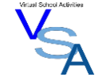  VIRTUAL SCHOOL ACTIVITIES  https://virtualschoolactivities.com/  A collection of sites to live webcams, virtual tours/trips, and other miscellaneous fun educational sites.
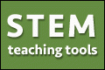  STEM TEACHING TOOLS  http://stemteachingtools.org/news/2020/guidance-for-supporting-science-learning-during-covid-19  Supporting Students' Science Learning in the Era of COVID-19 (available in five different languages) | EVERFI  https://everfi.com/k-12/parent-remote-learning/ (parent portal)  100+ game-based, interactive lessons Self-paced digital lessons equip your child with skills for life: character development, mental wellness, financial readiness, career exploration  https://everfi.com/k-12/teacher-remote-learning/ (teacher portal) | 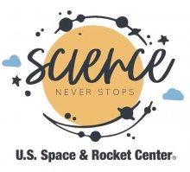  SCIENCE NEVER STOPS  https://www.rocketcenter.com/scienceneverstops  Science Never Stops, STEAM videos exploring museum artifacts, hands-on science, live astronomy demonstrations and so much more!
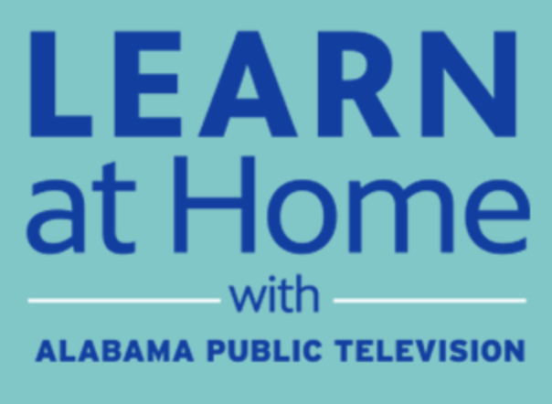

PBS Education

https://apt2.org/education/

APT and PBS have integrated the broadcast schedule and the digital content on that site and in addition, the education broadcast is streaming each weekday from that site, providing an additional point of access to the education content.

