DISTANCE LEARNING RESOURCES
GRADES K-2 MATH
Additional resources will be added to this document in the coming days.
CORBETTMATHS  https://corbettmaths.com/  This resource from England provides math videos, math practice questions, and worksheets with answers. | MOBYMAX  https://www.mobymax.com/  Three-pronged approach features personalized learning, pinpoint assessments, and interactive classroom. | 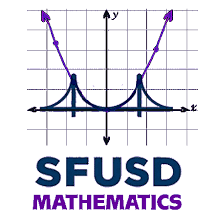  SFUSD MATHEMATICS  Elementary Math School Closure Lessons  https://docs.google.com/document/d/1dZYk76pzn28LaYWWtbZGTN3WwFvPXRIEuViR8LpiWhQ/mobilebasic  Ready to print lessons for K-5 available in both English and Spanish
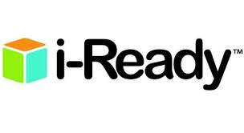  i-READY  https://www.curriculumassociates.com/supporting-students-away-from-school?utm_source=VanityURL_CAI-562381d&utm_medium=WordofMouth_Multi-use&utm_content=athome&utm_campaign=vanity  Ready to print lessons for K-5 available in both reading and math | 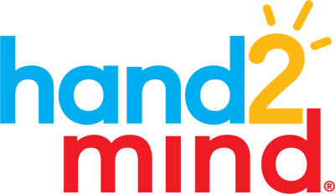  HAND 2 MIND  https://www.hand2mind.com/resources/lessons  Ready to print lessons and simple center activities for K-5 | 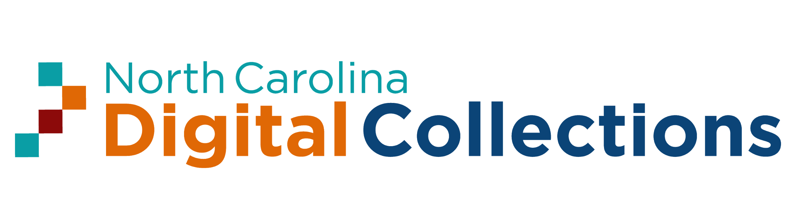  NORTH CAROLINA DIGITAL COLLECTIONS FORMATIVE ASSESSMENT and INSTRUCTIONAL TASKS  https://digital.ncdcr.gov/digital/collection/p16062coll9/id/28131  The North Carolina Department of Public Instruction is committed to continued development of quality teaching and on-going classroom assessment as essential preparation for the students to master rigorous standards as defined by the NC Standard Course of Study: Common Core State Standards and Essential Standards.
edcite  https://www.edcite.com/  Teachers can help students prepare for ACAP Summative Assessment with digitally enhanced questions and multi-select questions. Teachers can utilize the question bank on the site for any subject matter or build their own questions. | ILLUMINATIONS  https://illuminations.nctm.org/Default.aspx  This site, from the National Council of Teachers of Mathematics (NCTM), features complete lesson plans, mobile games for students, interactive activities, and brain teasers. | ILLUSTRATIVE MATHEMATICS  https://www.illustrativemathematics.org/  High-quality educational resources for teachers and students. Excellent math tasks, videos, lesson plans, and problem-based curriculum modules.
PRODIGY  https://www.prodigygame.com/  Math games that tackle more than 1,200 crucial math skills in a fun and engaging way. | 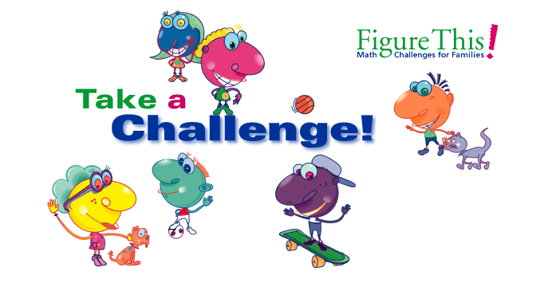  FIGURE THIS!  https://figurethis.nctm.org/index.html  Figure This! is a site designed to encourage families to practice math together. It includes fun and engaging math games and high-quality challenges. It even offers challenges in Spanish. | QUIZLET  https://quizlet.com/  Students can create study flashcards, play learning games, practice skills, collaborate with other students, and more.
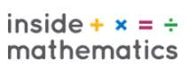  INSIDE MATHEMATICS  https://www.insidemathematics.org/performance-assessment-tasks  These tasks are grade-level formative performance assessment tasks with accompanying scoring rubrics and discussion of student work samples. They are aligned to the Common Core State Standards for Mathematics. You may download and use these tasks for professional development purposes without modifying the tasks. | 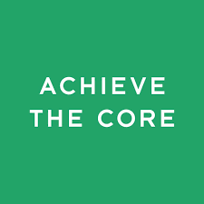  ACHIEVE THE CORE  https://achievethecore.org/  This site offers standards aligned resources, lessons, and task-based on math standards that illustrate rigor, coherence, and focus at each grade level. | NZ MATHS  https://nzmaths.co.nz/  Nzmaths.com includes problem solving and numeracy activities by content areas to support teacher's planning for math instruction.
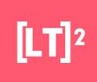  LEARNING TRAJECTORIES  https://www.learningtrajectories.org/  A web-based tool for teachers and students that includes activities that support math development in grade K-3. | 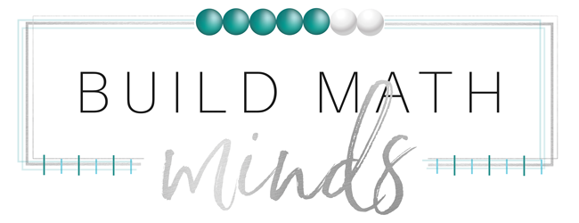  BUILD MATH MINDS  https://buildmathminds.com/freebies/  This site has free resources available for educators to use to develop numeral fluency and through conceptual learning activities. The site also offers online classes for teachers, lesson, and videos on development of math instruction. | 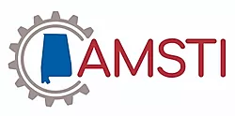  AMSTI UPDATE  https://www.smore.com/qt413  Tutorial for teachers regarding making lessons using hyperdocs and posting them on Google classroom.
LEARN ZILLION  https://learnzillion.com/p/  Cloud-based curriculum for K–12 students, focusing on supporting both traditional and blended classrooms. | KHAN ACADEMY  https://www.khanacademy.org/  Khan Academy is on a mission to give a free, world-class education to anyone, anywhere. Their personalized learning resources are available for all ages. Video learning segments are followed by practice activities. | ASSISTMENTS  https://new.assistments.org/content  Create assignments using mathematics problem sets, Pre-built assignments to demonstrate skill mastery, Skill-based practice problem sets
VIRTUAL MANIPULATIVES  https://www.didax.com/math/virtual-manipulatives.html  Our Virtual Manipulatives are a great way to enhance at-home learning. Simply drag the manipulatives into position to see math concepts come alive! | 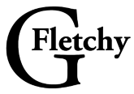  GFetchy  https://gfletchy.com/  Graham Fletcher (GFletchy). Graham Fletcher's site has a plethora of resources centered around the conceptual teaching of elementary mathematics. His site includes 3-Act Tasks, Fresh Ideas, Captured Talks/Podcasts, and a Blog. Of particular interest are his progressions videos that give a brief and yet detailed explanation of the K-5 progressions for Early Number and Counting, Addition and Subtraction, Multiplication, Division, and Fractions. This site can serve the dual purposes of providing sample problems and tasks and also to provide teachers with professional learning. The progression videos could be utilized during online PLCs and math meetings. | 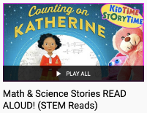  STEM READS  https://www.youtube.com/playlist?list=PL3gBRxwlIAz1f_vok6I4q7qiOE6MzD6vS  Math & Science Stories Read Aloud!
GREG TANG MATH  https://gregtangmath.com/  Free resources and math games. | 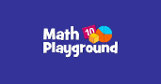  MATH PLAYGROUND  https://www.mathplayground.com/math-games.html  A variety of mathematics games. | TEACHER CREATED MATERIALS  https://www.teachercreatedmaterials.com/teachers/free-home-learning/  Over 500 free teacher created resources
TVA STEMready  http://www.tvastem.com/high-school-lessons/  Provides K-12 lessons for teachers in every discipline of science about STEM topics. | HAND2MIND  https://www.hand2mindathome.com/  Daily Lessons & Activities for K–5 Students, which will offer a series of free daily lessons and activities created and delivered by teachers. | 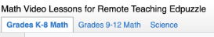  EDPUZZLE  https://docs.google.com/spreadsheets/d/1LVzgd5M-9nmys7pMRNCVPoIWX4-BrhpWs6LozRuo9CI/htmlview#  Spreadsheet of math and science video lessons for remote learning, created using EdPuzzle, organized by grade levels, topics, CCSS, etc., also contains link to YouTube videos.
OPEN MIDDLE  https://www.openmiddle.com/  Open middle problems generally require a higher Depth of Knowledge than most problems that assess procedural and conceptual understanding. They support the Common Core State Standards and provide students with opportunities for discussing their thinking. | ST MATH  https://www.stmath.com/coronavirus  At MIND Research Institute, our mission is to ensure that all students are mathematically equipped to solve the world’s most challenging problems. With schools across the country temporarily closing, we're providing resources and no-cost access to ST Math so the learning can keep on happening at home. | ORIGO  https://www.origoeducation.com/athome/  ORIGO Education has developed a sequence of weekly math activities for grades K-5, designed for implementation outside of school by parents, caregivers and/or tutors.  There are 2 weeks worth of lessons, activities and games currently available. New lessons and activities will be released each Friday.
HAPPY NUMBERS  https://happynumbers.com/  To prepare today's elementary students for the jobs of tomorrow, we first need to prepare them for high school and college.  This is why implementing quality resources and instruction in grades PK—5 is so critical. | EVERFI  https://everfi.com/k-12/parent-remote-learning/ (parent portal)  100+ game-based, interactive lessons Self-paced digital lessons equip your child with skills for life: character development, mental wellness, financial readiness, career exploration  https://everfi.com/k-12/teacher-remote-learning/ (teacher portal) | 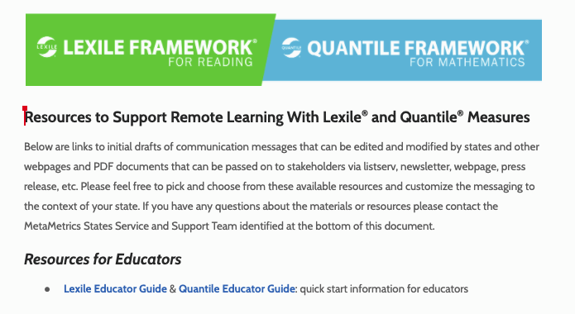  LEXILE & QUARTILE FRAMEWORKS INDEX PAGE  https://docs.google.com/document/d/1q9wcJC-winFbEajDnVQLJ-ynLIJpN_aAv6J10grUXc0/edit#heading=h.h8kb1gfplzyu  Links to initial drafts of communication messages that can be edited and modified by states and other web pages and PDF documents that can be passed on to stakeholders via listserv, newsletter, webpage, press release, etc.
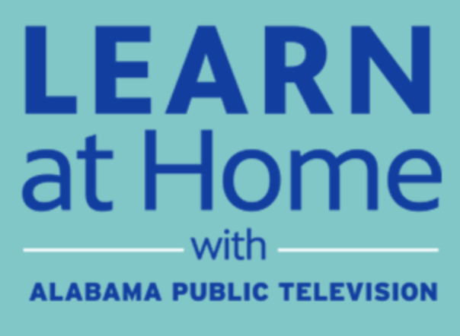  PBS Education  https://apt2.org/education/  APT and PBS have integrated the broadcast schedule and the digital content on that site and in addition, the education broadcast is streaming each weekday from that site, providing an additional point of access to the education content. | INVESTIGATIONS  https://investigations.terc.edu/at-home-resources/  Watch this space for an evolving set of resources to support teachers, educators, and families during school closures. These will include digital assets, math activities families can do at home, and ideas for supporting students as they work on math problems.

