REMOTE LEARNING RESOURCES
GRADES 6-8 PE and HEALTH
Additional resources may be added to this document in the coming days.
KHAN ACADEMY  https://www.khanacademy.org/  Khan Academy is on a mission to give a free, world-class education to anyone, anywhere. Their personalized learning resources are available for all ages. Video learning segments are followed by practice activities. | GONOODLE  https://www.gonoodle.com/  GoNoodle's mission is to get kids moving to be their strongest, bravest, silliest, smartest, bestest selves. The video content in GoNoodle is designed to encourage and inspire that movement. | OPEN ONLINE PHYSICAL EDUCATION NETWORK  https://openphysed.org/  OPEN has one mission: to improve the effectiveness of physical education for every child.  We help teachers help their students by providing rigorous, outcomes-based curriculum tools to every physical education teacher – no exceptions.  ACTIVE HOME RESOURCES  2-WEEK FITNESS JOURNAL
SHAPE AMERICA  https://www.shapeamerica.org/  SHAPE America's mission is to advance professional practice and promote research related to health and physical education, physical activity, dance, and sport. | KIDS HEALTH  https://kidshealth.org/  We aim to give families the tools and confidence to make the best health choices. | ACTION for HEALTHY KIDS  https://www.actionforhealthykids.org/  We are a national nonprofit that brings together dedicated volunteers and partners to make schools healthier places where kids thrive.  GAME ON ACTIVITY LIBRARY
PE CENTRAL  https://www.pecentral.org/  PE Central provides lesson plans, best practices, videos, and other great resources that teachers can use.  KIDS PROGRAMS | NCHPAD  https://www.nchpad.org/Educators  NCHPAD seeks to help people with disability and other chronic health conditions achieve health benefits through increased participation in all types of physical and social activities, including fitness and aquatic activities, recreational and sports programs, adaptive equipment usage, and more. | AMERICAN HEART ASSOCIATION  https://www.heart.org/  As part of our mission, we focus on specific causes designed to help people achieve a heart-healthy lifestyle.
ALLIANCE for a HEALTHIER GENERATION  https://www.healthiergeneration.org/articles/covid-19-update-key-resources-to-support-families-educators-and-employers  The goal of the Alliance for a Healthier Generation is to reduce the prevalence of childhood obesity and to empower kids nationwide to make healthy lifestyle choices. We work with schools, companies, community organizations, healthcare professionals and families to transform the conditions and systems that lead to healthier kids. | 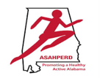  ASAHPERD  https://www.asahperd.org/  ASAHPERD’s Mission is to promote and support healthy lifestyles of Alabama citizens through high-quality programs in health, physical education, recreation, dance, sport and exercise science by: providing opportunities for professional growth and development; communicating the importance and value of our profession; encouraging and facilitating research findings to the profession and to the public; developing and evaluating standards and guidelines within the profession; and advocating for quality instruction by working with policymakers across the state. | HEALTHY EATING ACTIVE LIVING  https://healunited.org/  HEAL’s mission is to transform health culture in Alabama through education & practice of healthy lifestyle behaviors
EVERFI  https://everfi.com/k-12/parent-remote-learning/ (parent portal)  100+ game-based, interactive lessons Self-paced digital lessons equip your child with skills for life: character development, mental wellness, financial readiness, career exploration  https://everfi.com/k-12/teacher-remote-learning/ (teacher portal) | 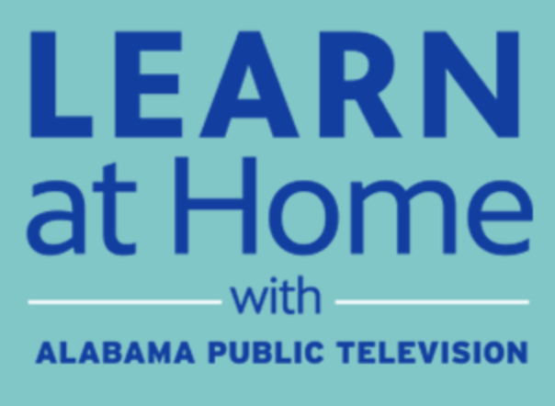  APT EDUCATION  https://aptv.org/education/  With Alabama school districts closed due to concerns over COVID-19, Alabama Public Television is here to support your education needs. While students are away from the classroom, we are broadcasting and sharing online educational resources and materials that support distance learning, including our award-winning Learning Adventures! In addition, the education broadcast is streaming each weekday from that site, providing an additional point of access to the education content.

