REMOTE LEARNING RESOURCES
GRADES 6-8 SOCIAL STUDIES
Additional resources may be added to this document in the coming days.
KHAN ACADEMY  https://www.khanacademy.org/  Khan Academy is on a mission to give a free, world-class education to anyone, anywhere. Their personalized learning resources are available for all ages. Video learning segments are followed by practice activities. | 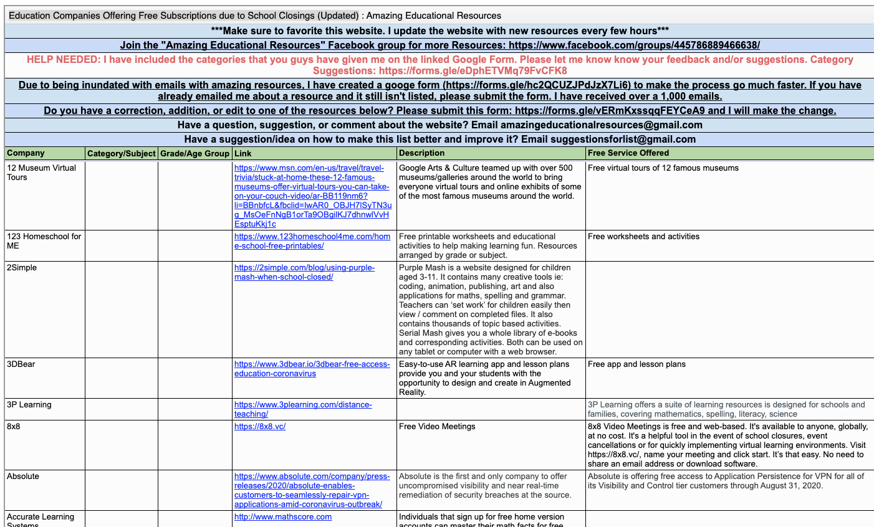  AMAZING EDUCATIONAL RESOURCES  http://www.amazingeducationalresources.com/  Education Companies Offering Free Subscriptions due to School Closings (Updated) | PBS KIDS  https://www.pbs.org/parents  For ages 2-8. PBS KIDS’ offers activities, videos, over 200 games, favorite characters, and tips you can use to help kids play and learn at home.
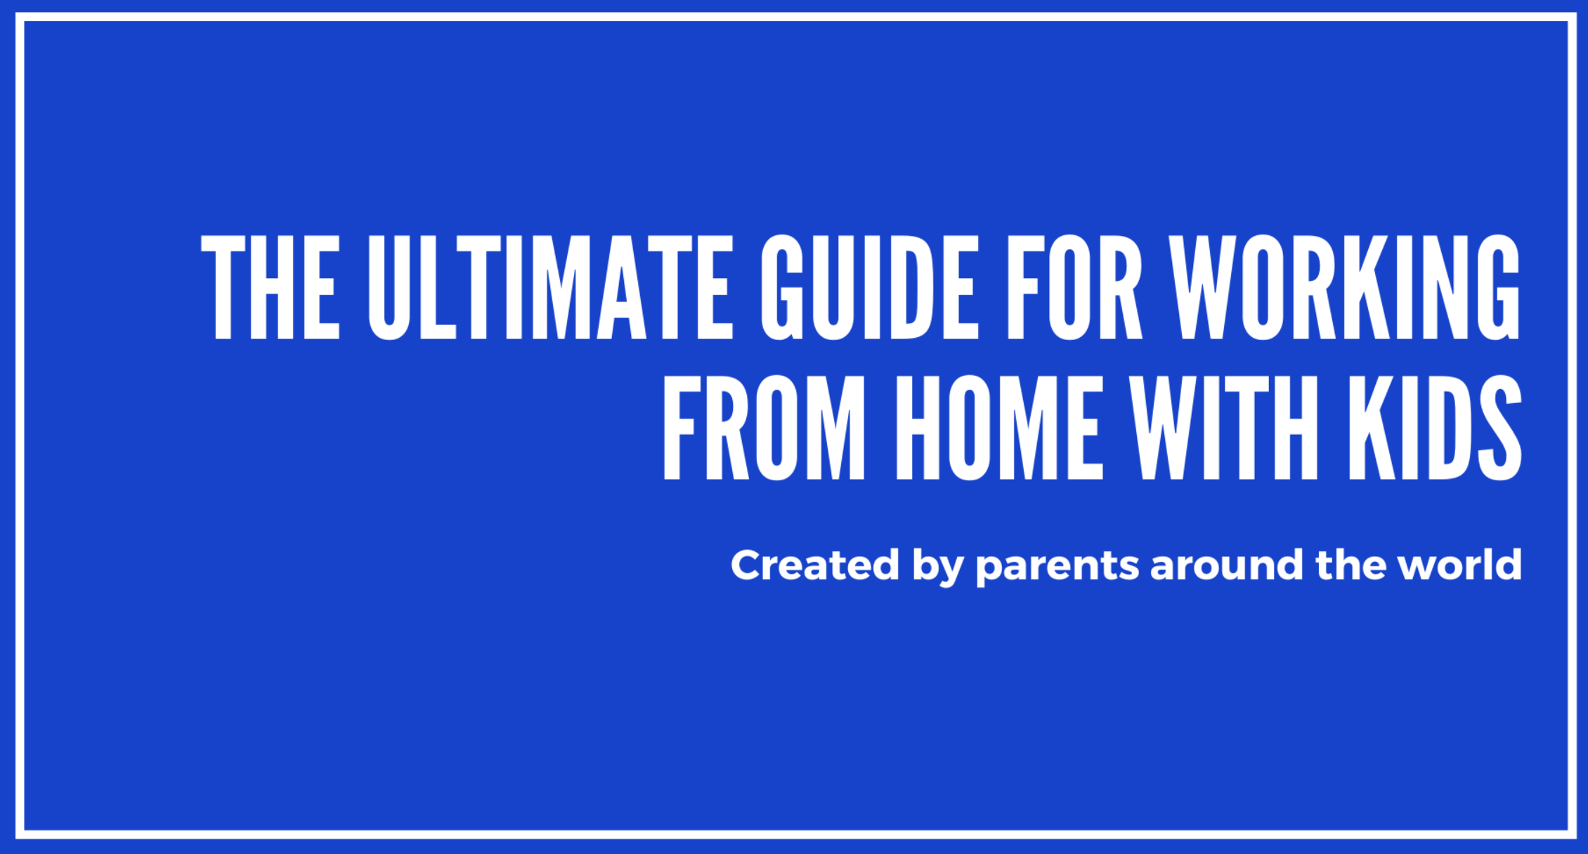  SCHOOL CLOSURES  https://schoolclosures.org/enrichment  150+ Enrichment Activities for Children While Parents are Working Remotely: It’s for ages 0-18 (and beyond!). You can search it by age, parental involvement level, prep time, cost, whether it’s for a group or one child, whether it involves a screen or not, and more. You can also add the activities keeping your kids busy and happy to the list. We welcome your contributions! | OPEN TEXTBOOK PROJECTS  https://www.uen.org/oer/index.shtml  Utah has geared up to begin providing K-12 teachers, students, and parents with materials to support the Core Standards, instruction, and teaching. Created by groups of content and teaching experts, including university faculty, district and school specialists, teachers, and USBE staff. | OER WEB COLLECTIONS  https://www.uen.org/oer/index.shtml#web  Utah has geared up to begin providing K-12 teachers, students, and parents with materials to support the Core Standards, instruction, and teaching. Created by groups of content and teaching experts, including university faculty, district and school specialists, teachers, and USBE staff.
UTAH EDUCATION NETWORK  https://www.uen.org/k12student/interactives.shtml  Keep Learning with Online Resources for PreK – Grade 12 Students | NATIONAL ARCHIVES  https://www.archives.gov/education  The National Archives is an invaluable resource for learners of all ages and interests. | EDUTOPIA  https://www.edutopia.org/  Shared evidence and practitioner-based learning strategies that empower you to improve K-12 education.
ILLINOIS OPEN EDUCATIONAL RESOURCES  http://ioer.ilsharedlearning.org/  IOER provides you with open, standards-aligned educational and career content. Use our tools to find, share, curate, and create resources. Users can like, rate, comment on and follow resources. IOER offers easy-to-use, no-cost, immediate online access to education and career resources and tools for individuals, schools, and organizations. | CURRIKI: HIGH SCHOOL CIVICS  https://www.curriki.org/community/Civics  Today, through our K-12 Library of free and open teaching and learning resources, we offer educator-vetted, openly licensed, online educational materials for use, reuse, adaptation, and sharing. | 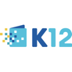  FREE ONLINE K-12 RESOURCE LIBRARY  https://www.k12.com/  We are K12, providing families an online option for a high-quality, personalized education experience. With innovative technology, inspiring teachers, and a dynamic, interactive curriculum, students can thrive, find their passion, and learn at the pace that's right for them.
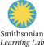  SMITHSONIAN LEARNING LAB  https://learninglab.si.edu/search?item_type=collections&st=&f%5Battributes_by_type_full.ll-subjects%5D%5B%5D=115845  The Smithsonian Learning Lab is a major rethinking of how the digital resources from across the Smithsonian’s 19 museums, 9 major research centers, the National Zoo, and more, can be used together, for learning. | 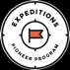  GOOGLE EXPEDITIONS PIONEER PROGRAM  https://edu.google.co.uk/pioneer-program/  Imagine visiting the bottom of the sea, Buckingham Palace or even the surface of Mars all in an afternoon. With Google Expeditions, K-12 teachers can take their classes on immersive virtual journeys to bring their lessons to life. | 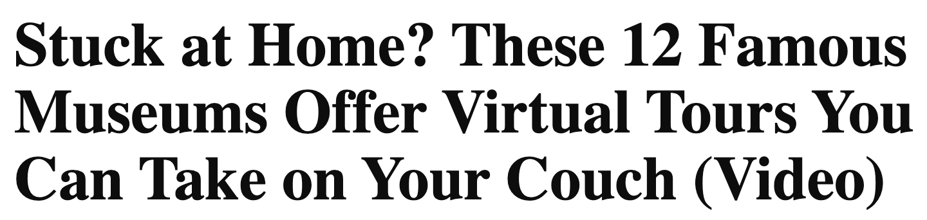  12 FAMOUS MUSEUM TOURS  https://www.travelandleisure.com/attractions/museums-galleries/museums-with-virtual-tours  12 Famous Museums from London to Seoul Offer Virtual Tour
iCIVICS  https://www.icivics.org/  iCivics looks to cultivate a new generation of students for thoughtful and active citizenship. iCivics works to ensure every student in America receives a quality and engaging civic education and graduates from high school well prepared and enthusiastic for citizenship | 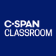  C-SPAN CLASSROOM  https://www.c-span.org/classroom/  Free video-based materials for K-12 social studies teachers. FREE education resources featuring C-SPAN's programs including current events videos, Lesson Plans, Bell Ringers, Constitution Clips and OTD in History events. | 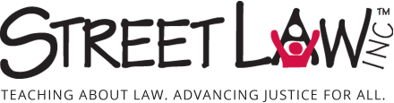  STREET LAW  https://www.streetlaw.org/additional-pages/for-educators  Curricula and Teaching Materials that are relevant to students’ lives and delivered via interactive, student-centered teaching strategies
CENTER on REPRESENTATIVE GOVERNMENT: TEACHING WITH PRIMARY SOURCES  https://corg.iu.edu/programs/teachers/index.html  The Center on Representative Government is a member of the Library of Congress' Teaching with Primary Sources Consortium.The TPS Consortium extends the reach and use of the TPS program by creating curriculum, delivering professional development to pre-and in-service teachers, and contributing to researching effective strategies for incorporating primary sources in K-12 instruction. Their projects reflect focus on a diverse array of teacher and student populations, professional concentrations, program approaches, and geographic locations. | 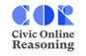  STANFORD HISTORY EDUCATION GROUP: CIVIC ONLINE REASONING  https://cor.stanford.edu/  If young people are not prepared to critically evaluate the information that bombards them online, they are apt to be duped by false claims and misleading arguments. To help teachers address these critical skills, they developed assessments of civic online reasoning—the ability to judge the credibility of digital information about social and political issues. | EconEdLink  https://www.econedlink.org/about/  EconEdLink provides a premier source of classroom-tested, Internet-based economic and personal finance lesson materials for K-12 teachers and their students. With over 435 lessons to choose from, teachers can use as many of the lessons as they would like and as often as they would like.  EconEdLink: Teaching the News
GEN i REVOLUTION  https://www.councilforeconed.org/resources/gen-i-revolution/  CEE’s Gen i Revolution is a free, online personal finance game for high school students that can be played online, on a tablet device, and via Facebook. Students assume the role of a secret agent assigned to solve a variety of financial problems—in the form of 15 missions—and defeat the “Murktide” of financial confusion that is spreading across the country. | ECON ED at the ST. LOUIS FED  https://www.stlouisfed.org/education  Our free economics and personal finance lessons, activities, and readings provide flexibility and real-world connections, making it easier to prepare students with 21st century skills for college and career readiness. We have great resources for consumers and parents, too! | NATIONAL GEOGRAPHIC CLASSROOM RESOURCES  https://www.nationalgeographic.org/education/classroom-resources/  Bring National Geographic to your K-12 classroom through lesson plans, maps, and reference resources.
DRIVING EXCELLENCE in HUMANITIES EDUCATION  https://edsitement.neh.gov/  EDSITEment! hosts resources from the National Endowment for the Humanities and they have teacher lesson plans and also have resources for student activities. | DOCS TEACH  https://www.docsteach.org/documents  Choose from thousands of primary sources for use in K-12 classroom activities.The online tool for teaching with documents, from the National Archives. | C3 TEACHER/STUDENT INQUIRIES  http://www.c3teachers.org/inquiries/  C3 Teachers is pleased to publish these inquiries through our work on the New York State Social Studies K-12 Resource Toolkit project.
LIBRARY OF CONGRESS  http://www.loc.gov/teachers/  The Library of Congress offers classroom materials and professional development to help teachers effectively use primary sources from the Library's vast digital collections in their teaching. | HISTORY LESSONS: Read Like a Historian  https://sheg.stanford.edu/history-lessons  The Reading Like a Historian curriculum engages students in historical inquiry. Each lesson revolves around a central historical question and features a set of primary documents designed for groups of students with a range of reading skills. | BEYOND THE BUBBLE: History Assessments  https://sheg.stanford.edu/history-assessments  Beyond the Bubble unlocks the vast digital archive of the Library of Congress to create History Assessments of Thinking (HATs). Explore over 80 easy-to-use assessments that measure students' historical thinking rather than recall of facts.
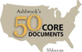  ASHBROOK’S 50 CORE DOCUMENTS  https://ashbrook.org/50docs/  At Ashbrook, we teach about America by using original historical documents. We believe this list of 50 core documents provides an essential starting point for students, teachers, and citizens to think about what it means to be an American. | 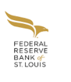  Kiddynomics: An Economics Curriculum for Young Learners, Lessons for Grades PreK-K  https://www.stlouisfed.org/education/kiddynomics-an-economics-curriculum-for-young-learners  Kiddynomics: An Economics Curriculum for Young Learners is a set of lessons designed to introduce young children to the economic way of thinking. Informed decision-making is a critical thinking skill that students can use throughout their school, personal, and work lives. And, as citizens in a democratic society, they should understand basic principles of how the economy operates. Beginning economic education early and building on that learning throughout students’ education is the best way to ensure they develop vital decision-making skills. | C3 TEACHER/STUDENT INQUIRIES  http://www.c3teachers.org/inquiries/  C3 Teachers is pleased to publish these inquiries through our work on the New York State Social Studies K-12 Resource Toolkit project.
Annenberg Learner: Social Studies & History  https://www.learner.org/subject/social-studies-history/  As part of its mission to advance excellent teaching in American schools, Annenberg Learner funds and distributes educational video programs – with coordinated online and print materials – for the professional development of K-12 teachers. | 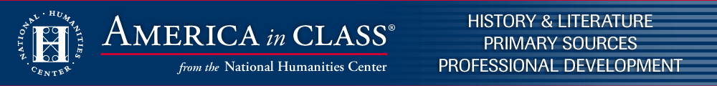  America in Class from the National Humanities Center  https://americainclass.org/  The lessons for grades 4 through 12 present challenging primary resources in a classroom-ready format, with background information and strategies that enable teachers and students to subject texts and images to analysis through close reading. | THE BIG HISTORY PROJECT  https://school.bighistoryproject.com/bhplive  Free, open, and online. All lessons are instantly accessible, evaluated and updated regularly, highly customizable, and free to learners and educators everywhere. More than 1,600 teachers and 80,000 students are teaching and taking the course each year.
HISTORICAL THINKING MATTERS  http://historicalthinkingmatters.org/students/  Historical Thinking Matters provides high school students (9-12) with a framework that teaches them to read documents like historians. Using these "habits of mind," they will be able to interrogate historical sources and use them to form reasoned conclusions about the past. Equally important, they will become critical users of the vast historical archives on the web. Historical Thinking Matters equips students to navigate the uncharted waters of the World Wide Web. The site is the winner of the American Historical Association's 2008 James Harvey Robinson Prize for an Outstanding Teaching Aid. | THE DIGITAL HISTORY READER  https://www.dhr.history.vt.edu/modules/us/intro/index.html  An online learning experience designed to enable students (in grades 6-12) to develop the analytical skills employed by historians. The Reader presents key events in U.S. and European history in the format of self-contained modules. Students learn by exploring the data presented, evaluating conflicting accounts or interpretations, and developing their own conclusions based on the evidence provided. | NewseumED  https://newseumed.org/  NewseumED.org offers free resources to cultivate the First Amendment and media literacy skills essential to civic life. Learn how to authenticate, analyze and evaluate information from a variety of sources and put current events in historical context through standards-aligned lesson plans, videos, primary sources, virtual classes and programs.
NEXT GEN PERSONAL FINANCE  https://www.ngpf.org/curriculum/  Browse the Unit library to find K-12 lessons, interactives, assessments and other resources for engaging students with quality personal finance curriculum. | TEACHER CREATED MATERIALS  https://www.teachercreatedmaterials.com/teachers/free-home-learning/  Over 500 free teacher created resources | 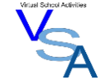  VIRTUAL SCHOOL ACTIVITIES  https://virtualschoolactivities.com/  A collection of sites to live webcams, virtual tours/trips, and other miscellaneous fun educational sites.
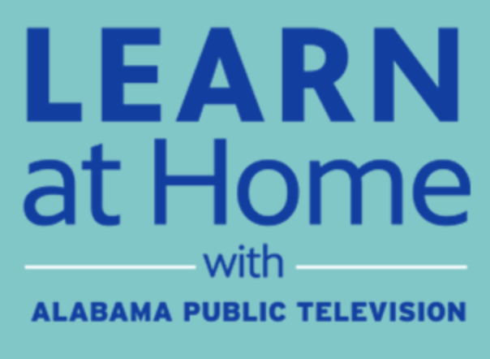  APT EDUCATION  https://aptv.org/education/  With Alabama school districts closed due to concerns over COVID-19, Alabama Public Television is here to support your education needs. While students are away from the classroom, we are broadcasting and sharing online educational resources and materials that support distance learning, including our award-winning Learning Adventures! In addition, the education broadcast is streaming each weekday from that site, providing an additional point of access to the education content. | STEM TEACHING TOOLS  https://aptv.pbslearningmedia.org/  APT and PBS have curated FREE, standards-aligned videos, interactives, lesson plans, and more for teachers like you. | EVERFI  https://everfi.com/k-12/parent-remote-learning/ (parent portal)  100+ game-based, interactive lessons Self-paced digital lessons equip your child with skills for life: character development, mental wellness, financial readiness, career exploration  https://everfi.com/k-12/teacher-remote-learning/ (teacher portal)

