REMOTE LEARNING RESOURCES
GRADES 9-12 DLCS
Additional resources may be added to this document in the coming days.
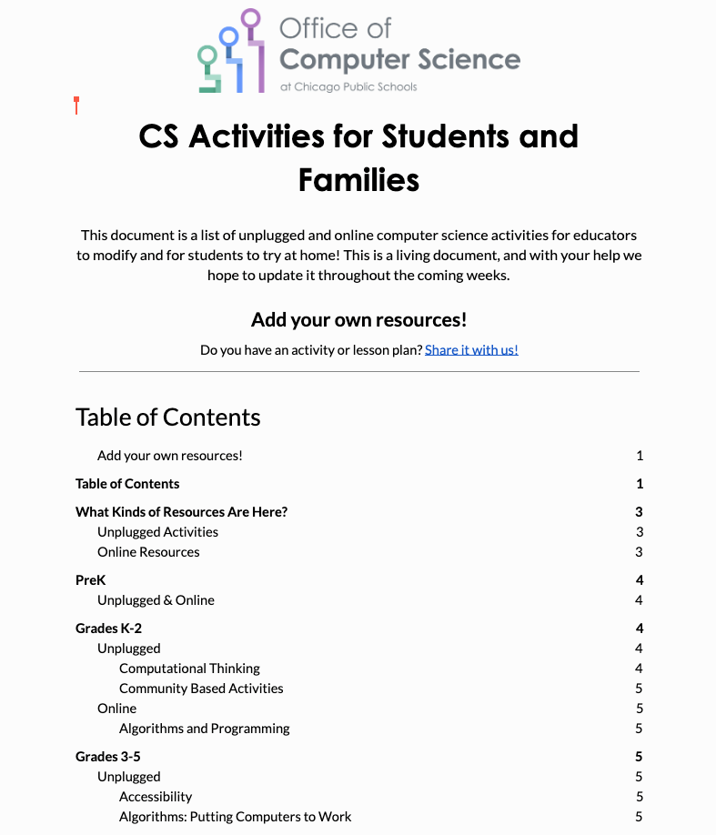  CS ACTIVITIES for STUDENTS and FAMILIES  https://docs.google.com/document/d/1Q4MDWtFuYzSmc_ebVqeMuzzLZX2qyZc-C-KfxKnMEvk/edit#  This document is a list of unplugged and online computer science activities for educators to modify and for students to try at home! This is a living document, and with your help we hope to update it throughout the coming weeks. | 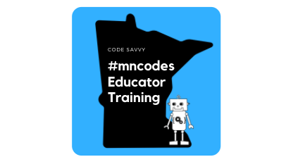  COLLABORATIVE K12 CS EDUCATION DISTANCE LEARNING RESOURCES  https://docs.google.com/document/d/1Qy2GayfYq1qheAxsDVSEPtjgrLH5Dj7swjo-tDfu6V4/mobilebasic  This is a collaborative resource document - anyone is welcome to add resources that may be helpful to other K12 computer science educators (of all experience levels) | CS Unplugged  https://csunplugged.org/en/  CS Unplugged is a collection of free teaching materials that teach Computer Science through engaging games and puzzles that use cards, string, crayons and lots of running around.
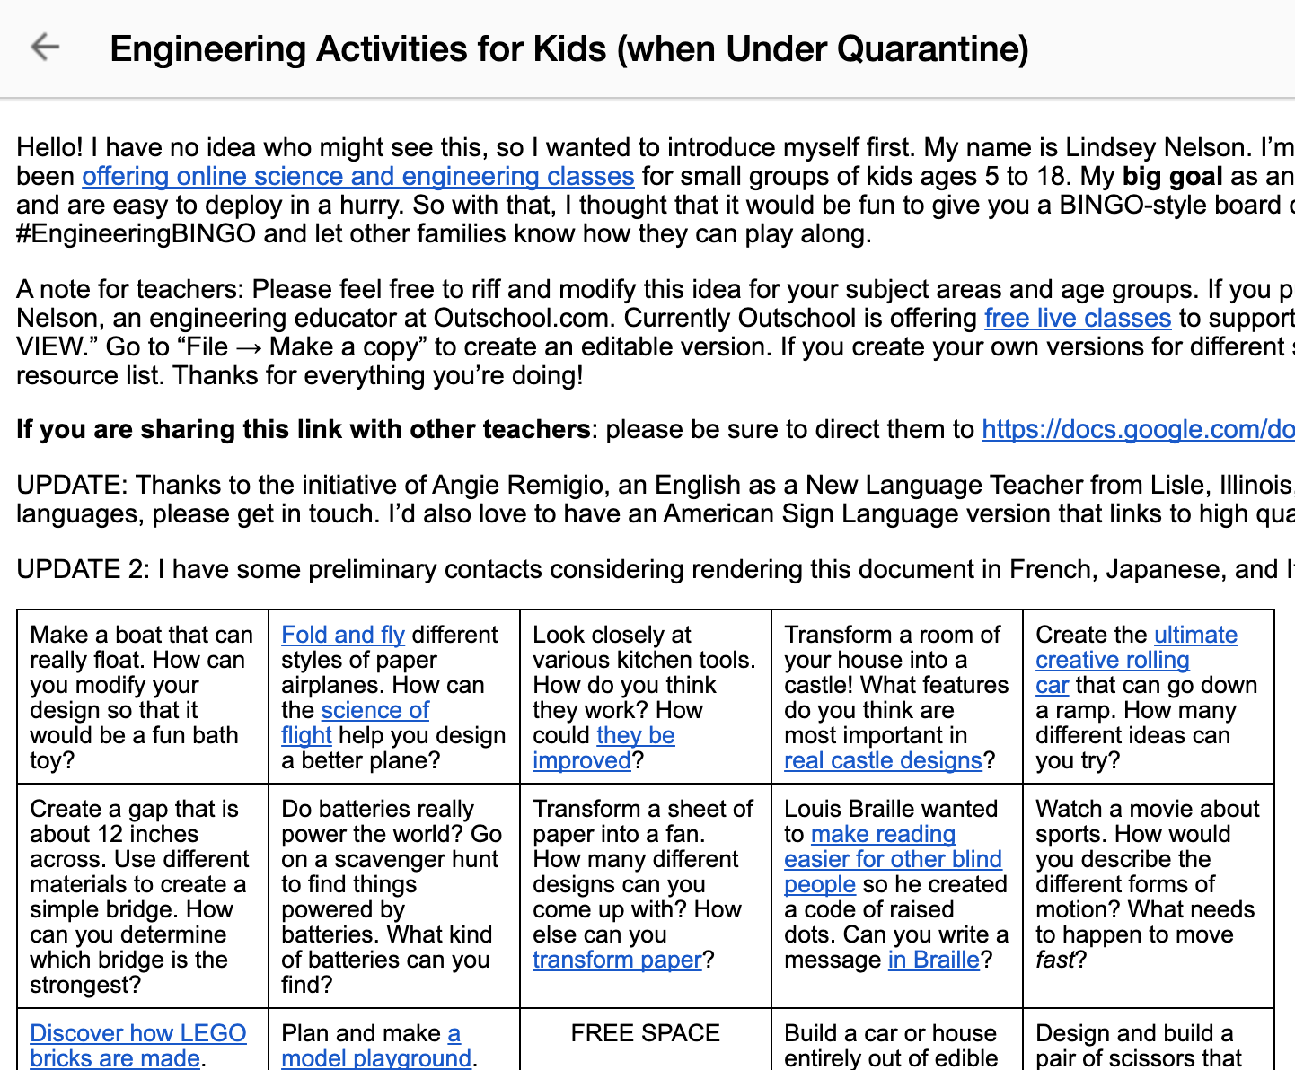  ENGINEERING ACTIVITIES for KIDS  https://docs.google.com/document/d/1oCM2Ue9w32EUIGfRXsjwEXU_-Up8D6FSSWT8YGiBEtE/mobilebasic  My big goal as an engineering educator is to design activities that use low-cost supplies you already have around the house and are easy to deploy in a hurry. So with that, I thought that it would be fun to give you a BINGO-style board of awesome engineering that jives well with social distancing. Share your activities on social media with #EngineeringBINGO and let other families know how they can play along. | 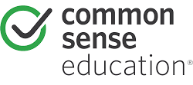  COMMON SENSE EDUCATION  https://www.commonsense.org/education/digital-citizenship/curriculum?grades=k%2C1%2C2  Designed and developed in partnership with Project Zero at the Harvard Graduate School of Education -- and guided by research with thousands of educators -- each digital citizenship lesson takes on real challenges and digital dilemmas that students face today, giving them the skills they need to succeed as digital learners, leaders, and citizens tomorrow. | 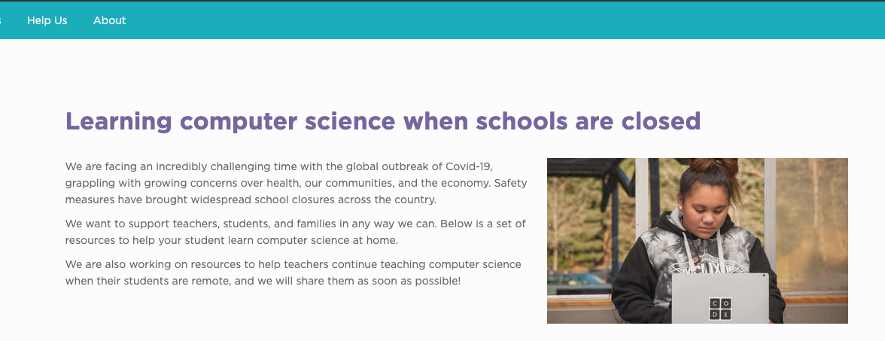  LEARNING COMPUTER SCIENCE WHEN SCHOOLS ARE CLOSED (Code.org)  https://code.org/athome  We want to support teachers, students, and families in any way we can. Below is a set of resources to help your student learn computer science at home.  We are also working on resources to help teachers continue teaching computer science when their students are remote, and we will share them as soon as possible!
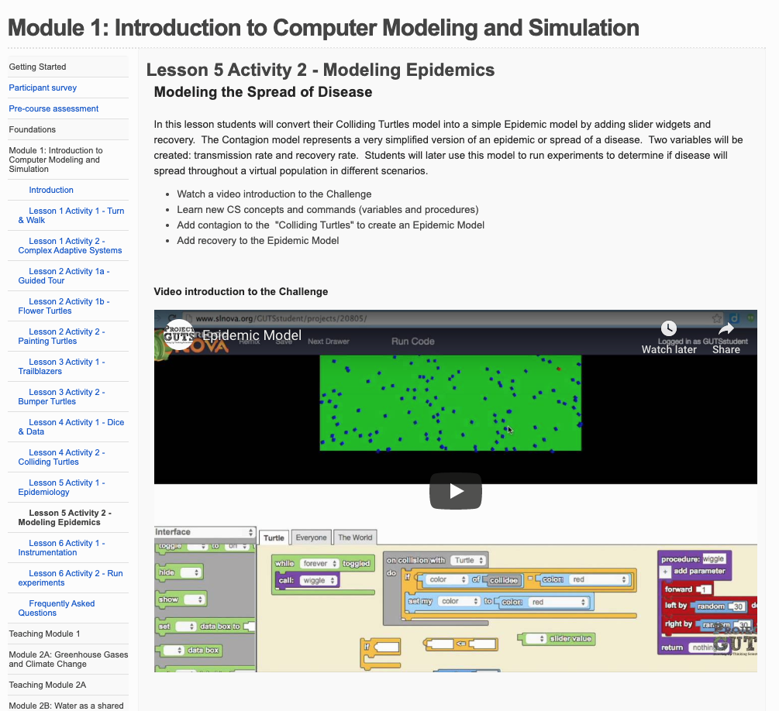  PROJECT GUTS: Introduction to Computer Modeling and Simulation  https://guts-cs4hs.appspot.com/unit?unit=18&lesson=29  In this lesson students will convert their Colliding Turtles model into a simple Epidemic model by adding slider widgets and recovery. The Contagion model represents a very simplified version of an epidemic or spread of a disease. Two variables will be created: transmission rate and recovery rate. Students will later use this model to run experiments to determine if disease will spread throughout a virtual population in different scenarios. | 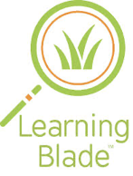  LEARNING BLADE  http://www.learningblade.com/AL  Learning Blade sends students on engaging missions that both interest and excite them. Within each mission you will find a wide variety of lessons, each one tied back to a career, tool or technology of a STEM related field. | 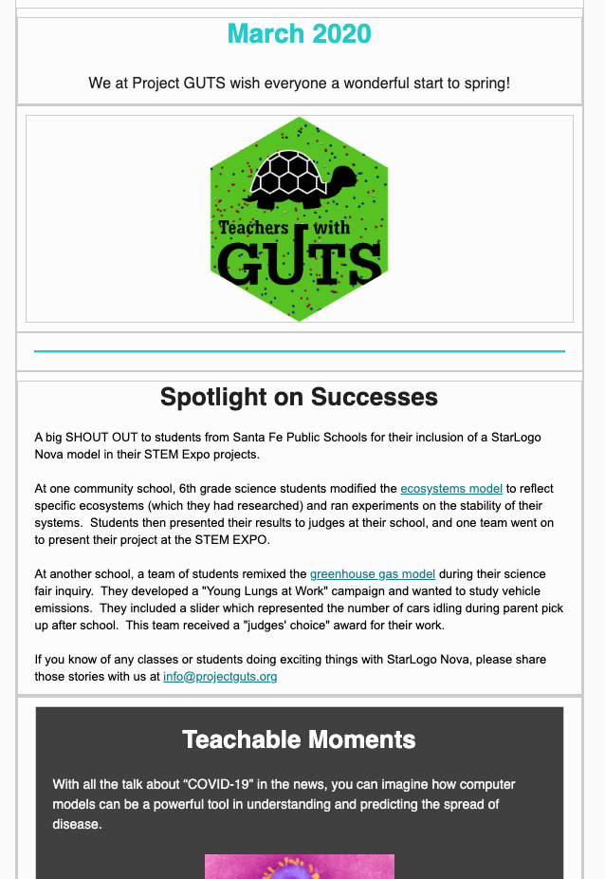  PROJECT GUTS: Spotlight on Success  https://mailchi.mp/teacherswithguts/teachers-with-guts-newsletter-march2020-4790442  Using computer science to model science
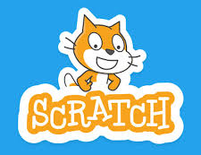  Scratch  https://scratch.mit.edu/educators/  Students can use Scratch to code their own interactive stories, animations, and games. In the process, they learn to think creatively, reason systematically, and work collaboratively — essential skills for everyone in today’s society. Educators are integrating Scratch across many different subject areas and age groups. | 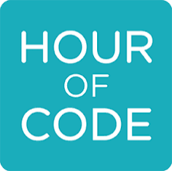  SWITCHEROO ZOO  https://hourofcode.com/us  Anyone, anywhere can organize an Hour of Code event. One-hour tutorials in over 45 languages. No experience needed. | Hopscotch  https://scratch.mit.edu/educators/  Build competency in computer science by helping your students create their own versions of popular App Store games like Crossy Road and Subway Surfers. Differentiated and aligned to the Common Core and Next Generation Science and Engineering Standards.
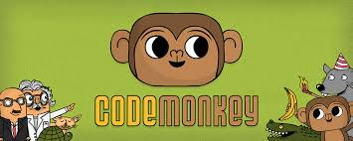  CodeMonkey  http://www.maxwainewright.com/a-z/index.html  CodeMonkey is a fun and educational game-based environment where kids learn to code without any prior experience. After completing CodeMonkey's award-winning coding courses, kids will be able to navigate through the programming world with a sense of confidence and accomplishment. | 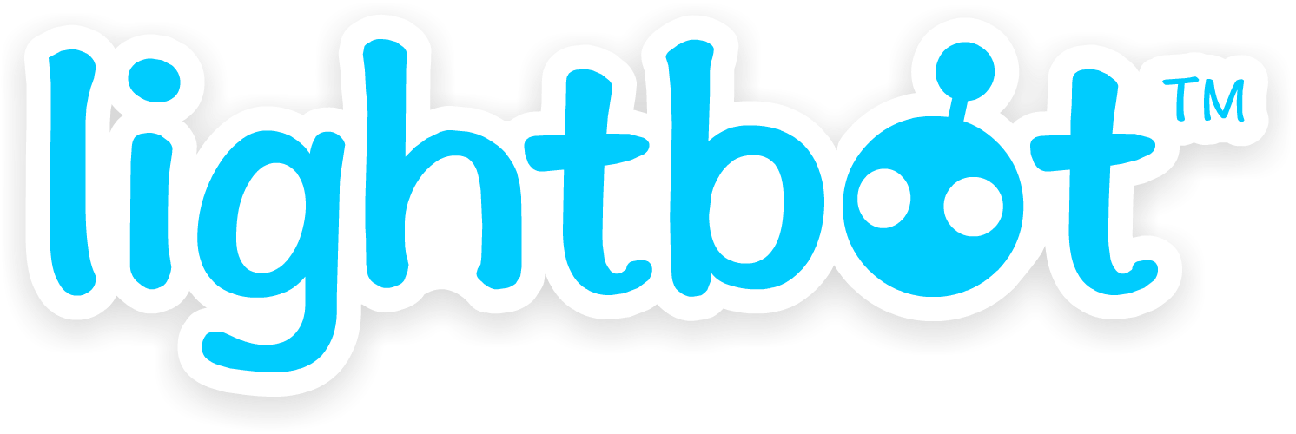  LIGHTBOX  https://lightbot.com/hour-of-code.html  LightBot is a puzzle game that helps students understand basic programming practices and concepts. Specifically, students learn:  Sequencing, Overloading, Procedures, Recursive Loops, Conditionals | CODE ACADEMY  https://www.codecademy.com/  From building websites to analyzing data, the choice is yours. Not sure where to start? We'll point you in the right direction.

COMPUTER SCIENCE for FUN

http://www.cs4fn.org/

Computer Science is fun. cs4fn's aim is to share our passion about all things to do with Computer Science and especially to show that it is an exciting subject that is great to learn about just for the fun of it.

