REMOTE LEARNING RESOURCES
GRADES 9-12 SCIENCE
Additional resources will be added to this document in the coming days.
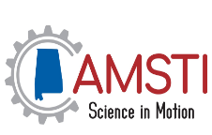  AMSTI SCIENCE IN MOTION  https://cws.auburn.edu/asim/Home/Links  (Biology, Chemistry, Physics, Earth and Space, Environmental Science, Anatomy Physiology)  This page provides links for teachers that are recommended by Alabama Science in Motion. | BOZEMAN SCIENCE  http://www.bozemanscience.com/  (Biology, Chemistry, Physics, Earth and Space, Environmental Science, Anatomy Physiology)  Video essentials for AP Biology, AP Chemistry, AP Environmental Science, and AP Physics aligned to the AP curriculum. | 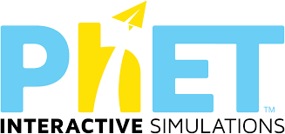  PhET COLORADO  https://phet.colorado.edu/  (Biology, Chemistry, Physics, Earth and Space, Environmental Science, Anatomy Physiology)  Simulations for Biology, Chemistry, Physics, and Earth and Space Science. Teachers can log on for free online lesson plans that correspond to each simulation
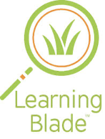  LEARNING BLADE  http://www.learningblade.com/AL  Learning Blade sends students on engaging missions that both interest and excite them. Within each mission you will find a wide variety of lessons, each one tied back to a career, tool or technology of a STEM related field. | 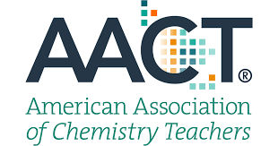  AMERICAN ASSOCIATION OF CHEMISTRY TEACHERS  https://teachchemistry.org/classroom-resources  (Chemistry, AP Chemistry, and Physical Science)  Content and Lab ideas for chemistry teachers | 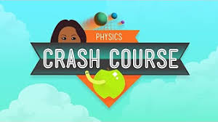  CRASH COURSE PHYSICS  https://www.youtube.com/user/crashcourse/playlists  (Physics)  46 VIdeo tutorials related to physics materials
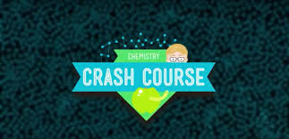  CRASH COURSE CHEMISTRY  https://www.youtube.com/user/crashcourse/playlists  (Chemistry)  47 VIdeo tutorials related to chemistry materials | 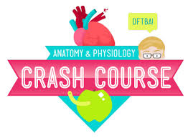  CRASH COURSE ANATOMY and PHYSIOLOGY  https://www.youtube.com/user/crashcourse/playlists  (Anatomy and Physiology)  48 VIdeo tutorials related to Anatomy | 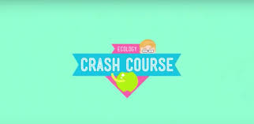  CRASH COURSE ECOLOGY  https://www.youtube.com/user/crashcourse/playlists  (Environmental)  12 VIdeo tutorials related to Ecology
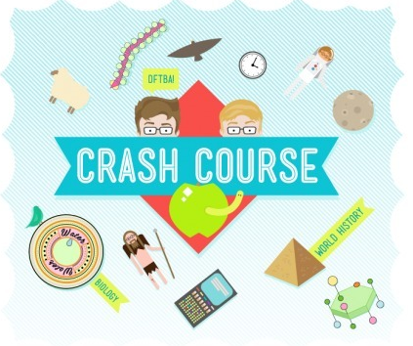  CRASH COURSE HISTORY of SCIENCE  https://www.youtube.com/user/crashcourse/playlists  (Biology, Chemistry, Physics, Earth and Space, Environmental Science, Anatomy Physiology)  12 Videos that provides a historical look at science | 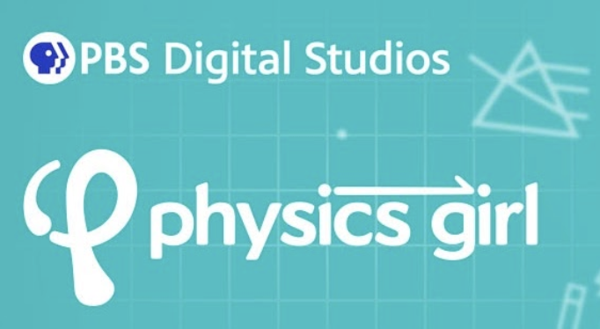  PHYSICS GIRL  https://www.youtube.com/user/physicswoman/about  (Physics)  Physics Girl is a YouTube Channel where Physicist Dianna Cowern explains phenomena in Physics | PHYSICS CLASSROOM  www.physicsclassroom.com  (Physics)  Physics Tutorials, interactive simulations, review questions, and lesson
AAPT RESOURCE LIBRARY  https://www.compadre.org/?  (Physics and Astronomy)  DIgital Library of free online resources for Physics and Astronomy | 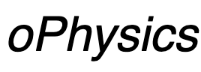  oPHYSICS  http://www.ophysics.com/  (Physics and Physical Science)  Interactive Physics related simulations | cK-12 EDUCATION CHEMISTRY  https://flexbooks.ck12.org/cbook/ck-12-chemistry-flexbook-2.0/  (Chemistry)  Online text that covers Chemistry Concepts including SIMs, real life examples, and videos all aligned to the Alabama Standards
cK-12 EDUCATION PHYSICS  https://flexbooks.ck12.org/cbook/ck-12-physics-flexbook-2.0/  (Physics)  Online text that covers Physics Concepts including SIMs, real life examples, and videos all aligned to the Alabama Standards | cK-12 EDUCATION BIOLOGY  https://flexbooks.ck12.org/cbook/ck-12-biology-flexbook-2.0/  (Biology)  Online text that covers Biology Concepts including SIMs, real life examples, and videos all aligned to the Alabama Standards | cK-12 EDUCATION PHYSICAL SCIENCE  https://flexbooks.ck12.org/cbook/ck-12-middle-school-physical-science-flexbook-2.0/  (Physical Science)  Online text that covers General Physical Science Concepts including SIMs, real life examples, and videos all aligned to the Alabama Standards
OPENSTAX  https://openstax.org/subjects/science  (Biology, Chemistry, Physics, Earth and Space, Environmental Science, Anatomy Physiology)  Online Text for science students from Rice University | GIZMOS  https://www.explorelearning.com/  (Biology, Chemistry, Physics, Earth and Space, Environmental Science, Anatomy Physiology)  Online Simulations that impower Inquiry-Based Education | FLIPGRID  Link to Remote Learning with Flipgrid  (Biology, Chemistry, Physics, Earth and Space, Environmental Science, Anatomy Physiology)  Over 12,000 ready to use topics accessible to teachers
MOLECULAR WORKBENCH  http://mw.concord.org/modeler/  (Biology, Chemistry, Physics, Earth and Space, Environmental Science, Anatomy Physiology)  Visual interactive simulations for teaching and learning science | MOLECULAR LEVEL LABORATORY EXPERIMENTS MoLES  http://genchem1.chem.okstate.edu/CCLI/Startup.html  (Chemistry)  MoLEs (Molecular Level Laboratory Experiments) is an NSF sponsored materials development project designed to produce web-based computer simulations and companion inquiry activities that explore key concepts in beginning chemistry. | 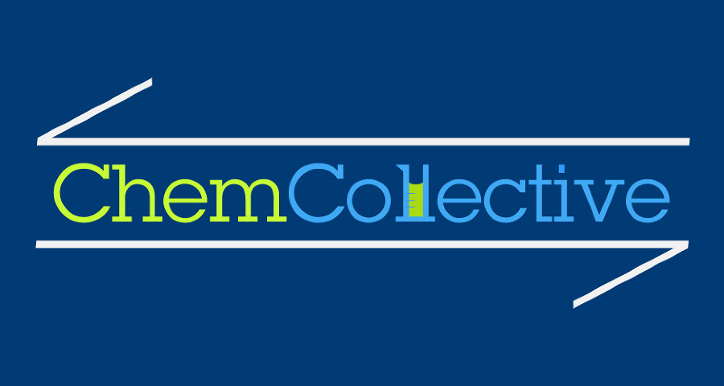  CHEM COLLECTIVE  http://www.chemcollective.org/  (Chemistry)  Resources for teaching and learning chemistry
THE BIOLOGY PROJECT  http://www.biology.arizona.edu/cell_bio/activities/cell_cycle/cell_cycle.html  (Biology)  Resources from the University of Arizona about biology and cell biology | IB CHEMISTRY WEB  https://www.ibchem.com/htm/ibsyllabus.htm  (IB Chemistry)  IB Chemistry notes and questions to help teach the IB topics | QUIZLET  https://quizlet.com/  Students can create study flashcards, play learning games, practice skills, collaborate with other students, and more.
LEARN ZILLION  https://illuminations.nctm.org/  Cloud-based curriculum for K–12 students, focusing on supporting both traditional and blended classrooms. | KHAN ACADEMY  https://www.khanacademy.org/  Khan Academy is on a mission to give a free, world-class education to anyone, anywhere. Their personalized learning resources are available for all ages. Video learning segments are followed by practice activities. | PHYSICSPORT  https://www.physport.org/recommendations/Entry.cfm?ID=119906  (Physics and Astronomy)  Support for teachers who suddenly have to support virtual/online learning.
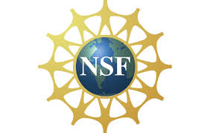  NSF SUPPORTED MATERIALfor AP CHEMISTRY  Teacher Link: http://genchem1.chem.okstate.edu/BDA/Topics.php  Student Link: http://intro.chem.okstate.edu/BDA.html  (AP Chemistry)  NSF funded resources for Before, During, and After activities for chemistry topics. There is a teacher link and a student link. | ALCHEMIE  https://www.alchem.ie/  (Chemistry)  A resource for teachers and students Organic Chemistry | ALBERT  https://www.albert.io/try-albert  (All Disciplines K-12 including ACT and SAT Prep Questions)  Albert.io has resources for both middle and high school, through AP level.
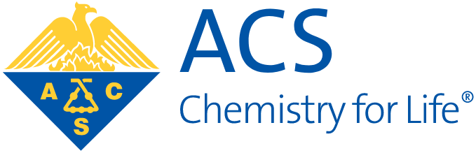  AMERICAN CHEMICAL SOCIETY and CHEM MATTERS MAGAZINE  https://www.acs.org/content/acs/en/education/resources/highschool/chemmatters/articles-by-topic.html  (Chemistry and Physical Science)  The American Chemical Society has ChemMatters magazines, targeted for high schoolers, available online. In addition to chemistry, there are article that are biographies of chemists, and historical articles. | BIOLOGY SIMULATIONS  https://www.biologysimulations.com/  (Biology and Anatomy)  Biology Simulations helps students to learn about biology and practice data analysis skills. | BITSCIS  https://bitescis.org/  (Biology, Chemistry, and Physics)  BiteScis integrates current scientific research into NGSS-aligned lessons . Lessons may be modified for remote learning.
STUDYIB.NET  https://studyib.net/  (IB Science Classes)  IB resources broken down by topic for IB Science Courses | ROYAL SOCIETY of CHEMISTRY  https://edu.rsc.org/resources/secondary  (Chemistry and Physical Science)  Over 1000 resources to enrich your lessons, spark excitement and encourage understanding and interaction of Chemistry. | GOING 3D WITH GRC  https://sites.google.com/3d-grcscience.org/going3d/high-school-lessons?authuser=0  (All Disciplines)  A plethora of 3D lessons that utilize phenomenon organized by the Core Ideas of the NGSS.
PROJECT GUTS  https://guts-cs4hs.appspot.com/unit?unit=18&lesson=29  (Biology and Anatomy)  Project GUTS' Computer Science in Science curriculum makes it easy to integrate computer modeling and simulation into middle and high school science classrooms. | 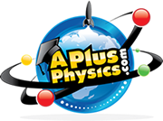  APLUS PHYSICS  https://www.aplusphysics.com/index.html  (AP Physics)  Website that supports materials for AP Physics | THE PHYSICS AVIARY  www.thephysicsaviary.com  (Physics)  Programs to help physics students master big ideas in physics
COLLISIONS  https://www.playmadagames.com/product/  (Chemistry)  Collisions helps high school students visualize and interact with chemistry concepts through fun and challenging games. | FLINN PREP  https://www.flinnprep.com/  (AP Biology, AP Chemistry, AP Physics, and AP Environmental Science)  FlinnPrep is a complete learning solution that helps prepare and support students through AP Science Courses. | WHITEBOX LEARNING from FLINN SCIENTIFIC  https://www.whiteboxlearning.com/  (All Disciplines)  WhiteBox Learning is a complete standards-based STEM learning system for grades 6-12 that brings real-world design to the classroom
PBS LEARNING MEDIA  https://www.pbslearningmedia.org/collection/universe/#.XnTQaKhKiUk  (Earth and Space Science)  Free digital media resources you can use to teach topics in K–12 Earth and Space Science. | MOLECULAR WORKBENCH  http://mw.concord.org/modeler/  (Biology, Chemistry, Physics, Earth and Space, Environmental Science, Anatomy Physiology)  Visual interactive simulations for teaching and learning science | 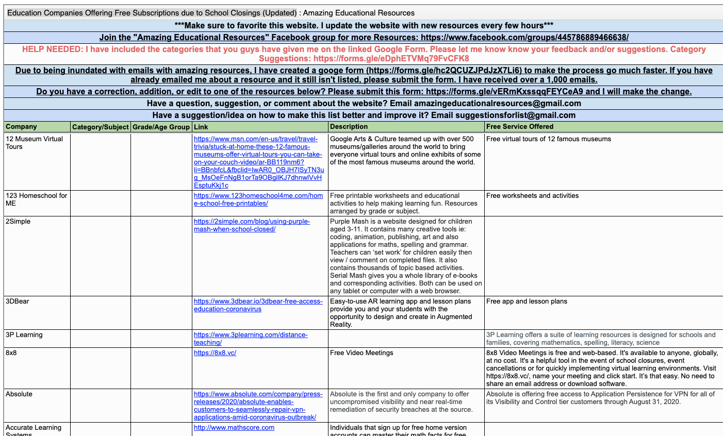  AMAZING EDUCATIONAL RESOURCES  http://www.amazingeducationalresources.com/  Education Companies Offering Free Subscriptions due to School Closings (Updated)
SCIENCE FRIDAY  https://www.sciencefriday.com/educate/  (All Disciplines)  Science Friday partners with educators and scientists to create free STEM activities, lessons, and resources for all learners. | TEACHER CREATED MATERIALS  https://www.teachercreatedmaterials.com/teachers/free-home-learning/  (All Disciplines)  Over 500 free teacher created resources | TWU PHYSICS  https://sites.google.com/site/twuphysicslessons/home  (AP Physics and Physics)  AP Physics 1 and AP Physics 2 lessons are designed for students who have never had physics before.
PLASMA GAMES  https://play.plasma.games/  (Chemistry and Physical Science)  Chemistry class with real-world applications and in-demand careers | HUDSON ALPHA: Beyond the Blog  https://hudsonalpha.org/beyond-the-blog/  (All DIsciplines)  Makes sense of the science related to the coronavirus COVID-19. | CADRE  http://cadrek12.org/  (All Disciplines)  PreK-12 education researchers offer online curriculum, modules, simulations, apps and general resources to support virtual student learning.
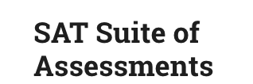  SAT Suite of ASSESSMENTS  https://collegereadiness.collegeboard.org/sat/practice/full-length-practice-tests  (All DIsciplines)  A library of practice SAT test questions for high school students | ACT  https://www.act.org/content/act/en/products-and-services/the-act/test-preparation/science-practice-test-questions.html?page=0&chapter=0  (All DIsciplines)  A library of practice ACT test questions for high school students | NATIONAL GEOGRAPHIC  https://www.nationalgeographic.org/education/classroom-resources/learn-at-home/  (All DIsciplines)  A collection of activities for educators and parents to implement with K–12 learners.
GEORGIA PUBLIC BROADCASTING: PHYSICS  https://www.gpb.org/physics-in-motion  (Physics)  A video series with support materials that provide practice and support materials. | GEORGIA PUBLIC BROADCASTING: CHEMISTRY  https://www.gpb.org/chemistry-study-of-matter  (Chemistry and Physical Science)  A video series with support materials that provide practice and support materials. | 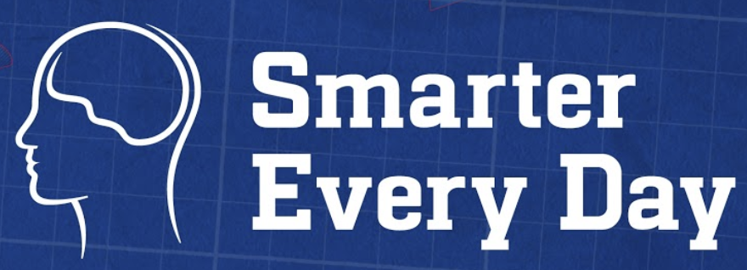  SMARTER EVERY DAY  https://www.youtube.com/user/destinws2/about  (All DIsciplines)  Videos that explain the science of everyday concepts by an Engineer from Alabama. Students will enjoy seeing how the science they are learning is actually applied in the world.
IT’S OKAY TO BE SMART  https://www.pbslearningmedia.org/collection/its-okay-to-be-smart/  (All DIsciplines)  A video series that explores the eccentricities of the scientific world. From physics, astronomy, biology, earth science and much more. You can connect this to your Google Classroom. | 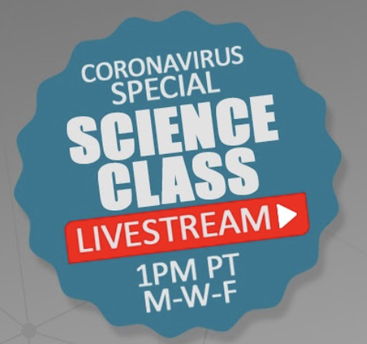  MARK ROBER  https://www.youtube.com/user/onemeeeliondollars/about  (All DIsciplines)  Former NASA engineer who explains new ideas in science engineering in an engaging way so everyone understands science. | TVA STEMready  http://www.tvastem.com/high-school-lessons/  (All DIsciplines)  Provides K-12 lessons for teachers in every discipline of science about STEM topics.
VIRTUAL SCHOOL ACTIVITIES  https://virtualschoolactivities.com/  A collection of sites to live webcams, virtual tours/trips, and other miscellaneous fun educational sites. | 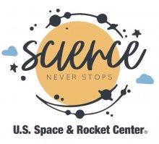  SCIENCE NEVER STOPS  https://www.rocketcenter.com/scienceneverstops  Science Never Stops, STEAM videos exploring museum artifacts, hands-on science, live astronomy demonstrations and so much more! | ADAPTIVE CURRICULUM SCIENCE  https://www.adaptivecurriculum.com/us/lessons-library/science-AO-introduction.html  Get free access during school closures to Adaptive Curriculum’s online, instructional solution that builds middle and high school science through dynamic, interactive learning with one-of-a-kind virtual experiments, simulations, guided discovery, and concept development activities.  Teachers can assign interactive lessons to their students as part of their weekly assignments and track their progress and performance. Open to all schools during school closures. If a school contacts them for Free Access, they’ll create accounts for all teachers and students for home access.

LEARNING TOGETHER APART 2020
http://hghelix.hudsonalpha.org/f7c1a3ec-53aa-447c-8708-af89b0ae2ec6/49fe8a58-cef1-4008-a5c4-2045f6d26703

(All DIsciplines)
The HudsonAlpha Educational Outreach team is working right alongside of you as you plan and execute a new process for teaching. HG Helix was designed specifically to bring information and resources directly to your screen. We are making digital copies of activities, videos, and educational support materials available to educators around the globe through this platform.
Educational resources made available through HG Helix are organized by topic. You can navigate HG Helix and explore the resources for each topic by clicking the book icon in the upper left corner of your screen and selecting 'Learning Together Apart 2020' from the list. You will find topics ranging from COVID-19 to Ecology. Selecting a topic within 'Learning Together Apart 2020' will give you the topics that you can click to access. We will continue to add to HG Helix and update resources, so we encourage you to visit the site often.
HudsonAlpha Website
ACT  https://www.act.org/content/act/en/covid19.html  (All DIsciplines)  ACT is offering digital learning and workforce resources to assist students, teachers, schools and workers impacted by COVID-19. | 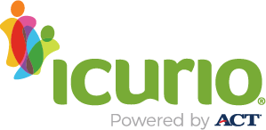  incurio  https://support.icurio.com/coronavirus/  (All DIsciplines)  Via icurio, the classrooms in your districts will have free access to over 360,000 vetted, tagged and maintained digital learning resources.  Our platform does the hard work, so you don’t have to by curating, vetting and maintaining thousands of standards-aligned resources from the best online educational providers. | 3M SCIENCE AT HOME  https://www.3m.com/3M/en_US/gives-us/education/science-at-home/?utm_medium=redirect&utm_source=vanity-url&utm_campaign=3m.com/scienceathome  3M’s Science at Home program provides fun and educational science experiments for students ages 6-12.  These simple, at-home experiments conducted by 3M scientists use common household items and are designed to reinforce core scientific principles. School systems, educators, parents, and caregivers are encouraged to use this educational content in virtual classrooms and at home.  3M will post new experiments, featuring 3M scientists and some special guests along the way. Be sure to check back weekly for new content to try at home.

