Prairieview-Ogden District Newsletter
March News
Check out the new look – ensuring compatibility with our new website and social media!
Illinois Principal’s Association Award Winners 2018
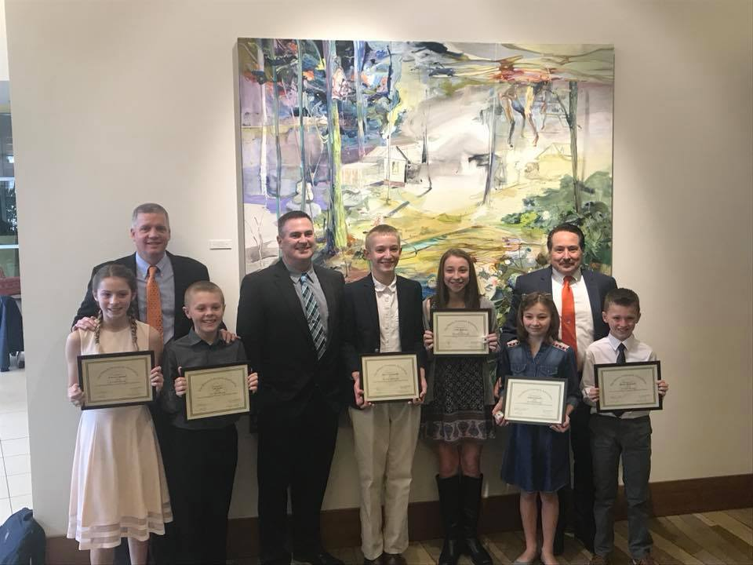
The district would like to congratulate the winners of this year’s IPA award. Abby Behrens, Ben Cunningham, Allison Schmitz, Kodey McKinney, Lauren Lannert, and Cole Pruitt represented PVO at the recognition luncheon held last week at the IHotel. Students chosen to receive this award set a good example for their peers, not only with their academic success, but also with the work ethic, responsibility, and citizenship each of these students demonstrates in their buildings every day. Congratulations to each of these students!

Spiking Out Hunger Event Hosted by the 7th/8th Volleyball Team
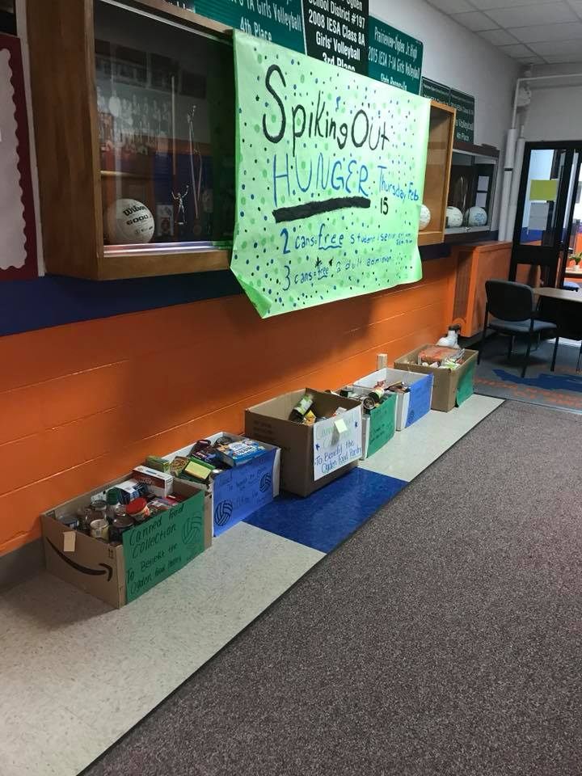
On February 15th, the PVO volleyball team hosted a “Spiking Out Hunger” philanthropy event to benefit the Ogden Food Pantry. The team sold t-shirts in the weeks prior to the event and then went door-to-door in Ogden and Royal on Saturday, February 10th. The team collected over 500 nonperishable food items! The event continued into the week with a canned food drive at each school and more food came in when fans brought in items as admission to Thursday night’s game. There was also a chili cook-off in the cafeteria to raise money for the organization. Stephanie Buck took home the “Golden Spoon” after being voted as the best pot of chili. All-in-all the event raised over $800.00 and brought in almost 1,000 nonperishable food items for the Ogden Food Pantry. The players and coaches would like to thank the parents, fans, and communities for their amazing support of this event!
Mrs. Och’s 3rd Grade Class at North
We are learning many new and exciting things in third grade. In math, we have finished learning multiplication and division facts. We had so much fun playing multiplication and division games as we practiced our facts.

We are learning about the Earth’s resources in science. The students recently “made” igneous, sedimentary, and metamorphic rocks. We will also be having a pollution poster contest.

At the beginning of February, the class celebrated 101 Day. On this day we celebrated place value and remainders with many fun activities. One of our favorite activities was dressing up like we were 101 years old and writing what our lives would be like. Here are some of our ideas:

“When I am 101, I will watch baseball on my T.V.” - Alex
“I would go get a cup of coffee with a friend.” - Anna
“I would go get coffee.” - Cylas
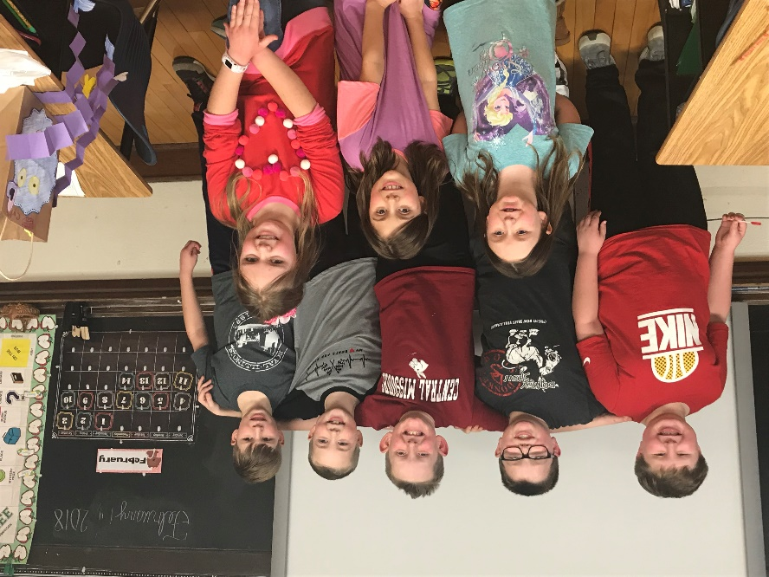
“I would go shopping.” - Garrett
“I would go have coffee at a café.” - Hannah
“I would play with my grandkids.” - Jaxson
“I would go fishing with my grandkids.” - Jaxton
“I would sit and watch T.V.” - Mason
“I would watch The Price is Right.” - Olivia
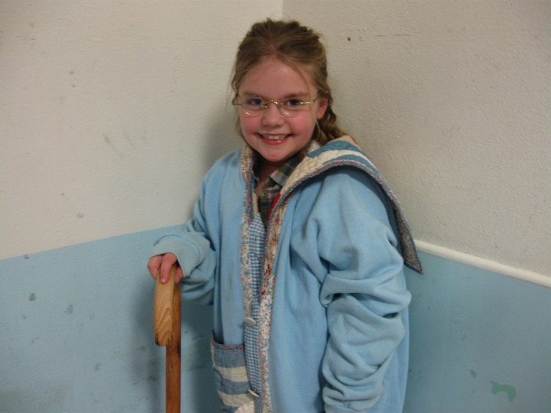
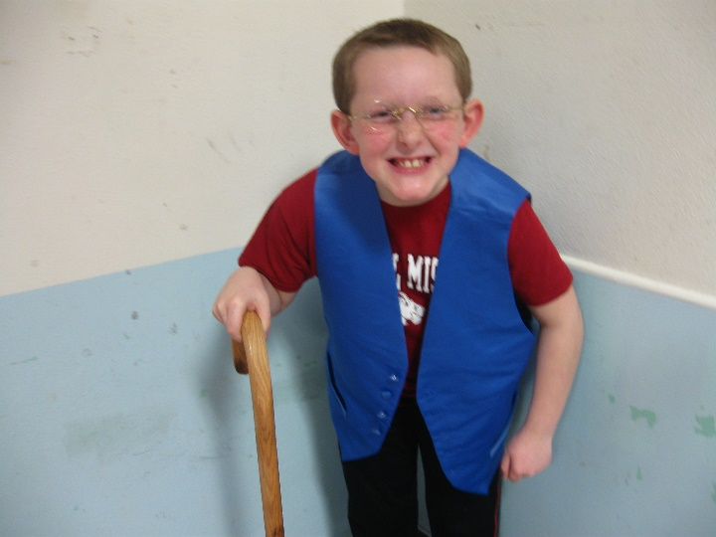

Mrs. Howard’s 2nd Grade Class at South
The second grade class at PVO South celebrated being 100 days smarter! We did 100 second challenges and were amazed at how long 100 seconds actually is. We drew pictures of what we thought we would look like when we are 100 years old. We used an aging app on the phone to help us see what we would actually look like when we are 100 years old. We decorated 100 day glasses and enjoyed a sweet snack to celebrate our 100th day. Officer Keyes came to visit with her police dog, Harley. We were able to witness her getting engaged at our program! Congratulations to Officer Keyes! We are currently creating our own Olympic events and participating in our own classroom Olympic games. Each student wanted to share some of what we have learned during these past 100 days.
Airin Rash: Some of us are learning multiplication. We did 3-digit addition and subtraction. We also learned about the axis.
Evelyn Valentine: We learned about the weirdest Olympic sports. We went to the petting zoo.
Leigha Larson: We learned how the heart pumps blood. We grew a plant. We are learning cursive.
Grayson Vedder: We went to the petting zoo. We learned cursive. We learned about the axis.
Adyn Westerfield: We learned how to do daily five. We learned about Mystery Doug. We learned about the axis.
Atleigh Miller: We learned about matter. I learned multiplication. Yay! We learned about plants.
Ericka Aguilera: We learned about the Earth’s axis. We learned cursive writing. We learned many things through Mystery Doug.
Connor McMahon: We learned things through Mystery Doug. We learned how the heart pumps blood, the weirdest sports on the Olympics and a lot of stuff.
Gage Ramm: We learned to go back and reread lines when you make a mistake in reading.
Kellyn Irwin: We learn about new things on Mystery Doug. We learned about the Olympics.
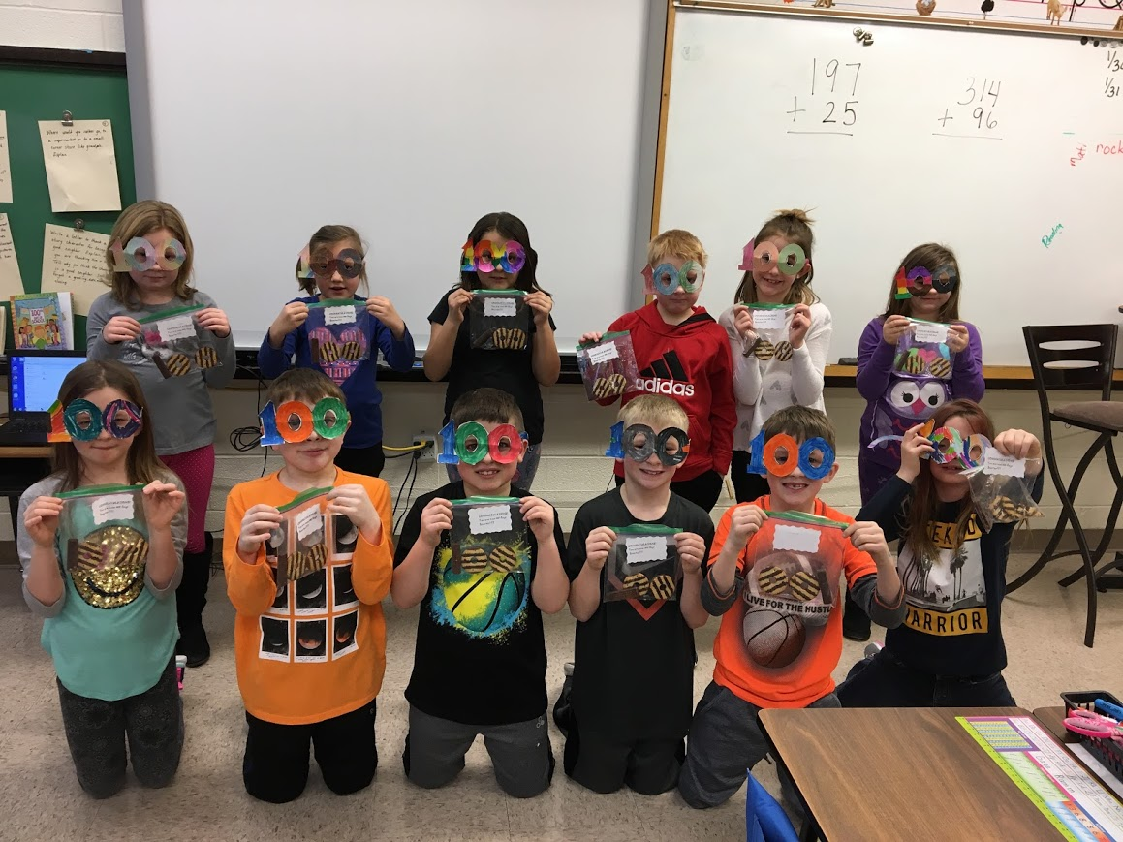
Zoe Valentine: We learned about the axis. We learned how plants grow. We learned how to add 3-digit addition.
Wyatt McKinney: Mystery Doug helps answer our questions. We learned about weird sports in the Olympics. We learned about blood. We learned cursive. We learned about the axis.
Jaylin Seal: We learned Mystery Doug. We learned how your heart pumps blood. We learned cursive. We learned about matter and we changed matter to make bread. We learned what mass was.
Mrs. Izard’s 2nd Grade Class at North
The second grade has had a very busy February. Here are a few highlights of our activities:
Mrs. Howard invited us to South to meet a Champaign County Canine. We were able to learn all about the work Officer Keyes and Harley do. As an extra special surprise, we were able to witness a surprise wedding proposal. Congratulations Officer Keyes!
We had a wonderful Valentine’s Day party! We also enjoyed a fun trip to the SJO FFA Petting Zoo.
We are learning about biographies. Each second grader wrote a presidential biography. We also learned about Abraham Lincoln and George Washington. We are currently writing our own autobiographies.
The Olympics provided a lot of learning opportunities! We learned about the different events and some famous Olympians, including Champaign’s Bonnie Blair.
Although we have had a fun February, we are looking forward to spring and
Royce: having baseball practice.
Jameson: playing baseball.
Greta: wearing shorts.
Casen: playing baseball.
Korinne: playing softball.
Roisin: the flowers.
Keegan: going fishing.
Lane: playing football.
Alyssa: warm weather.
Jansen: the spring smells.
Mataya: the blooming flowers.
Gavin: going to the zoo.
Lucas: playing outside.
Makayla: planting flowers.
Isabella: flowers.
Leah: not having to play outside. You can stay inside.

Mrs. Dalton’s 3rd Grade Class at South
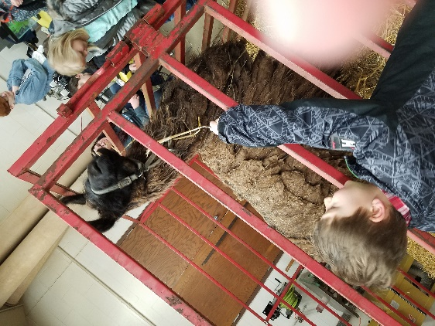
Hello from 3rd grade at South! The school year is nearly over! We may be a small class, but each day is full of adventure here in Mrs. Dalton’s room! Since we last checked in the students have done a lot of fun things in all subjects. They have learned about many different Native American tribes in social studies. We just wrapped up multiplication and division in math. Now, we are focusing on properties and equations, and will be jumping into fractions soon. In science, the students have learned all about matter, how objects are made, and what chemical and physical changes are! The class also got to attend the SJO High School FFA petting zoo!! The kids loved the animals and learning about life on the farm.

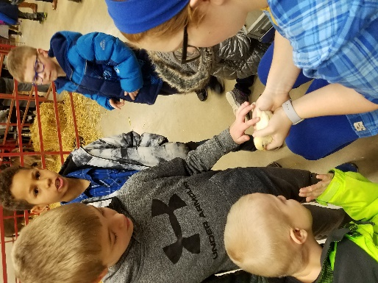
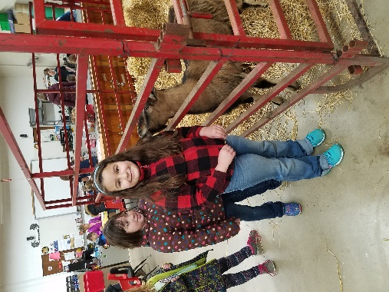
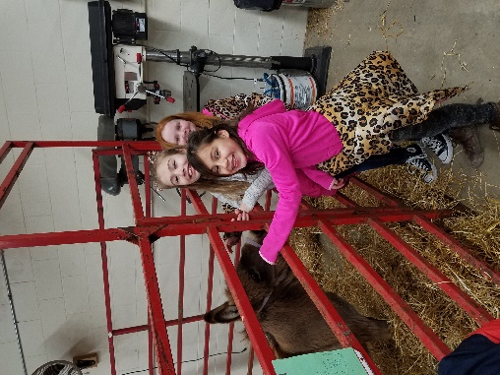

Junior High Language Arts
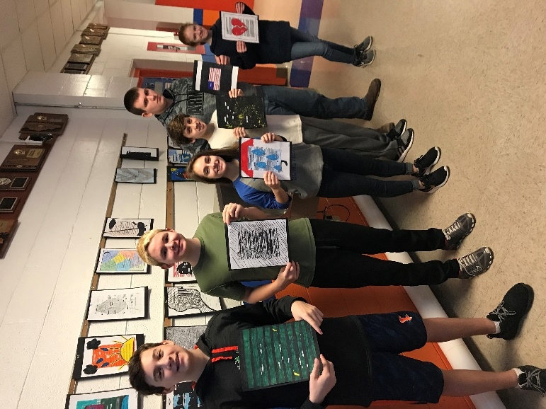
Both the 7th and 8th grade classes have finished up their most recent grammar units and are now starting poetry units in their perspective classes. The 7th graders are looking at poems and focusing on the theme and the narrator, as well as comparing poems by the same poet. The 8th graders are just getting started on a very in-depth unit focusing on famous poems and the analysis of those poems. Students are reading poems including “O’ Captain, My Captain” by Walt Whitman and sonnets by Shakespeare. We are looking closely at the structure of the poems as well as their background history and connections to other writings such as music.

If you’re in our building, check out the creative writing projects the students produced to kick off our poetry unit. The 7th graders created poems focusing on their “favorite part of me.” Students were asked to write a creative poem using any style or structure about the one thing they like the most about themselves. They then took a photo portraying their favorite characteristic. The 8th graders also had a creative writing poetry projected called Blackout poetry! The final projects for this assignment turned out beautifully. I’m so proud of the students’ creativity and effort on these projects!
PVO Volleyball Season Recap
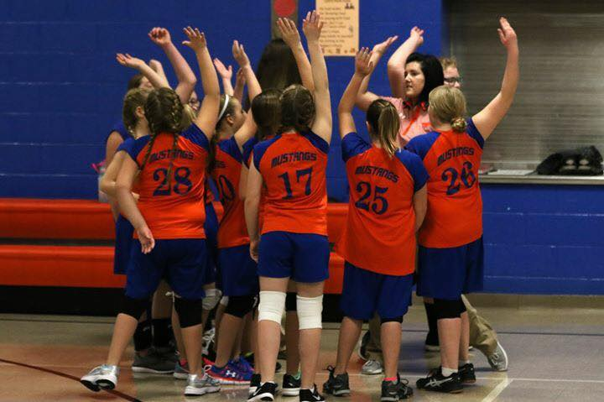
5th/6th Volleyball at South – The 5th and 6th grade teams have finished up another successful season. Coach Hilton and Coach Izard really worked with the girls to develop good fundamentals to help prepare them for junior high volleyball next year. The girls really focused on their passing and serving; two key elements to the game. Most importantly, the girls learned how to work together on the floor. We even had a couple of practice where we focused on team bonding! The most exciting part of coaching a young team is seeing the interest in the sport and the future of our program! We are so proud of our 5th/6th team!

7th/8th Volleyball at the JH – Boy, has this been an exciting season for our 7th and 8th girls’ volleyball teams. The 7th grade team improved SO much from the start of the season to the end! The girls had outstanding matches against Holy Cross on our “Spiking out Hunger” night and then again at Chrisman! It was wonderful to watch each player grow as the season went on. Unfortunately, the 7th grade team lost in three to Potomac in the regional championship; a match that typified what a championship game should be – excitement, teamwork, and a back-and-forth battle to the very end.
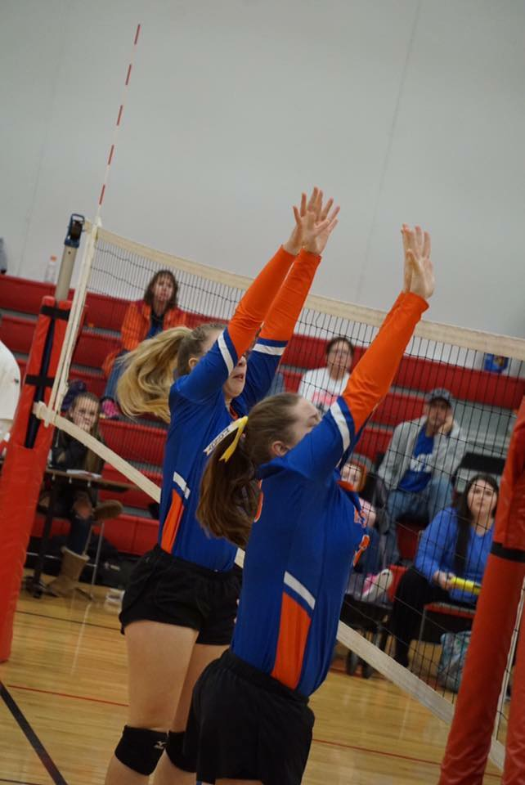
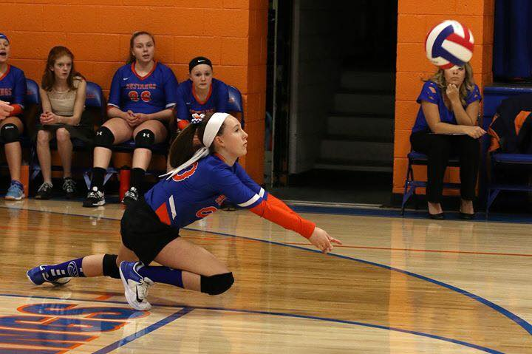
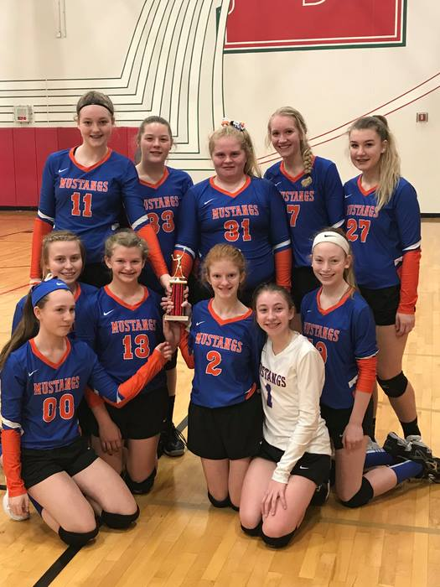
The 8th grade team’s season has been battered with illness, facing a three-week period of time where the team faced opponents without at least one starter or team member for the game! However, that hasn’t stopped this very special group of girls! They have had an outstanding season! Currently the team has a record of 19-5 including a 2nd place finish at the very competitive Effingham Shootout tournament. While playing at Effingham, the 8th grade team defeated a 4A school, the defending state runner-up, and lost in three to the defending 2A state champions for the championship of the tournament. The 8th graders then returned to our home floor to defeat Champaign Edison (4A team who placed 4th in state last year)! Post-season play begins for the 8th grade team on Saturday with regionals at Danville Schlarman. We wish them the best of luck!

