**ELLIOTT COUNTY SCHOOLS**

**KINDERGARTEN SCREENING & REGISTRATION**

**2018 – 2019 SCHOOL YEAR**

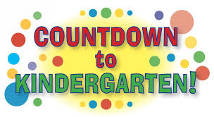

* Tuesday, March 20 at Sandy Hook Elementary (1:00 – 5:00)
* Thursday, March 22 at Isonville Elementary (1:00 – 5:00)
* Tuesday, March 27 at Lakeside Elementary (1:00 – 5:00)

**Children *may* enroll for primary school/ kindergarten for the 2018 – 2019 school year if they turn five years old on or before AUGUST 1 of 2018.**

***\*Children turning five years old between August 2 and October 1 may be eligible for early enrollment. Applications for early enrollment will be accepted April 9 – June 29, 2018.***

**If you have questions concerning enrollment, contact your elementary school.**

**All children who attend and register will receive a free bag with books and other materials.**

C:\Users\jwhitt\AppData\Local\Microsoft\Windows\Temporary Internet Files\Content.IE5\7U95BSNU\MC900351202[1].wmf