North Lyon County USD 251 Request for Proposal
PO Box 527, 614 Main Street, Americus KS 66835

Fiber Optic Wide Area Network (WAN) For School District.

Issued: 2/19/2018.
Closes: 3/19/2018

Timeline:
- February 28: Site walk-through of hub location from 1-3pm (non-Mandatory). Meet at NHHS High School, 1208 Highway 56, Allen, KS 66833.
- March 2: Questions must be submitted on or before this date to erate@usd251.org.
- March 19: RFP responses are due via email submitted on or before this date to erate@usd251.org.

Terms:
- North Lyon County USD 251 has the right to reject any and all proposals.
- North Lyon County USD 251 has the ability to conduct contract negotiations on details beyond what is specified in the RFP.
- North Lyon County USD 251 has the ability to move to next bidder if contract negotiations aren’t concluded to district’s satisfaction.
- North Lyon County USD 251 has the ability to adjust timeline and/or ask additional questions of bidders based on initial responses.
- North Lyon County USD 251 has the requirement for insurance coverages for any potential liability in the case of a self-provisioned fiber contract.

SCOPE OF SERVICES

North Lyon County USD 251 is requesting proposals for self-provisioned fiber construction and services provided over third-party networks for delivery of wide area network (WAN) services to the district. Services over third-party networks includes consideration for comparable leased lit fiber, leased dark fiber, IRU and any other type of technology neutral, point-to-point broadband service delivered over a service provider or other third-party owned network. The current WAN services are provided by Microwave Radio Transmission but enhanced services are now required to support rapidly growing bandwidth needs and to meet the State Education Technology Directors Association standard recognized in the FCC Second E-rate Modernization order as the benchmark standard for bandwidth for school districts
.
- Service is expected to be delivered from the district hub, the Northern Heights High School at 1208 Highway 56, Allen, KS 66833
  - Demarcation Point: Network Closet in Special Education / IDL Building behind main gym.

- Service is expected to be delivered to the eligible service locations from the district hub at the following locations:
- Eligible Entity 1, the Americus Elementary / NLC Junior High building at 804 E. 6th, Americus, KS 66835
  - Demarcation Point: Technology Coordination Office, Room #304
- Eligible Entity 2, the District Office at 614 Main Street, Americus KS 66835
  - Demarcation Point: Store Room / Communication Wall
- Eligible Entity 3, the Reading Elementary School at 424 1st St, Reading, KS 66868
  - Demarcation Point: Gym Store Room / Network Closet

The new service is being planned to begin on July 1, 2018 which represents the expiration of the current leased WAN service.

North Lyon County USD 251 is seeking multiple options for bids. Respondents may bid one, all, or any number of options. All respondents must be capable of providing telecommunication services under the Universal Service Support Mechanism, be a registered vendor with USAC, and have a USAC issued 498 ID (formerly Service Provider Identification Number-SPIN).

- The first option is a fully managed, leased lit fiber solution. One-time special construction should be bid separately from the monthly recurring cost for the fully managed leased service.
- The second option is a leased dark fiber solution that includes special construction, the monthly lease fee, and maintenance. One-time special construction costs should be bid separately from the monthly lease fee. Maintenance fees can be included in the monthly lease fee.
- The third option is a leased dark fiber (IRU) solution that includes special construction, the IRU fee, and fiber maintenance. One-time special construction costs should be bid separately from the IRU fee. Monthly maintenance fees should be bid separately from the IRU fee.
- The fourth option is for services delivered over third-party networks. This service option is to represent any technology neutral third party transport mediums including both fiber and non-fiber options. The service is a fully managed service, with the service provider supplying the equipment, provisioning the bandwidth and providing technical support/management of the service. One-time special construction should be bid separately from the monthly recurring cost for the fully managed leased service. While the bandwidth and service requirements are the same as leased lit fiber, this request is technology neutral and can include non-fiber solutions.
- The fifth option is for self-provisioned (district owned) fiber to the designated locations and includes all eligible special construction charges. Maintenance should be bid separately from the special construction charges for the self-provisioned fiber.
- For any leased dark fiber, leased dark fiber (IRU), and self-provisioned solutions, we also require necessary network equipment to place fiber into service. Equipment should be bid separately from any fiber services.

North Lyon County USD 251 will consider traditional network designs (such as hub and spoke) or alternative proposals that, in accordance with E-rate guidance, maximize cost effectiveness. Respondents should clearly illustrate proposed network design and construction routes. North Lyon County USD 251 is not advocating or mandating any preconceived network design or construction route and leaves this decision up to the vendor to present their best solution while recognizing the cited termination locations.

In E-rate terminology, special construction refers to the upfront, non-recurring costs associated with the installation of new fiber to or between eligible entities. If no new fiber is being installed, then any installation costs are considered standard non-recurring costs (NRC). Applicants may seek funding for special construction charges in connection with leased lit fiber, leased dark fiber, and self-provisioning. Special construction charges eligible for Category One support consist of three components:
- construction of network facilities
- design and engineering
- project management

Note: The term “special construction” does not include network equipment necessary to light fiber, nor the services necessary to maintain the fiber. Charges for network equipment and fiber maintenance are eligible for Category One support as separate services, but not as special construction.

All options can include special construction or one-time E-rate eligible non-recurring costs as well as E-rate eligible recurring circuit costs. To the extent that the winning service provider installs additional strands of fiber for future business ventures, the winning service provider assumes full responsibility to ensure those incremental costs are allocated out of the special construction charges to the district in accordance with FCC rules and orders. If, after the issuance of the FCDL, USAC or the FCC determines that the winning service provider did not cost allocate those charges associated with the additional strands, North Lyon County USD 251 will not be responsible for reimbursing the winning vendor and the winning vendor will assume all responsibilities deemed ineligible by USAC. For examples of cost allocation, please see document in Appendix D as prepared by the State E-rate Coordinators’ Alliance (SECA).

Based on the bids and both a short term and long-term cost effectiveness analysis, North Lyon County USD 251 will determine which, if any, of the proposed solutions or some combination of solutions is acceptable. The specifications related to each solution option are as follows.

Leased Lit Fiber or Services Provided Over Third-Party Networks
North Lyon County USD 251 must have dedicated, symmetrical transport bandwidth of at least 1Gbps with Service Level Agreement (SLA) guarantees between the designated endpoints. The solution must be scalable to 10 Gbps with 1Gbps cost increments. Price quotes are requested for 12 month, 36 month, and 60 month terms of service. Each respondent is required to complete the leased lit fiber / Services Provided Over Third-Party Networks pricing matrix located in Appendix A of this RFP. If special construction is necessary, respondents are required to separate out pricing in Appendix B: Special Construction Pricing. No increased pricing will be allowed during the term of the quoted special construction, NRC, and MRC rate in each pricing cell of the matrix. If an increase in bandwidth is requested during the contract period the contract does not renew. As bandwidth needs are steadily rising, respondents are free to bid higher tiers of bandwidth than what is requested to demonstrate their future scalability.

Leased Dark Fiber Solutions
Leased dark fiber solutions should be for a lease of two (2) strands (1 pair) of single-mode fiber from the hub to each eligible entity location for 36 month, 60 month, and 120 month terms of service. Each respondent is required to complete the leased dark fiber pricing matrix located in Appendix A of this RFP. If special construction is necessary, respondents are required to separate out pricing in Appendix B: Special Construction Pricing.
Leased Dark Fiber (IRU) Solutions
Indefeasible right to use (IRU) solutions should be a 10 year price for two (2) strands (1 pair) of single-mode fiber between the specified hub and each eligible entity location. North Lyon County USD 251 is interested in IRU-type pricing with a one-time capital cost payment for the IRU combined with “all-in” recurring payments for maintenance costs for the entire length of the IRU. Each respondent is required to complete the Leased Dark Fiber (IRU) pricing matrix located in Appendix A of this RFP. If special construction is necessary, respondents are required to separate out pricing in Appendix B: Special Construction Pricing and North Lyon County USD 251 expects significant reductions from prevailing market rates for the IRU fee and annual maintenance charges.

Self-Provisioned Fiber Construction
As an alternative, North Lyon County USD 251 requests that respondents propose design and pricing for a self-provisioned build of new fiber between the specified hub and each eligible entity location. We are requesting that twelve (12) strands (6 pair) be built to each eligible entity location and we intend to light two (2) strands (1 pair) to each site in the first year. In accordance with USAC rules, the cost of any strands not lit during the funding year must be allocated out as ineligible charges (Please see Appendix D for guidelines on cost allocation). North Lyon County USD 251 desires a fully “turn-key” project so respondents should provide explanation for North Lyon County USD 251’s involvement in the process including ownership and sourcing of permits, etc. When submitting a self-provisioned proposal, the respondent is required to complete the pricing matrix located in Appendix B of this RFP. The solution should include all costs related to the deployment of the proposed circuit.

Self-Provisioned Fiber Construction Specifications & Project Management:
- North Lyon County USD 251’s specifications for a newly constructed fiber infrastructure are contained in Appendix C: OSP Installation Specifications.
- Selected respondent and its subcontractors will provide all project management to accomplish the installation of all project work as outlined in Appendix C.
- Project management should include all necessary paperwork and permits including but not limited to rights of way, easements, and pole attachments.
- The respondent will provide engineer(s), certified on selected fiber system specifications and procedures to manage all phases of project as outlined in this proposal. This includes ordering and managing the bill of materials as outlined in Appendix C, directing and managing cable placement and restoration, directing and managing splicing crews and providing detailed documentation at the end of the project.
- Selected respondent and its subcontractors will develop a project management plan, which will include a milestone chart. The milestone chart will outline any critical path events and then track these with the appropriate agency/organization whether; selected respondent, subcontractor or the district.

Maintenance for Leased Dark Fiber, IRU or Self-Provisioned Fiber Projects
North Lyon County USD 251 requires on-going maintenance of the fiber on all leased dark fiber, leased dark fiber (IRU), or self-provisioned fiber solutions. Respondent may offer maintenance services either themselves or through 3rd party subcontractors. If respondent intends to use 3rd party subcontractors to deliver a part or all of the service, this should be clearly indicated in the response. Maintenance responses are required as follows:
Leased Dark Fiber & IRU Maintenance
All dark fiber responses (lease and IRU) require maintenance as part of the response, even if maintenance is subcontracted out to a third party. In the case of the 3rd party maintenance, the respondent must hold and manage the subcontract and is ultimately responsible for the SLA. It is assumed that the dark fiber network is part of a more comprehensive fiber infrastructure of the service provider. The respondent will include only the portion of maintenance that is required to support the North Lyon County USD 251 fiber segments versus overall network maintenance. If the fiber serves multiple customers, the cost of maintenance should be shared among all the recipients.
- For leased dark fiber, it is assumed that maintenance costs are included in the monthly lease fee.
- For a leased dark fiber (IRU):
  - The fiber owner (not the district) must claim responsibility for repairs in the event of a catastrophic cut or relocate.
  - Describe the process for relocates including assumption of costs.
  - If maintenance cannot be quoted for entire time span of the IRU, please include alternate time span quote as well as explanation for the shorter time span.

Self-Provisioned Fiber Maintenance
Self-provisioned fiber construction responses are not required to include a maintenance response. Maintenance on self-provisioned fiber may be bid as a stand-alone service by anyone, even if they are not bidding on any fiber service. Please note that respondents submitting a self-provisioned fiber proposal may also bid on maintenance services provided they bid it separately and do not bundle maintenance costs with their fiber proposal. Price quotes are requested for36 month and 60 month terms of service. Respondents are required to fill out the Self-Provisioned Fiber Maintenance pricing matrix located in Appendix A of this RFP. Responses for maintenance on self-provisioned fiber must include scheduled routine maintenance as a monthly or annual cost as well as unscheduled break/fix maintenance as an annual time and material cost estimate. Explanation of how the annual scheduled and unscheduled maintenance was estimated should be included.
Maintenance Terms and Conditions
Respondent shall maintain the applicable fiber seven days per week, twenty-four hours per day. Upon notification from the district of a malfunction relating to the applicable fiber, respondent shall respond to such malfunction within two (2) hours and thereafter proceed to correct the malfunction with reasonable diligence. When pricing maintenance, the respondent should include an overview of maintenance practices including:
- Routine maintenance and inspection
- Scheduled maintenance windows and scheduling practices for planned outages
- Marker and handhole inspection and repair
- Handling of unscheduled outages and customer problem reports
- What service level agreement is included and what alternative service levels may be available at additional cost
- What agreements are in place with applicable utilities and utility contractors for emergency restoration
- Repair of fiber breaks
- Mean time to repair
- Replacement of damaged fiber
- Post repair testing
- Replacement of fiber that no longer meets specifications
- Policies for customer notification regarding maintenance
- Process for changing procedures, including customer notification practices
- Process for moves, adds, and changes
- Process for responding to locate requests

Network Equipment for Leased Dark Fiber, IRU, or Self-Provisioned Fiber Projects
North Lyon County USD 251 is also seeking bids for necessary network equipment to place circuits into service at 1Gbps once leased dark fiber, leased dark fiber (IRU), or self-provisioned fiber is available. Network equipment should be compatible with handoff to existing 1Gbps in building networks currently implanted with Cisco Meraki network equipment. Pricing information, as well as manufacturer and model, should be included in Equipment pricing matrix of Appendix A. Network equipment for leased dark fiber, leased dark fiber (IRU) and self-provisioned fiber may be bid as a stand-alone service by anyone, even if they are not bidding on any fiber service. Please note that respondents submitting a fiber proposal may also bid on equipment provided they bid them separately and do not bundle equipment costs with their fiber proposal.

General Terms for All Proposals
Description of Proposal
Respondent will provide a description of their proposal for all services and solutions. Description will include an overview of the proposal, any deviations from the requested architecture, design or requirements, assumptions made, and other detail North Lyon County USD 251 may find useful or necessary (or could differentiate the solution from a competing proposal).

Service Level Agreement
- Respondent will provide a description of the proposed services and service levels provided with the leased lit fiber, leased dark fiber, and leased dark fiber (IRU) responses. The respondent will provide a proposed service level agreement (SLA) with the RFP response. The proposal must include a description of the following services and how these services will be measured.
- Fiber Network Availability: the provider will make all reasonable efforts to ensure 99.99% network availability of each circuit.
- Leased lit fiber and services provided over third-party networks proposals only:
  - .25% frame/packet loss commitment
  - 25ms network latency commitment
  - 10ms network jitter commitment
  - There is no right of provider to limit or throttle the capacity of the circuit at any time for any reason

In addition to the required services, the proposal may include but is not to be limited to the following services:
- Network operations center: Solution will provide customer support functions including problem tracking, resolution and escalation support management on a 24x7x365 basis. Customer has the right and is encouraged to call concerning any problems that may arise relative to its connection with vendor provided services.
- Trouble reporting and response: Upon interruption, degradation or loss of service, Customer may contact Vendor by defined method with a response based on trouble level. Upon contact from the Customer, the Vendor support team will initiate an immediate response to resolve any Customer issue. Customer will receive rapid feedback on trouble resolution, including potential resolution time.
- Escalation: In the event that service has not been restored in a timely manner, or the Customer does not feel that adequate attention has been allocated, the Customer can escalate the trouble resolution by request. A list of escalation contacts will be provided when implementation schedule is completed.
- Resolution: The Customer will be notified immediately once the problem is resolved and will be asked for verbal closure of the incident.
- Trouble reporting, escalation and resolution: A detail trouble reporting, escalation and resolution plan will be provided to the district.
- Measurement: Vendor stated commitment is to respond to any outage within two (2) hours and a four (4) hour restoration of service. Time starts from the time the Customer contacts vendor and identifies the problem. Credits for outages of shortage will be identified.
- Reports: Upon request, an incident report will be made available to the Customer within five (5) working days of resolution of the trouble.
- Link performance per segment: The service will maintain the proposed link performance throughout the term of the contract.
- Historical uptime: Provide aggregate uptime statistics for your proposed service in the geographic area encompassing North Lyon County USD 251.

Timeline
For each response, respondents must include a timeline for all bringing all sites online and an explanation of how much they are able to adhere to North Lyon County USD 251’s specified timeline. Respondents with existing infrastructure in the area should be able to bring all sites online by the July 1 start of the funding year. For self-provisioned fiber construction responses, use September 1, 2018 as the construction start date and base the roadmap timeline off of that date. Include how the timeline changes per site given an earlier or later start date. Actual start date on a self-provisioned fiber construction project is dependent on the timing of the E-rate funding commitment decision letter.

Demarcation
All solutions whether leased lit fiber, leased dark fiber, leased dark fiber (IRU), or self-provisioned fiber construction must terminate service or infrastructure in the demarcation point at each address specified in this RFP. Solutions bringing service to the property line but not to the demarcation point are not acceptable. Respondent must specify specific demarcation setup included in base fees, e.g. wall mounted CPE and CAT6a handoff, rack mount patch panel, etc.

Network Diagram
For each response, respondents must include a network diagram displaying the paths to be used to serve each endpoint. For self-provisioned fiber responses, respondents must include identification of aerial vs. buried fiber segments, detailed drawings showing fiber and equipment locations, and any other pertinent details (See Appendix C of this RFP for more details).
References
Where possible, for each response, respondent should provide 3 references from current or recent customers (preferably K-12) with projects equivalent to the size of North Lyon County USD 251. If respondent responds to more than one option (e.g. leased lit fiber service as well as leased dark fiber), provide references for each option.

Special Construction Payment Plan Option
North Lyon County USD 251 requests that the respondents consider allowing North Lyon County USD 251 to pay the non-discount share of special construction costs (portion of costs that are the responsibility of the applicant) to be paid in equal monthly installments over three years from Funding Year 2018 to Funding Year 2021 inclusive. Responses must include agreement or non-agreement of this request.

Special Construction Information for Form 471 and PIA Review
All E-rate applications including special construction are subject to detailed questioning during PIA review where the cost of proposed special construction will be reviewed based on the cost of historical fiber builds in the region. Additionally, certain information on necessary special construction is needed to accurately fill out the Form 471. Respondents are required to fill out the table in Appendix B. Additionally, respondents are encouraged (but not required) to submit the additional information described in Appendix B that will likely be requested during PIA review. If respondents do not submit this additional information with their bid, and their solution is chosen, they must be prepared to promptly provide that information and any additional information not described in this RFP when requested. Please note that vendors may assist applicants with preparing funding requests or responding to PIA questions and may speak directly with PIA reviewers.

Required Notice to Proceed and Funding Availability
North Lyon County USD 251 will follow the purchasing policies of the North Lyon County USD 251 Board and requirements and procedures of the FCC’s E-rate program as administered by the Universal Service Administrative Company to be eligible for all available funding. The implementation of any associated contracts resulting from this competitive bid process will be dependent on the district's’ issuance of a written Notice to Proceed. E-rate funding notification alone will not signify Notice to Proceed. The district will have the right to allow the contract to expire without implementation if appropriate funding does not come available.

Additionally, any projects requiring special construction are also contingent on issuance of matching funds from Kansas. The district will have the right to allow the contract to expire without implementation if this specific funding does not come available.

E-rate Modernization Order Note
Special construction and service eligibility for reimbursement have changed starting funding year 2016. See the Federal Communications Commission E-rate modernization order 2 (WC Docket No. 13-184) (https://www.fcc.gov/document/fcc-releases-order-modernizing-e-rate-21st-century-connectivity) for more information.
Appendix A: MRC/NRC Cost Tables

 |  | Eligible Monthly Recurring Cost |  |  | Ineligible monthly recurring cost | Eligible install/non-recurring cost | Ineligible install/non-recurring cost
Location | Bandwidth | 1-year contract | 3-year contract | 5-year contract
Leased Lit Fiber / Services Provided Over Third-Party Networks

 | Eligible Monthly Recurring Cost |  |  | Ineligible monthly recurring cost | Eligible install/non-recurring cost | Ineligible non-recurring cost
Location | 3-year contract | 5-year contract | 10-year contract
Leased Dark Fiber

Leased Dark Fiber (IRU) - 10 year contract
Location | Eligible IRU Fee | Ineligible IRU fee

Fiber Maintenance for Leased Dark Fiber (IRU) and Self-Provisioned proposals
For self-provisioned construction costs please use Appendix B.
 | Pricing structure: ___ Monthly ___ Yearly
Contract Length | Eligible Cost | Ineligible Cost

Equipment for Leased Dark Fiber, Leased Dark Fiber (IRU) and Self-Provisioned proposals
Location | Manufacturer | Model | Eligible cost | Ineligible cost

Appendix B: Special Construction Pricing

Required with all bid submissions that include special construction
Location | Strand Count | Segment Mileage | Total Segment Cost | Eligible Cost | Ineligible Cost*
Total project mileage and costs

*See Appendix D for guidelines on determining ineligible special construction costs

Information that can be included now, but will be requested at a later date for chosen solution:
- Special construction cost breakout worksheet
- Route map of all build segments in kmz format
- Explanation of alternative routes that were explored and why the chosen route is the most cost-effective
- Explanation of special materials and procedures required that may have increased construction costs, such as:
  - Historical preservation or environmental issues
  - Bridge, waterway, railway, or highway crossings
  - Galvanized conduit
  - Directional boring through hard rock or under a paved surface
  - An excessive number of handholes, marker posts, or other OSP materials
  - Expensive pole attachment fees or make ready costs

Appendix C: OSP Installation Specifications

Material Requirements
- Material will comply with those standards as established by UL or NEMA and shall be commercial grade. All materials will be new and free from defects.
- Selected contractor and its subcontractors will provide all material management to ensure that the project remains on track according to the project milestones,
- All due caution will be exercised in transporting and off-loading all materials to prevent any damage during shipping or placement. Any damage to any materials after their initial receipt and inspection by the respondent will be the sole responsibility of the respondent, who will replace such damaged hand holes at no additional expense to the district.
- Buried conduit shall be EMT (Electrical Metallic Tubing) multi-duct with at least three innerducts. EMT fitting shall be gland or set screw type, and each conduit shall be equipped with a graduated pull tape or rope.
- Unless specified by right-of-way owner, crossings will be two conduits, PVC-Sch 40 or better.
- The exact requirements for location and type of conduit within the building shall be verified with building owner.
- All Hand Holes shall be (State) DOT approved, 45,000 lb. load rated CDR or comparable enclosures on roadways and railways, and pedestrian rated hand holes for non-roadways and railways.
- Large-radius sweeps shall be provided where required for offset or change in direction of conduit. Bend radius rating of the cable must be adhered to for all conduit bends, pull boxes, and hand holes.
- Fiber must be single-mode with the following specifications:
  - TU‐T G.652.C/D compliant
  - Maximum Attenuation @ 1310nm: 0.34 dB/km
  - Maximum Attenuation @ 1385nm: 0.31 dB/km
  - Maximum Attenuation @ 1550nm: 0.22 dB/km
- Connector types should be LC unless otherwise specified by the district.
- Any warranties associated with the fiber and any other outside plant materials must revert to the district as the fiber owner upon completion of construction,

Specifications
Survey
- Comply with all ordinances and regulations. Where required, secure permits before placing or excavating on private property, crossing streams, pushing pipe or boring under streets and railways. Pre-survey shall be done prior to each job.
- Respondent will locate underground lines of third parties in cable route area

Permits and Traffic Control
- The respondent must adhere to all applicable laws, rules and requirements and must apply for permits to place infrastructure per specification per county or city ordinance applicable to where the infrastructure is being placed.
- All traffic control, in accordance with local, state, county, or permitting agency laws, regulations, and requirements, will be the respondent’s responsibility. The respondent’s construction schedule will take into consideration sufficient time for the development and approval of a traffic control plan.
Tracer Wire Installation
- Tracer wire shall be placed with all conduit installed unless armored or traceable cable is used. The respondent will provide the tracer wire and shall install, splice and test (for continuity) the tracer wire. If the tracer wire is broken during installation, the wire should be repaired and tested for continuity after repair.
- For multi-duct installation, install a 5/8” X 8” copper clad ground rod in the hand-hole located on public right–of-way. Place a #12 insulated copper locate wire from the ground rod to the fiber optic termination room or to the outside of the building directly below the pull box and terminate on one side of an insulated indoor/outdoor terminal block to the master ground bar in the fiber optic termination room or place a ground rod on the outside of the building. Locate block in an accessible location. This is for “locate purposes only,” not for grounding purposes. Note on as-built where ground is placed and tag located wire as “locate wire.”
Depth of Burial
- Except where otherwise specified, the cable shall be placed to a minimum depth of 36” along roadways and 24” on private property. Greater cable depth will be required at the follow locations:
  - Where cable route crosses roads, the cable shall be placed at a minimum depth of 48” below the pavement or 36” below the parallel drainage ditch, whichever is greater, unless the controlling authority required additional depth, in which case the greatest depth will be maintained.
  - Where cable crosses existing sub-surface pipes, cables, or other structures: at foreign object crossings, the cable will be placed to maintain a minimum of 12” clearance from the object or the minimum clearance required by the object’s owner, whichever is greater.

Highway, Railroad, and Other Bored Crossings
- All crossings of state or federal highways and railroads right-of-way shall be made by boring and placing a pipe casing. The cable shall be placed through the pipe casing. Country road and other roadways shall be bored, trenched, or plowed as approved by the appropriate local authority.
- All work performed on public right-of-way or railroad right-of-way shall be done in accordance with requirements and regulations of the authority having jurisdiction there under.
- Respondent shall give all notices and comply with all laws, ordinances, rules and regulations bearing on the conduct of the Work as drawn.
- Where the cable route crosses railroad right-of-way, the cable shall be placed at a minimum depth of 60” below the railroad surface or 36” below the parallel drainage ditch, whichever is greater, unless the controlling authority requires additional depth, in which case the greatest depth will be maintained.
Cable Markers
- Cable markers shall be placed within 48 hours of cable installation. Unless the right-of-way or property owner specifies otherwise, cable markers shall be placed at all change in directions, splices, fence line crossings, at road and stream crossings, and other points on the route not more than 1,000 feet apart.
- In addition, on highway right-of-way, the markers shall be located at the highway right-of-way line. Markers shall always be located so that they can be seen from the location of the cable.

Hand Holes
- Hand holes will be placed in accordance with standard industry practice following the specifications provided in the construction plans, typical drawings, and detail drawings. Special attention and planning must be exercised to ensure accessibility by other groups after construction has been completed.
- All hand holes unless otherwise stipulated by the drawings will be buried with 12” to 18” of cover at final grade.
- Immediately after placement, the soil around and over the hand hole will be tamped and compacted. Should any washouts occur, the respondent will be responsible for correcting the problem immediately without additional cost to the district.
- After cable placement, all ducts will be sealed.
- All splice hand holes/manholes will be grounded
- A minimum of 100’ coil of cable shall be left in each hand hole/building for splicing use.

Splicing
- Fiber to fiber fusion splicing of optical fibers at each point including head ends is required.
- Complete testing services, such as end to end, reel testing, and splice loss testing, ORL, power meter/laser source testing and WDM testing is required.
- Individual splice loss will be 0.10 dB for single-mode unless after 3 attempts these values cannot be achieved, then the fibers will be re-spliced until a splice loss within 0.05 dB of the lowest previous attempts is achieved. Splice loss acceptance testing will be based on the fusion splicer’s splice loss estimator.
- All cables to buildings shall be fusion spliced within a minimum of 50’ of entering a building at a location to be determined by the owner with an existing single mode fiber and terminated at customer’s rack.

Aerial Plant
- District is open to aerial fiber runs using existing utility poles, but respondent must adhere to pole owners’ requirements for clearances, spans, grounding, guys and attachments.

Testing Cable
- The respondent shall be responsible for on-reel verification of cable quality prior to placement.
- Completed test forms on each reel shall be submitted to the district.
- Respondent assumes responsibility for the cable after testing. This responsibility covers all fibers in the cable.
- The respondent shall supply all tools, test equipment, consumables, and incidentals necessary to perform quality testing.
- The cable ends shall be sealed upon completion of testing.
- In addition to splice loss testing, selected respondent will perform end-to-end insertion loss testing of single-mode fibers at 1310 nm and 1550 nm from one direction for each terminated fiber span in accordance with TIA/EIA-526-7 (OFSTP 7). For spans greater than 300 feet, each tested span must test to a value less than or equal to the value determined by calculating a link loss budget.

Restoration
- All work sites will be restored to as near their original undisturbed condition as possible, all cleanup will be to the satisfaction of the district and any permitting agencies.
- Respondent shall provide a brief description of restoration plan in the response, with the expectation that a more detailed restoration plan will be delivered prior to construction begins.
- Work site restoration will include the placement of seed, mulch, sod, water, gravel, soil, sand, and all other materials as warranted.
- Backfill material will consist of clean fill. Backfilling, tamping, and compaction will be performed to the satisfaction of the district, the representative of any interested permitting agency, and/or the railroad representative.
- Respondent will be responsible for any restoration complaints arising within one year after the district’s final acceptance.
- Excess material will be disposed of properly.
- Debris from clearing operations will be properly disposed of by the respondent/subcontractors as required by permitting agencies or the railroad. Railroad ties, trees, stumps or any foreign debris will be removed, stacked, or disposed of by the respondent as per requirements by other interested permitting agencies, and/or the district.
- Road shoulders, roadbeds, and railroad property will be dressed up at the end of each day. No payment for installation will be permitted until cleanup has been completed to the satisfaction of the any permitting agencies, and/or the district.
- Site clean-up will include the restoration of all concrete, asphalt, or other paving materials to the satisfaction of the other interested permitting agencies, and/or the district.

Documentation
As-built drawings will include:
- Fiber cable routes
- Drawings, site drawings, permit drawings, and computerize design maps and electronically stored consolidated field notes for the entire route must include:
  - Verification of as-built and computerized maps
  - Splicing locations
  - Optical fiber assignments at patch panels
  - Optical fiber assignments at splice locations
  - Installed cable length
  - Date of installation
  - Aerial installation documents should include
    - Pole attachment inventories
    - Pole attachment applications
    - Pole attachment agreements between respondent and other utilities
    - GPS points of reference for utility poles
    - Photo images of poles to which fiber is attached
  - Underground installation documents should include
    - Conduit design and detailing
    - Manhole detailing
    - Preparation of all forms and documentation for approval of conduit construction and/or installation,
- Fiber details will include:
  - Manufacturer
  - Cable type and diameter
  - Jacket type: singlemode
  - Fiber core and cladding diameter
  - Fiber attenuation per kilometer
  - Fiber bandwidth and dispersion
  - Index of refraction
- OTDR documentation will include:
  - Each span shall be tested bi-directionally from endpoint to endpoint.
  - Each span’s traces shall be recorded and mapped. Each splice loss from each direction and the optical length between splices as well as any of the information required by Span Map.
  - Reel acceptance
  - Individual fiber traces for complete fiber length
  - Paper and computer disk records of all traces
  - Losses of individual splices
  - Anomalies
  - Wavelength tests and measurement directions
  - Manufacturer, model, serial number, and date of last calibration of OTDR
- Power Meter documentation will include:
  - Total link loss of each fiber
  - Wavelengths tested and measurement directions
  - Manufacturer, model, serial number, and date of last calibration for all equipment used

References, Standards, and Codes
Specifications in this document are not meant to supersede state law or industry standards. Respondents shall note in their response where their proposal does not follow the requested specification to comply with state law or industry standard. The following standards are based upon the Customer-Owned Outside Plant Design Manual (CO-OSP) produced by BICSI, the Telecommunications Distribution Methods Manual (TDMM) also produced by BICSI, ANSI/TIA/EIA and ISO/IEC standards, and NEC codes, among others.

It is required that the respondent be thoroughly familiar with the content and intent of these references, standards, and codes and that the respondent be capable of applying the content and intent of these references, standards, and codes to all outside plant communications system designs executed on the behalf of the district.

Listed in the table below are references, standards, and codes applicable to outside plant communications systems design. If questions arise as to which reference, standard, or code should apply in a given situation, the more stringent shall prevail. As each of these documents are modified over time, the latest edition and addenda to each of these documents is considered to be definitive.
Table 1 — References, Standards, and Codes
Standard/Reference | Name/Description
BICSI CO-OSP | BICSI Customer-Owned Outside Plant Design Manual
BICSI TDMM | BICSI Telecommunications Distribution Methods Manual
BICSI TCIM | BICSI Telecommunications Cabling Installation Manual
 | Customer-Owned Outside Plant Telecommunications Cabling Standard
TIA/EIA - 568 | Commercial Building Telecommunications Cabling Standard
TIA/EIA - 569 | Commercial Building Standard for Telecommunication Pathways and Spaces
TIA/EIA - 606 | The Administration Standard for the Telecommunications Infrastructure of Commercial Buildings
TIA/EIA - 607 | Commercial Building Grounding and Bonding Requirements for Telecommunications
TIA/EIA - 455 | Fiber Optic Test Standards
TIA/EIA - 526 | Optical Fiber Systems Test Procedures
IEEE 802.3 (series) | Local Area Network Ethernet Standard, including the IEEE 802.3z Gigabit Ethernet Standard
NEC | National Electric Code, NFPA
NESC | National Electrical Safety Code, IEEE
OSHA Codes | Occupational Safety and Health Administration, Code of Federal Regulations (CFR) Parts 1910 - General Industry, and 1926 - Construction Industry, et al.

Appendix D

E-rate Special Construction
Excess Strands - Cost Allocation Scenarios
Funding Year 2018
Prepared by the State E-rate Coordinators’ Alliance
October 23, 2017

- LEASED LIT FIBER AND LEASED DARK FIBER

- Excess Strands for Applicant’s Future Use

If the service provider installs additional strands for the applicant’s exclusive future use in a leased dark fiber or leased lit fiber special construction project, and if the applicant can show documentation that buying a cable containing the number of strands placed in the fiber system for the applicant’s future use is more cost effective then buying a fiber cable with the number of strands the applicant plans to place into service the first year, no cost allocation of the excess strands is required and no other special construction charges would need to be cost allocated.

If the service provider installs excess strands for the applicant’s exclusive future use in a leased dark fiber or leased lit fiber special construction project where the excess strands will remain dormant until they are lit for the applicant in the future, and if the applicant cannot show that it is not more cost effective than buying the exact number of fiber strands being lit in the first year, the applicant must cost allocate the costs associated with the excess strands only. No other special construction charges would need to be cost allocated.

- Excess Strands for Service Provider’s Future Use

For lit services special construction and leased dark fiber special construction, if the service provider wishes to place extra strands in the build for its own use, the E-rate applicant must cost allocate the cost of the service provider-owned extra strands, as well as all incremental costs of those extra strands from the special construction E-rate funding request. It is not a pro-rata share, but an incremental cost calculation that must be backed by detailed documentation.

Example 1 from Funding Year 2018 USAC Fiber Training Slides applies:

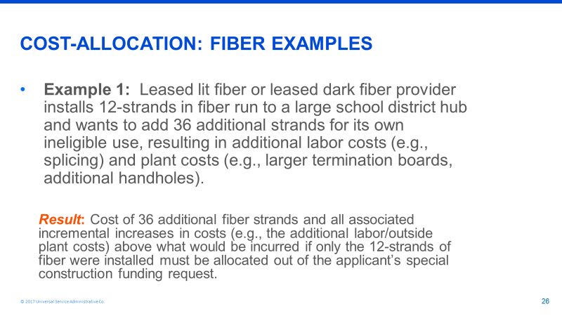

Applicant’s should seek documentation from the provider which outlines the added incremental costs attributable to designing, managing and constructing a fiber system with a 48-strand cable instead of a 12-strand cable. Such costs should include (but are not limited to):

- Splice Labor. If any fibers over the applicant’s fibers are spliced, the labor for these additional splices must be cost allocated.

- Splice Enclosures are placed to protect splices. If any fibers over the applicant’s fibers are spliced and require an enclosure, the enclosures for these additional splices must be cost allocated.

- Fiber Installation Labor. This represents the incremental cost of pulling a larger cable through the buried conduit.

- Structured materials installation. This represents the additional cost of burying a larger conduit to support the additional fibers.

Note that the costs associated with installing a larger cable strand than what is required by the applicant are ineligible and the service provider should not include such costs in their special construction billing to the applicant but should be prepared to show evidence during PIA review that it did not charge the applicant for these incremental costs.

Figure 1: Here is a table outlining some possible incremental costs:

Item | 12 Strand cable construction | 48 strand cable construction | Cost Allocation Amount that service provider should remove from the special construction request
Fiber Cable | 38 cents per foot | $1.04 per foot | 66 cents per foot
Design and Engineering | $2.12 per foot | $2.42 per foot | 30 cents per foot to depict additional splices at A and Z locations
Project Management | $1.18 per foot | $1.18 per foot | 0
Splice labor* | $11.00 per splice | $11.00 per splice | $11 per splice over 12 splices at any splice site
Splice enclosures** | $205 per enclosure | $205 per enclosure | $205 per enclosure for every enclosure over 12
Fiber Patch Panel | $71.43 per panel | $218.60 per panel | $147.17 per panel
Conduit and other structured materials | 1.25” conduit required  $1.95 per foot  Handhole (40,000 lb rated) $2695 per unit  Fiber Marker $30 per unit | 1.5” conduit required  $2.35 per foot  Handhole (40,000 lb rated) $2695 per unit  Fiber marker $30 per unit | 40 cents per foot  No cost difference for handhole  No cost difference per marker
Fiber Installation Labor *** | 25 cents per foot | 28 cents per foot | 3 cents per foot
Structured Materials Installation (conduit, markers, handholes)**** | $2.85 per foot | $3.10 per foot | 25 cents per foot
Markers | Place every 500’ | Place every 500’ | No cost difference
Handholes | Place every 1000’ | Place every 1000’ | No cost difference

- SELF-PROVISIONED (APPLICANT-OWNED) FIBER:

There are different cost allocation rules that apply, depending on whether fiber is only being purchased and used by:

- A single, eligible entity (school or library)
- A consortium of all eligible entities
- A consortium of eligible and ineligible “NON-public sector, municipal entities”
- A consortium of eligible and ineligible “public sector, municipal entities”

- Single, Eligible School or Library

- If the applicant installs the exact number of fiber strands that they will light in the first year, and no extra fibers are installed, all fiber strands and special construction charges are eligible and no cost allocation is required.

- If the applicant installs more fiber strands than it will light in the first year, E-rate will pay for the number of strands being lit in the first year, but not the additional strands. No cost allocation is required for the special construction charges. E-rate applicants can only receive E-rate funding for self-provisioned fibers that are lit within the funding year. If they request excess strands that will remain dormant until the applicant lights the excess strands for their exclusive future use, then they would need to cost allocate the cost of the unlit stands in the applicable funding year.

If the applicant can show documentation that buying a cable containing the number of strands placed in the fiber system for the applicant’s future use is more cost effective then buying a fiber cable with the number of strands the applicant plans to place into service the first year, no cost allocation for excess strands by the applicant is required.

Example 2 from the Funding Year 2018 USAC Fiber Training Slides applies:

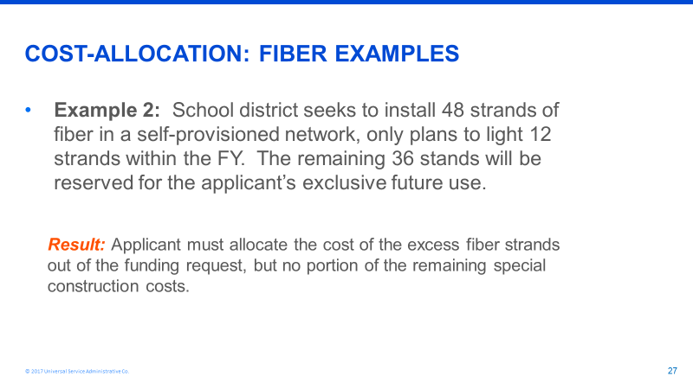

Item | 12 Strand Cable | 48 Strand Cable | Cost Allocation Amount that applicant should remove from the one-time special construction reimbursement request
Fiber Cable | $.38 per foot | $1.04 per foot | $.66 per foot

- Consortium Comprised of All E-rate Eligible Entities

As with Example 2, all fiber (lit and unlit in the first year) must be dedicated to only eligible entities only and the cost of strands not lit in the first year must be cost allocated.

- Consortium of Eligible and Ineligible Entities (NON-public sector, municipal)

If the eligible entity purchases and installs fiber for the usage of the eligible entities and the ineligible (non-public sector) entities, the funding request will be denied. E-rate funded self-provisioned fiber is exclusive owned by the E-rate applicant consortium and is for the exclusive use of the E-rate eligible applicant.

In this case, Example 3 from the Funding Year 2018 USAC Fiber Training Slides applies:

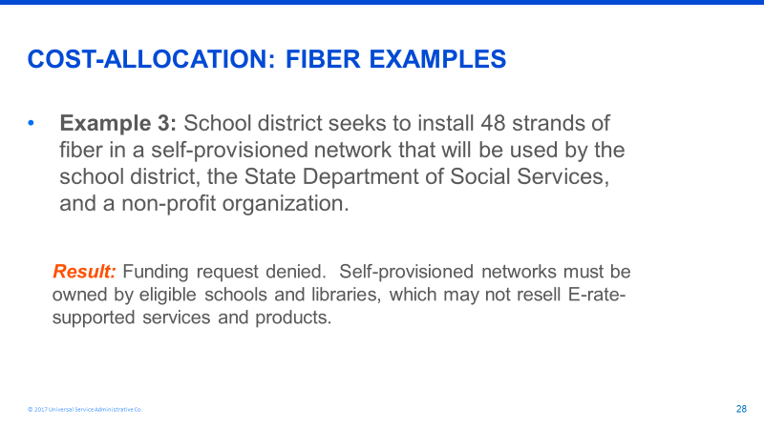

- Consortium of Eligible Entities and Ineligible “Public Sector, Municipal Entities”

For a self-provisioning consortium that includes a public-sector partner, the special construction cost-allocation rules are the same as the Leased Lit Fiber services with special construction or Leased Dark Fiber services with special construction. The cost of the ineligible fibers must be deducted from the funding request, but only the incremental costs related to labor, materials, engineering, project management, and design must be cost allocated.

For the purposes of E-rate, “public sector partner” is defined as health care providers and public sector (governmental) entities, including, but not limited to state colleges and universities, state educational broadcasters, counties and municipalities.
For this type of consortium, Example 4 from the Funding Year 2018 USAC Fiber Training Slides applies:

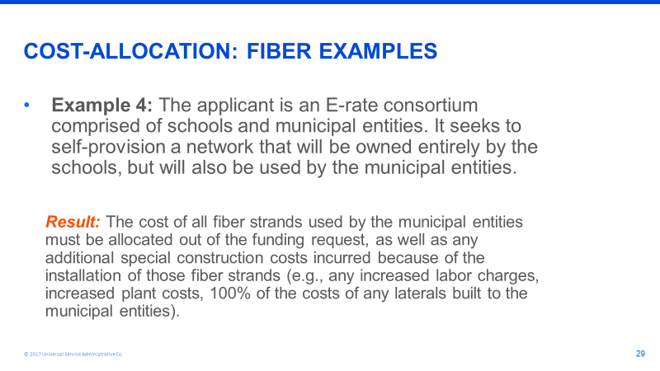

Note: The eligible applicant should be prepared to show evidence during PIA review that it has deducted all incremental costs associated with design, engineering, project management, construction, procurement of fiber and procurement of structured materials of the larger strand cable when compared to the costs associated with design, engineering, project management, construction, procurement of fiber and procurement of structured materials of the fiber strand cable only used by the eligible applicant.

