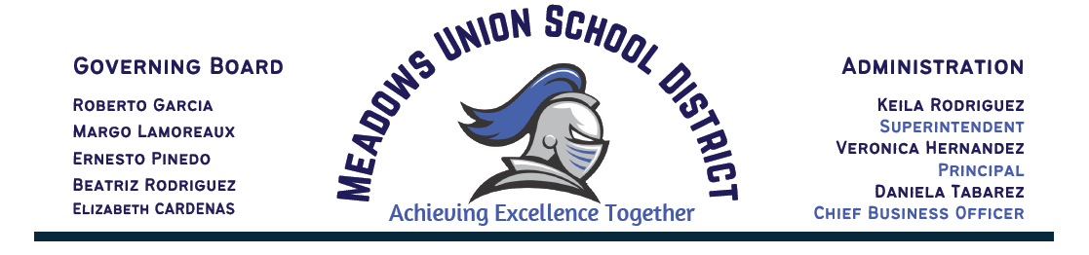
AGENDA
MEADOWS UNION SCHOOL BOARD OF TRUSTEES
REGULAR BOARD MEETING
2059 Bowker Road, El Centro 92243
May 11th, 2022
5:30pm Open Session
6:00 pm Closed Session
From time-to-time writings that are public records, which are related to open session items on an agenda for a regular meeting, may be distributed to school board members after the posting of the agenda. Whenever this occurs, such writings will be available for public inspection in the Office of the Superintendent located at 2059 Bowker Road, El Centro, CA, 92243.
Individuals who require special accommodation, including but not limited to accessible seating or documentation in accessible formats, should contact the Superintendent or designee at least two days before the meeting date at (760) 352-7512. (Government Code Section 54954.2).

- INTRODUCTORY PROCEDURES
Call to Order
Flag Salute
Roll Call
Present Absent
Margo Lamoreaux, President ______ ______
Ernesto Pinedo, Vice-President ______ ______
Beatriz Rodriguez, Clerk ______ ______
Robert Garcia, Member ______ ______
Elizabeth Cardenas, Member ______ ______

- MODIFICATIONS OF THE ORDER OF THE AGENDA, IF ANY.
Roll Call Vote: Lamoreaux____Piñedo____Rodríguez____Garcia____Cardenas____

- PUBLIC FORUM
Public Forum Rules-This is the opportunity for members of the public to address the Board regarding items on the agenda or other items within the Board’s jurisdiction. Your comments will be heard (with no action taken). Unless otherwise determined by the Board, persons wishing to address the Board will be limited to three (3) minutes and the total time for this purpose shall not exceed twenty (20) minutes. For the record: state your name, title, whom you represent, and the agenda item you are addressing. You are not allowed to make personal attacks on individuals or make comments which are slanderous, or which may invade an individual’s personal privacy. The District will not respond to your comments at this time. Your questions, concerns, and/or input will be referred to the appropriate Department. Any Member of the public who has a specific complaint about any district employee should use the District’s established complaint procedure

- BOARD COMMUNICATION

- STAFF COMMUNICATION

- CONSENT AGENDA ITEMS
All items appearing will be acted upon by one motion. Should any Trustee or other person request that any item(s) be considered separately or pulled from the Consent calendar that item will be added to the end of the agenda.

Roll Call Vote: Lamoreaux____Piñedo____Rodríguez____Garcia____Cardenas____

- Approval of the Minutes: April 13th, 2022 -Mrs. Rodriguez
Attachment A: Board Minutes
- Approval of payroll statement(s) in the amount of $480,226.07 (Regular)
Attachment B: Payroll Statements
- Approval of expenditure statement(s) in the amount of $166,666.24
Attachment C: Check Register

- INFORMATIONAL ITEMS
The District will provide information on the following:

- Superintendent Report-Mrs. Rodriguez
- CACFP Audit Attachment D – Mrs. Tabarez
- Playground Inspection Attachment E - Mrs. Rodriguez

- DISCUSSION/ACTION ITEMS
- Discuss/Approval of Science Curriculum Adoption- Mrs. Rodriguez
Attachment F: Science Curriculum Adoption
Roll Call Vote: Lamoreaux ____Piñedo____Rodríguez____Garcia____Cardenas___

- Approval of ICOE MOU Payroll- Mrs. Tabarez
Attachment G: ICOE Payroll Clerk
Roll Call Vote: Lamoreaux____Piñedo____Rodriguez____Garcia____Cardenas___

- Approval of ICOE MOU ERP – Mrs. Tabarez
Attachment H: ICOE ERP MOU

Roll Call Vote: Lamoreaux____Piñedo____Rodriguez____Garcia ____Cardenas____

- Approval of ICOE MOU Internet Filter-Mrs. Rodriguez
Attachment I : ICOE Internet Filter MOU

Roll Call Vote: Lamoreaux____Piñedo____Rodriguez____Garcia____Cardenas___

- Approval of teacher re-hires -Mrs. Rodriguez
Karen Beltran K-8 Teacher
Jessica Kelley SPED Teacher
Tanya Carbajal Grant Funded Independent Study Teacher

Roll Call Vote: Lamoreaux____Piñedo____Rodriguez____Garcia____Cardenas__

- Approval of MUTA MOU for Summer Rate -Mrs. Rodriguez
Attachment J: MUTA-MUSD Summer Rate
Roll Call Vote: Lamoreaux____Piñedo____Rodriguez____Garcia____Cardenas___
- Approval of CSEA MOU Increase of Hours for Maintenance/Custodian Employees #711 & #752 and 5-hr Bus Driver position, pending CSEA approval– Mrs. Rodriguez
Attachment K: CSEA MOU Extended Hours
Roll Call Vote: Lamoreaux____Piñedo____Rodriguez____Garcia____Cardenas___

- Approval of CSEA MOU for Special Project Assistant Position - Mrs. Tabarez
Attachment L: CSEA MOU Special Projects
Roll Call Vote: Lamoreaux____Piñedo____Rodriguez____Garcia____Cardenas___

- Approval to hire Bus Driver Yasmira Maldonado 5 hours Range 54/3 - Pending CSEA Approval of MOU– Mrs. Rodriguez
Roll Call Vote: Lamoreaux____Piñedo____Rodriguez____Garcia____Cardenas___

- Approval for Summer program curriculum
Attachment M: Right After School- Summer School Curriculum
Roll Call Vote: Lamoreaux____Piñedo____Rodriguez____Garcia____Cardenas___

- Approval of retirement request in the amount of $12,000 from employee id# 470-Mrs. Rodriguez
Attachment N: Employee Resignation Letter
Roll Call Vote: Lamoreaux____Piñedo____Rodriguez____Garcia____Cardenas

- Approval of purchase of modular trailer using ESSER III funds-Mrs. Rodriguez
Attachment O: CDE Equipment & Capital Expense Application
Roll Call Vote: Lamoreaux____Piñedo____Rodriguez____Garcia____Cardenas___

9. ITEMS PULLED FOR DISCUSSION

10. CLOSED SESSION Time:
a. Public Employee Performance Evaluation: Superintendent Evaluation

ANNOUNCEMENT OF ACTION(S) TAKEN IN CLOSED SESSION
Public Report of any action in closed session taken by the Governing Board which must be
reported out (Government Code Section 54957)

11. RECONVENE TO OPEN SESSION Time: ______________

12. NEW BUSINESS/OLD BUSINESS (discussion of any items for future or past board meetings)

13. ADVANCED PLANNING
Next Meeting June 15th, 2022, Time: 5:30pm.

14. ADJOURNMENT

