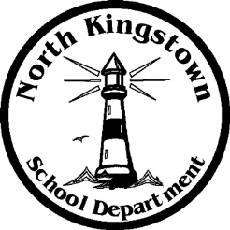
NORTH KINGSTOWN SCHOOL DEPARTMENT
Payroll Office
100 Fairway Drive
North Kingstown, RI 02852-6202
(401) 268-6461 www.nksd.net
Fax: (401) 268-6445 TDD: (401) 268-6457
nannette_mello@nksd.net

Challenging
Student
Excellence
The pay dates for 2013-2014 are as follows:

2013-2014 PAY DATES
PAY DATE |  |  | PAY DATE
07/05/2013 |  |  | 01/03/2014
07/19/2013 |  |  | 01/17/2014
08/02/2013 |  |  | 01/31/2014
08/16/2013* |  |  | 02/14/2014
08/30/2013 |  |  | 02/28/2014
09/13/2013 |  |  | 03/14/2014
09/27/2013 |  |  | 03/28/2014
10/11/2013 |  |  | 04/11/2014  *4/17/2014 Teachers only
10/25/2013 |  |  | 04/25/2014 –NOT include Teachers
11/8/2013 |  |  | 05/09/2014
11/22/2013 |  |  | 05/23/2014
12/06/2013 |  |  | 06/06/2014
12/20/2013 |  |  | 06/12/2014 or last day of school- TCHR 4 X'S BALLOON PAY
 |  |  | 06/20/2014
*The 1st scheduled pay date for returning teachers in 2013-2014 is August 16, 2013.

