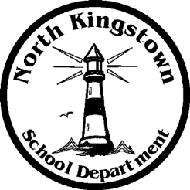
NORTH KINGSTOWN SCHOOL DEPARTMENT
Payroll Office
100 Fairway Drive
North Kingstown, RI 02852-6202
(401) 268-6461 www.nksd.net
Fax: (401) 268-6445 TDD: (401) 268-6457
nannette_mello@nksd.net

Challenging
Student
Excellence
The pay dates for 2014-2015 are as follows:

2014-2015 PAY DATES
PAY DATE |  |  | PAY DATE
07/03/2014 |  |  | 01/02/2015
07/18/2014 |  |  | 01/16/2015
08/01/2014 |  |  | 01/30/2015
08/15/2014 |  |  | 02/13/2015
08/29/2014* |  |  | 02/27/2015
09/12/2014 |  |  | 03/13/2015
09/26/2014 |  |  | 03/27/2015
10/10/2014 |  |  | 04/10/2015
10/24/2014 |  |  | 04/24/2015
11/8/2014 |  |  | 05/08/2015
11/21/2014 |  |  | 05/22/2015
12/05/2014 |  |  | 06/05/2015
12/19/2014 |  |  | 06/12/2015 or last day of school- TCHR 5 X'S BALLOON PAY
 |  |  | 06/19/2015

*The 1st scheduled pay date for returning teachers in 2014-2015 is 8/29/2014.

