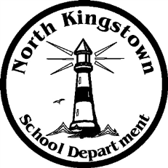
North Kingstown School Department

Payroll Department

100 Romano Vineyard Way Suite 120
North Kingstown, RI 02852-6202
(401) 268-6461 www.nksd.net
Fax: 268-6445 TDD: 268-6457
Alicia_jones@nksd.net
Educate

Inspire

Challenge

PAYROLL SCHEDULE SYE 16-17

PAY DATE PAY DATE

7/1/2016 1/13/2017

7/15/2016 1/27/2017

7/29/2016 2/10/2017

8/12/2016 2/24/2017

8/26/2016 3/10/2017

9/9/2016* 3/24/2017

9/23/2016 4/7/2017

10/7/2016 4/21/2017

10/21/2016 5/5/2017

11/4/2016 5/19/2017

11/18/2016 6/2/2017

12/2/2016 6/15/2017 or last day of school****

12/16/2016 6/16/2017**

12/30/2016 6/30/2017**

* First pay for Teachers SYE 16-17
** Only Admin, 10 & 12 month ESP (NO Teachers paid)
**** Teachers only Balloon Pay x 6 pays
REVISED ON 10/5/2016

